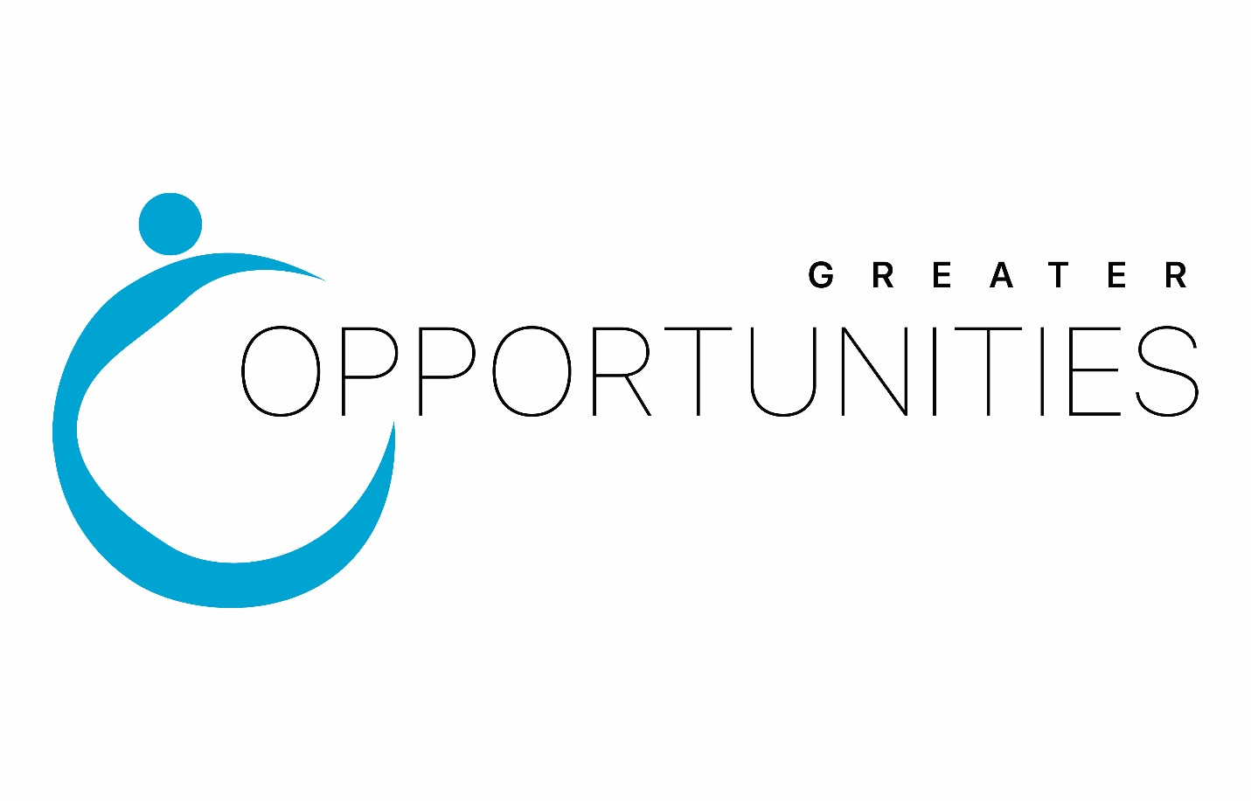
Community Needs Assessment Update
2023

TABLE OF CONTENTS
Methodology……...……………………………………………………………………………….3
Sources of Data and Data Collection Methods…..………………………………………………..3
Causes and Conditions of Poverty…………………..…….………………………………………4
Findings…………………………………...………………………………………………………7
State of the Grantee…………………………………………………………………………….....9
Service Area Profile……………………………………………………………………………..10
Population…………………….………………………………………………………………….11
Age and Gender Demographics………………………………………………………………….12
Households…………………………………………………………….…………………………14
Families………………………………..…………………………….…………………………...14
Poverty………………………………………………………………..………………………….15
Violent Crime……………………..……………………………………………………………..45
Property Crime…………………………………………………………………………………..46
Average Daily Population Counts in Area Jails……………..…………………………………..47
Citizenship Status…………………………………………………….………………………….47
Hispanic or Latino Citizens…………..………………………………………………………….48
Employment, Unemployment, and Labor Force……………………...………………………....49
Wages……………………………………………………………………………………………53
Commuter Travel Patterns………………………………..……………………………………...55
Travel Time to Work…………………..………………………………………………....56
Education………………………………………………………………………………………...57
School Enrollment……………………………………………………………………….58
High School Dropouts…………………………………………………………………...58
High School Graduates……………………………………………………………….....58
Educational Attainment.…………………………………………………………………59
Graduation Rate………………………………………………………………………....60
Adult Literacy Rate……………………………………………………...……………………..60
Early Care and Education………………………………...……………………………………...61
Housing………………………………………………………..…………………………………71
Income……………………………………………………………………………………………80
Health Care………………………………………………………………………………………90
Free and Reduced Lunch Program…………………………………………………..…………..97
Alice…………………………………………………………….………………………………102
Client Focus Groups……………………………………………………………………………104
Needs of Low-Income Individuals, Children and Families: Client Surveys…………….……..108
Needs of Low-Income Individuals, Children and Families: Stakeholder Survey……….……..110
Client Satisfaction Surveys…………………………………………………………………….111

Methodology
The purpose of the community-wide needs assessment is to provide a current snapshot of the well-being of families and children in our Broome and Chenango County service area. The community-wide needs assessment assists Greater Opportunities in designing programs that meet community needs and builds on the strengths and resources of our community. This report also summarizes a quantitative and qualitative exploration of the causes and conditions of poverty. This assessment has demonstrated the complexity of how community health, safety and economic opportunity interconnect with the ability of low-income people to achieve stability and economic security. The report also contains important awareness about the community assets valued by stakeholders, as well as customer sources of personal strength and resilience. This document is prepared in accordance with 45 CFR 1302.11. It provides information compiled from various national, state, and local sources and identifies community trends, the conditions in the service area that impact children and families, the demographic make-up, and other resources in the community. The purpose of the community-wide needs assessment is as follows:
- To guide and solidify the strategic planning and direction of the agency.
- To inform decision-making and program planning
- To educate staff, stakeholders, and agency customers
- To establish the program goals, including long and short-term program objectives
- To address changing priorities within our communities and respond to trends
- To assess community resources and maximize community collaborations
- To identify the service and recruitment area served by Head Start and Early Head Start
- The number of Head Start eligible children and families in the service area and appropriate locations for services

The community assessment was prepared by the staff of Greater Opportunities for Broome and Chenango, Inc. The community assessment will serve as the Greater Opportunities’ baseline for identifying current community needs, designing new strategic plans, developing community collaborations, evaluating the effectiveness and progress of current programming and interventions that serve low-income families and children in the community, and for making decisions about programming that can achieve outcomes for individuals and families.

Sources of Data and Data Collection Methods
Numerous data sources were used to describe the demographics of the service area and the physical, social, and economic well-being of the two-county low-income population. The first data gathering phase included surveys distributed to clients in all Greater Opportunities program areas, as well as community stakeholders representing community-based, faith based, private sector, public sector and educational organizations. In addition, focus groups were held with Greater Opportunities customers from all programs, including Housing, Head Start, and WIC. Through the analysis of this data, we were able to collect stakeholder perceptions about the health of the community, the performance of existing community infrastructure, and the conditions of poverty affecting its residents of all ages. In addition, the use of surveys and focus groups allowed Greater Opportunities the ability to collect information from our customer bases on community assets and sources of resilience that can be called upon on for community challenges.
Quantitative sources of data included population datasets, sources such as the U.S. Census Bureau, Bureau of Labor Statistics, New York State Department of Health, New York State Department of Temporary and Disability Assistance and others. Internal data included information from our agency centralized databases to create a profile of children and families, services received, and services for children with disabilities. These sources included the Head Start/Early Head Start Program Information Report for Greater Opportunities for Broome and Chenango, Inc. The primary data set used for the data collection was the U.S. Census 2015-2019 five- year estimates. Initial data analysis was completed by Greater Opportunities for Broome and Chenango, Inc. Findings, as well as recommendations, were prepared from this analysis for consideration by our Board of Directors and the Head Start Policy Councils. Findings and recommendations will form the foundation for planning and guide the agency strategies for the next several years.

Causes and Conditions of Poverty-Update 2023
Many interconnected factors contribute to the prevalence of poverty in Broome and Chenango Counties. Poverty continues to be a major influence that impacts the ability of individuals to obtain employment and the ability of families to meet their self-sufficiency needs. Two trends are largely responsible for causes and conditions of poverty: a growing shortage of living wage jobs and a simultaneous increase in poverty. The economy, job structure and poverty are inextricably linked. Individuals living in poverty are frequently unable to pay for housing, food, childcare, utilities and health care. The number of recipients receiving Temporary Assistance for Needy Families (TANF) in Broome and Chenango County has continued to increase over the past three years. The number of households receiving Supplemental Security Income (SSI) has had a small decrease over the past few years, with 6,952 households in Broome County and 1,568 in Chenango County receiving SSI. The problem is only compounded for an individual/family that has documented disabilities, such as mental illness and/or chemical addiction, as these individuals and families need to further navigate a system of service providers to get their additional needs met. Difficult choices must be made when limited resources cover only some of the necessities.
Traditionally, research has identified the opportunities for socioeconomic advancement in the form of employment opportunities and/or higher wages. Rents are becoming increasingly unaffordable, especially to those employed in the service or retail sectors. Per the U.S. Census data nearly half of Broome and Chenango County is employed in service occupations, such as retail and hospitality sectors, that often pay a lower wage and do not offer the range of benefits that professional occupations provide. The COVID-19 pandemic had only compounded this issue, as many of these sectors were forced to lay employees off for an extended period of time or close altogether due to the economic climate. In addition, the COVID-19 pandemic had forced many of the manufacturing companies to lay off a large percentage of their workforce, leaving many unemployed or underemployed. Broome and Chenango County are still haunted by the long-term manufacturing industry trend, as much of our work is rudimentary in nature and can be easily outsourced into lower cost markets. Advanced, specialized, or niche production can only survive in a competitively priced global market. The top 25 job openings in our area require a specific level of education, usually requiring additional training. The local Department of Social Services reported that many people applying for assistance is due to unemployment benefits ending, limited job availability, and people not having the education or skills to obtain employment. DSS continues to see people needing assistance with housing, food, utilities and health care. There are very few job opportunities for individuals with a High School Education/GED or less. For individuals struggling to pay the rent, a serious illness or disability can start a downward spiral into homelessness, beginning with a lost job, depletion of savings to pay for care, and eventual eviction.
Other caused of poverty can be attributed to a breakdown of social systems. Housing has become scarcer for those with little money. Earnings from employment and from benefits have not kept pace with the cost of housing and utilities for low-income and very low-income individuals. New York State Electric & Gas (NYSEG) has asked for substantial increases in recent years, which has made housing costs an even greater portion of a household budget. According to the National Low-Income Housing Coalition, an individual earning $761.00 a month from SSI can afford no more than $228 a month for an efficiency or one-bedroom unit while the fair market rents set by HUD are $758 (Broome) and $696 (Chenango) a month respectively. The Fair Market Rent (FMR), according to the 2023 HUD Fair Market Rents Schedule, for a two-bedroom apartment is $964 a month in Broome County and $829 a month in Chenango County. In order to afford this level of rent, without paying more than 30% of income, a family must earn $38,500 per year in Broome County and $33,900 per year in Chenango County. An individual must earn $30,250 per year in Broome County and $27,750 per year in Chenango County for a one-bedroom apartment. With rents unaffordable and the cost of utilities increasing, many individuals and families are forced to live in substandard housing, with family and friends, or in shelters and/or streets. Due to the COVID-19 pandemic, an eviction moratorium was issued in New York State in March 2020. Because of this moratorium, individuals and families that were living in substandard housing or were experiencing homelessness, had been unable to secure housing due to the lack of mobility among renter households. Although the Moratorium was lifted on January 15, 2022, both counties continue to struggle with housing issues. Many small landlords across Broome and Chenango County have gone nearly two years without any rental income. And while the moratorium has been lifted, many are still waiting for their day in court due to an immense back log in the County court systems, which has further exacerbated housing shortages in each area. In addition, due to the fact that many landlords have gone so long without payment, some have instituted stricter standards about renting to individuals without stable employment and income, leaving those with subsidies from Section 8 and/or local departments of social services having a more difficult time in securing permanent housing.
The nature of public service systems, especially in communities that lack needed resources, can create barriers for those trying to improve their economic mobility which can be linked to generational poverty. Within both Broome and Chenango County, the transportation systems are severely inadequate, especially in the rural locations. In addition, both communities lack adequate services to meet the mental health, addiction, oral health, and physical health care needs of individuals and families. Lack of transportation resources also can be noted as a cause of poverty and poor health as it limits the ability of individuals to reach needed resources, such as food and/or medical care, and can present as a barrier to maintaining employment or attendance in career training programs.
Education and access to education can be the key to moving out of poverty. The better public schools are often found in communities with higher income, with poorer schools being located in low-income neighborhoods. In addition, access to higher education is often blocked due to affordability, crowding, and the potential of a huge debt burden afterwards. Poverty is also more prevalent among specific cohorts based on age, gender, and race. Persistent issues of race and gender mean higher poverty among minorities and women. Many seniors are also forced to live on a fixed income from retirement, SSI, or SSD and these resources not provide enough to meets the rising cost of living.
In Broome and Chenango County, there is a prevalence of fluctuating rates of unemployment, crime, illicit drug abuse, teenage pregnancy, mental and physical disorders, single-parent female households, child maltreatment, high levels of movement out of the area, lack of child and adult health and mental health services, and low developmental outcomes achieved for children and adolescents. These problems can be the direct consequences of poverty and data collected for this community needs assessment indicates that the cost of living continues to rise and poverty rates have remained consistent over time. For our service area, the poverty rates are higher than a majority of New York. Also, child poverty rates are higher than poverty rates among other groups which can contribute to collective disadvantages over time leading to generational poverty.
Health discrepancies can be a consequence and condition of poverty. Lack of affordable health insurance often puts families and individuals at risk for poor health outcomes. In addition, lack of medical and mental health services can lead to individuals not being able to work and in rural communities, such as the majority of our service area, there is often lack access to these services. In both Broome and Chenango Counties, there is a higher rate of mental and physical health issues than most areas in New York State, however, there is a shortage of medical, dental, and mental health providers in our area. In addition to limited availability of certain services, our community is home to a large number of neighborhoods without readily available access to fresh, healthy, and affordable food, which can contribute to higher levels of obesity and other health related concerns.
Although the consequences and conditions listed above is not exhaustive, it demonstrates that assisting individuals and families in overcoming poverty is a lengthy endeavor that will only happen through personal and systematic change. Agencies, like Greater Opportunities, must utilize innovative strategies and programs that address the needs of those experiencing poverty, as well as addressing the underlying causes of poverty.

Findings and Recommendations-Update 2023
Finding 1: The systemic inequalities present in our communities has made accessing needed resources and services for low-income people to achieve economic stability even more constraining.
Recommendations for Finding 1:
- Prioritize unrestricted funding for safe and socially distant activities, such as an outdoor movie night or game night, to allow families and children the opportunity to engage in activities that encourage socialization.
- Create and provide training curriculum for individuals and families on how to navigate programs and resources available within our community. Examples can include the following: Classes that assist individuals in how to apply for resources, such as unemployment benefits, rental assistance, or accessing virtual appointments; and finally, support groups that allow individuals and families to discuss their concerns and work collectively to generate strength-based solutions.
- Create innovative ways of having parents and caregivers participate in and be active in the classroom so that they feel fully engaged in the educational process.
- Program leaders should fully engage in community-wide initiatives and efforts that advocate for the expansion of public transportation, especially in rural areas, to allow greater access to services.
Finding 2: Mental and behavioral health conditions, including addiction services, affect many individuals and families in the Greater Opportunities service area. Lack of these services is identified as a concern by stakeholders and clientele, while access to formal mental health services in each county is limited. When individuals and families face challenges or feel undervalued, many will access personal sources of strength and support to obtain emotional security.
Recommendations for Finding 2:
- Continue efforts to teach and develop social-emotional competencies in individuals and families by utilizing research-based methods including, but not limited to, trauma-informed care, active listening, intensive interventions, and targeted social-emotional supports.

- Research social-emotional assessments used to determine the needs of individuals and families to ensure that they take into consideration the circumstances and community factors that may affect those that are economically disadvantaged, such as family dynamics, housing conditions, and access to resources. Individual Service Plans and development of personal goals should be based on the conditions and circumstances of the community in which they live. Assist individuals and families in determining their goals and how to reach those goals based on what is available to them.

- Continue to work with community service providers to expand and improve access to mental and behavioral health treatment, through the development and utilization of peer- to-peer advocates, mobile mental health crisis teams, and other innovative strategies to support emotional well-being and treatment compliance.

- Raise community and client awareness of substance abuse prevention initiatives, including Narcan training, use of evidence-based programs that have demonstrated positive results based on scientific evidence, and the promotion of programs that enhance protective factors and reduce risk factors.
Finding 3: Due to the rising costs and limited availability of quality early childhood programs, families face challenges in trying to both secure and/or maintain gainful employment and having high-quality early childhood education for their young children.
Recommendations for Finding 3:
- Expand Early Head Start model and slots for center-based programming in both Broome and Chenango County. This initiative will provide education benefits from birth to age 3, while assisting in the reduction of childcare cost to parents and providing them an opportunity to obtain employment.
- Continue to explore Head Start and Early Head Start program models to ensure the provision of high-quality programming provision of intensive service delivery for children and the need to increase wages for Head Start personnel in order to avoid high turn-over rates in staffing. This would assist our programs in being in more uniformity state preschool programs operating in New York State.
- Explore collaborations with school districts and other service providers to provide wrap-around care and summer program options to Head Start children and families to relieve the child care cost burden for participating families.
- Continue to explore available buildings to be owned and operated by Greater Opportunities in order to expand and maintain our current Early Head Start, Head Start, and UPK programming. By owning our sites outright, Greater Opportunities would have permanent locations in order to provides educational, social, and emotional programming for children and families.

State of the Grantee
On July 27, 2020, Opportunities for Broome, Inc. merged with Opportunities for Chenango, Inc. to create the current agency of Greater Opportunities for Broome and Chenango, Inc. The unique thing about OFB and OFC’s decision to merge, is that neither agency needed to merge. Both agencies had remarkable reputations with funders and were considered strong agencies within our communities. The former OFB and OFC were not weak agencies, looking to survive in a turbulent economic climate. Rather, they were progressive agencies looking to see what we could do better to serve our clients and our communities by coming together as one.
In 2013, Opportunities for Broome and Opportunities for Chenango, Inc. began discussing the possibility of a merger of the two agencies. With economic down turns and possible funding scarcity, a merger would accomplish multiples goals: enhance organizational capacity to achieve results; reduce administrative costs; increase flexibility to meet the needs of the clients we serve; and provide an opportunity to focus on our mission of empowering people and our communities. Although bigger is not always better, a merged agency would provide the agency the capability of adapting to meet the needs of their communities and those they serve. With the dedicated support of the Board of Directors, the trust and support of the personnel of both agencies, and a tremendous amount of hard work, the merger became a reality.
Since 1965, Greater Opportunities has helped to serve their respective communities with their greatest needs. Community Action Agencies, like Greater Opportunities, were born out of President Johnson’s War on Poverty and were designed with the idea that local communities know best how to meet their needs. Greater Opportunities receives seed-funding from the federal Community Services Block Grant (CSBG). The mission of Greater Opportunities is to educate, advocate, and empower individuals and families to improve the quality of their lives through the development of self-reliance, while promoting a culture of people working together to help themselves, one another, and their community. The braiding of community resources and the building of effective partnerships, serves as the cornerstone for the foundation and success of the agency. Greater Opportunities works with their customers to help create the opportunities and programs that work for them as individuals. They do this with a hands-on approach in order to help track their progress and ensure their on-going journey to success. Greater Opportunities currently serves all of Broome and Chenango County and provides numerous services to the community through the following departments:
- Early Childhood Services: Head Start and Early Head Start
- Energy Services
- Supportive Housing Services
- First Time Homebuyer Programs
- Rehabilitative Housing Program

Service Area Profile

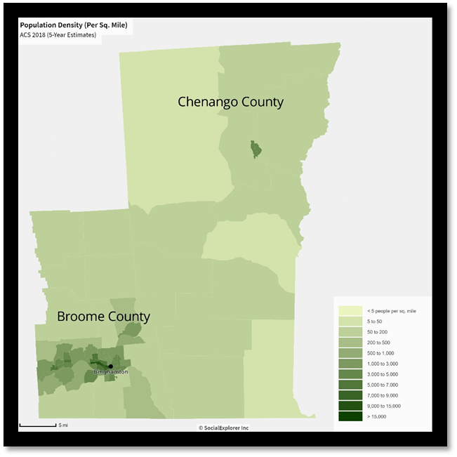

Population
Population change within the report area from 2010‐2020 is shown below. During this ten‐year period, total population estimates for the report area declined by ‐2.06 percent, decreasing from 251,075 persons in 2010 to 245,903 persons in 2020.
Since 2000, the service area counties have experienced a population decrease while the remainder of New York State, and the nation as a whole, experienced population increase. With the population decrease, this has also affected the birth rate in both counties. According to the NYS Department of Health Vital Statistics, there were only 1,419 births (0.2%) occurring in Chenango County from 2017-2019 and 5,908 (0.29%) occurring in Broome County during the same time period. The decrease in birth rates, as well as the population decrease in both counties may have a direct correlation to issues with enrollment and under-enrollment in our Early Head Start and Head Start programs.
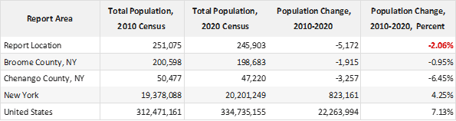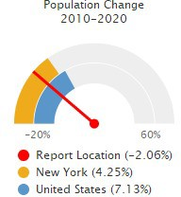

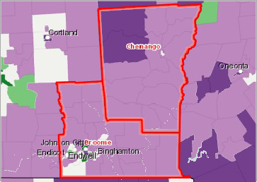
Population Change, Percent by Tract, US Census Bureau 2010 ‐ 2020

Over 10.0% Increase ( + )
2.0 ‐ 10.0% Increase ( + )
Less Than 2.0% Change ( +/‐ )
2.0 ‐ 10.0% Decrease ( ‐ )
Over 10.0% Decrease ( ‐ )
No Population or No Data
Report Location

Age and Gender Demographics
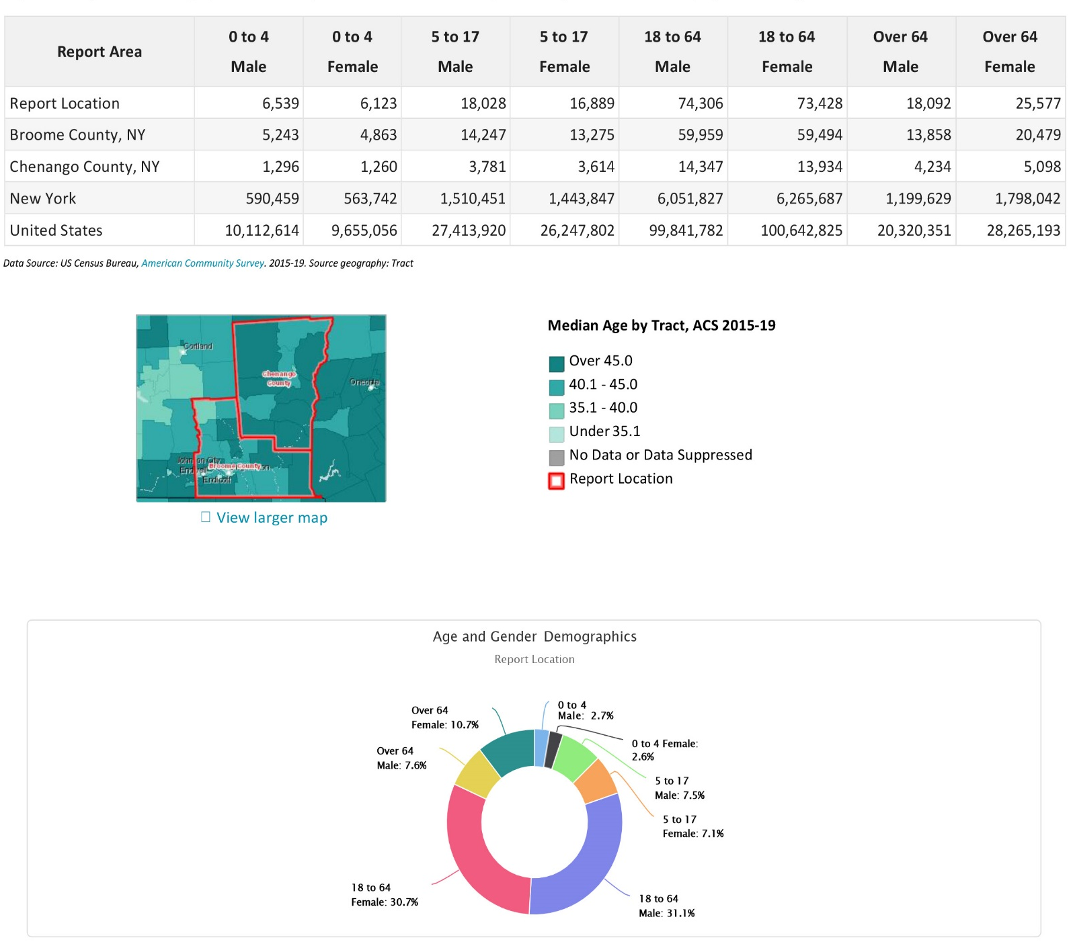
Population by gender within Broome and Chenango County is shown below. According to the ACS 2015‐2019 5-year population estimates for the service area, the female population comprised 51.06% of the report area, while the male population represented 48.94%. Aging has a significant impact on society. People of different ages and gender tend to differ in many aspects, such as legal and social responsibilities, outlooks on life, and self-perceptions. Young people tend to have fewer legal privileges (if they are below the age of majority), they are more likely to push for political and social change, to develop and adopt new technologies, and to need education. Older people have different requirements from society and government, and frequently have differing values as well, such as for property and pension rights.
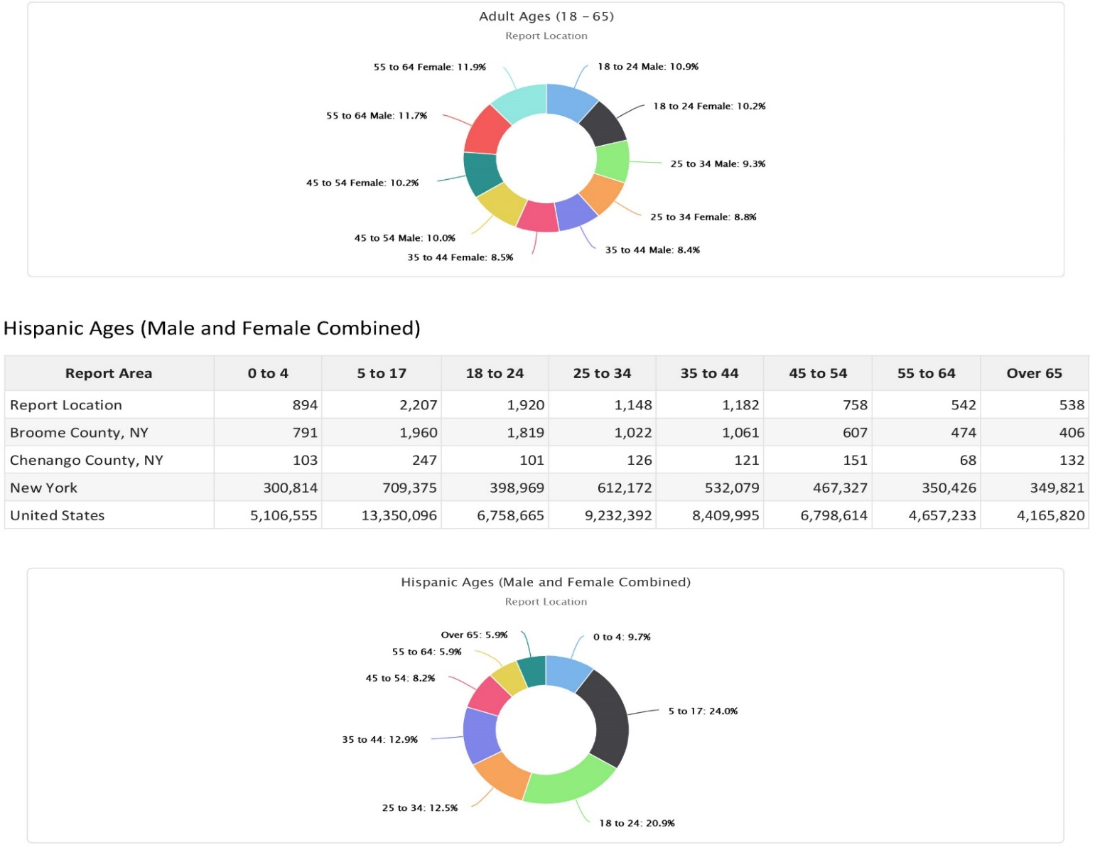
Both Broome and Chenango County features a male majority population, which has been a shift over the last several years. Areas in which the population is comprised of a greater proportion of women than men may be more impacted by issues related to gender equality. Research has shown that gender and poverty can be linked. For example, a woman’s risk of living in poverty is closely related to her marital and family status. Studies have shown that more single mothers within an area, contribute to higher rates of poverty within that area.

Households
The change in number of households within the report area from 2000 to 2015/2019 is shown below. Total households for the report area decreased by ‐1,429 * ‐1, or ‐1.42% in those counties reported in the 2019 American Community Survey (ACS) 5‐year data. This compares to a statewide increase of 4.06%.

Families
The American Community Survey (ACS) estimated there were 59,272 families in the report area in 2019. Married couple families comprised 72.78% of the total number. Families headed by men without wives comprised 7.96% of the total, while women without husbands headed 19.26% of families. Children living in single-parent households are overrepresented all areas of Greater Opportunities programming, including Head Start and Early Head Start. For children, growing up in single-parent households can increase their risk of poverty, physical health issues and mental health problems later in life.

Children from single-parent households, especially those living with single-mothers, are more likely to have moderate to very poor health outcomes, score higher on the emotional problem scale, and may experience more home environmental stress. These conditions most likely stem from lack of access to resources, which is evident in the reduced income for single mothers as demonstrated throughout the community assessment data. Single mothers also face additional barriers because they are frequently the only caregiver for their children.

Poverty
2019 poverty estimates show a total of 38,330 persons living below the poverty level in the report areas. Poverty information is at 100% of the federal poverty income guidelines.

Poverty Rate (ACS)
The following report section shows population estimates for all persons in poverty for the report area. According to the American Community Survey (ACS) 5-year estimates, an average of 16.62% of all persons lived in a state of poverty during the 2015 ‐ 2019 period. The poverty rate for all persons living in the report area is greater than the national average of 13.42%.
The poverty rate among the Broome County residents is 17.41%, compared to a rate of 13.53% in Chenango County, 14.07% in the state, and 13.42% of U.S. residents living in poverty. Among children aged 0 to 17 years old, the poverty rate is 22.6% in the service area, compared to a rate of 18.2% in New York, and 16.34% in the nation. Poverty is experienced at a higher rate for families headed by a single-mother, especially in Broome and Chenango County where single-parent female householders experienced a significantly higher rate of poverty than the state, and the nation at 54.7%.

Poverty Rate by Race and Ethnicity
There is a large racial disparity in the poverty rate exists in both Broome and Chenango counties. Of the total Black/African American population in the service areas, 38.5% are living in poverty which is higher the state average poverty rate of 21.06% and the national average of 23.04% of the entire Black/African American population. A total of 13.81% of the White population in the service area live in poverty, which is higher than the state and nation poverty rate for the White population. In addition, the services area also experiences a higher poverty rate than the state and the nation among other populations, including the Hispanic population (32.24%) and Asian Population (38.40%).

Population in Poverty Race Alone, Percent
This indicator reports the percentage of population in poverty in the report area by race alone.
Population in Poverty by Race Alone, Total
This indicator reports the total population in poverty in the report area by race alone.
Poverty Rate 200% (ACS)
In the report area 35.12% or 80,959 individuals are living in households with income below 200% of the Federal Poverty Level (FPL). This indicator is relevant because poverty creates barriers to access including health services, healthy food, and other necessities that contribute to poor health status.
Poverty Rate 125% (ACS)

In the report area 20.99% or 48,391 individuals are living in households with income below 125% of the Federal Poverty Level (FPL). This indicator is relevant because poverty creates barriers to access including health services, healthy food, and other necessities that contribute to poor health status.

Family Poverty Rate 125% (ACS)

In the report area 14.24% or 8,439 family households are living with income below 125% of the Federal Poverty Level (FPL).

Poverty Rate 200% (ACS) by School District

This indicator reports the number of people living in households with income below 200% of the Federal Poverty Level (FPL), by school district boundaries.

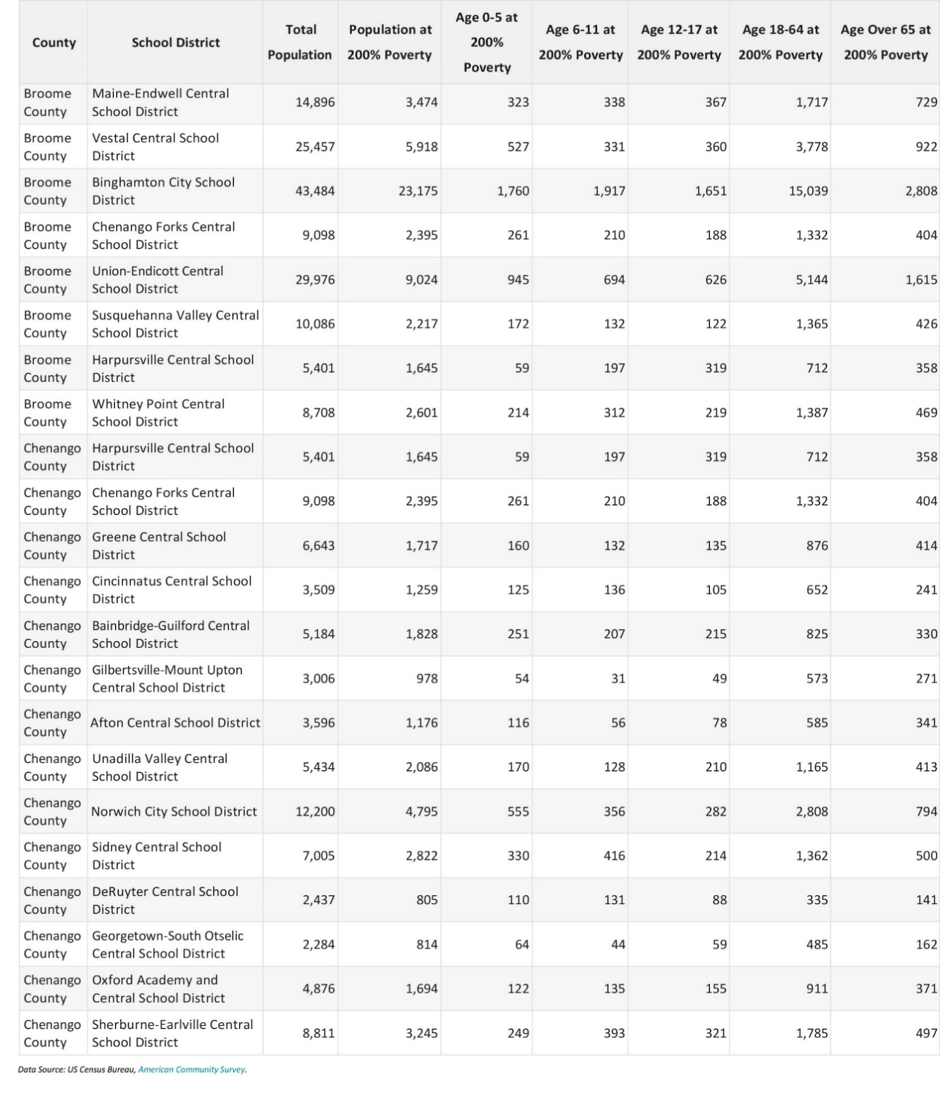

Poverty Rate 200% (ACS) by School District: Continued
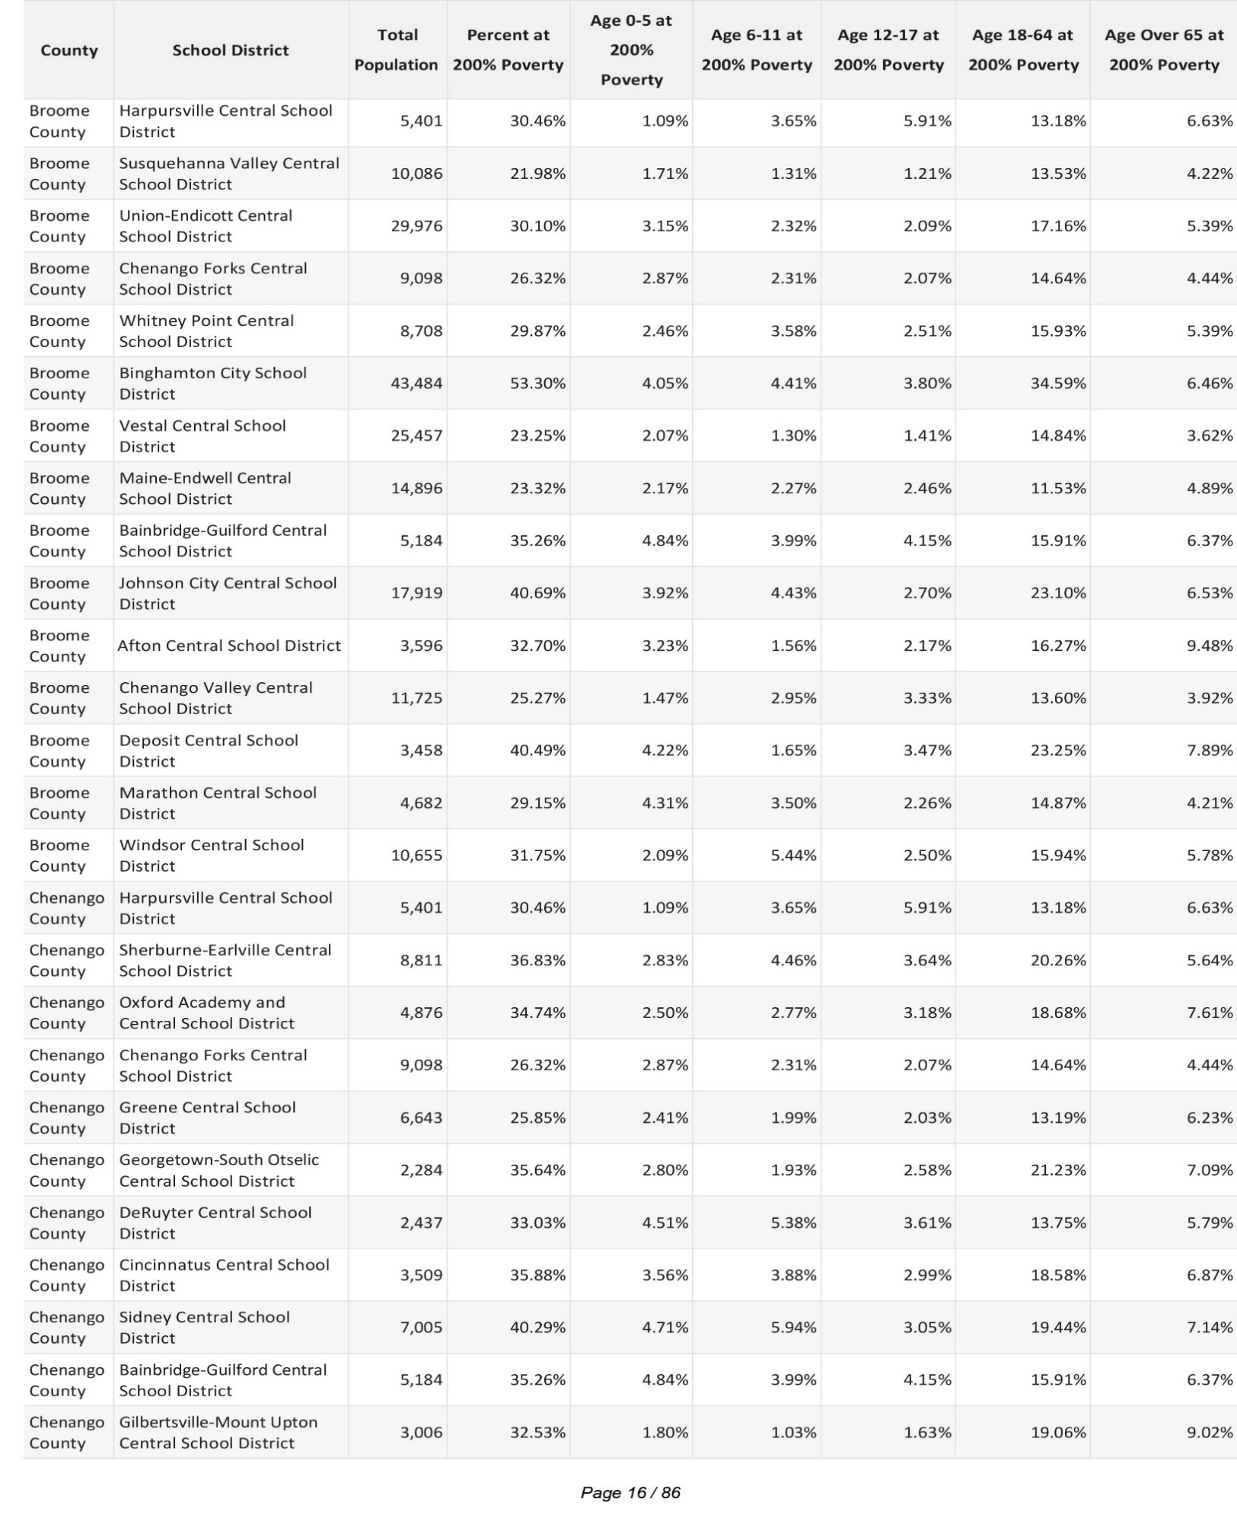
Poverty Rate 185% (ACS) by School District
This indicator reports the number of people living in households with income below 185% of the Federal Poverty Level (FPL), by school district boundaries.
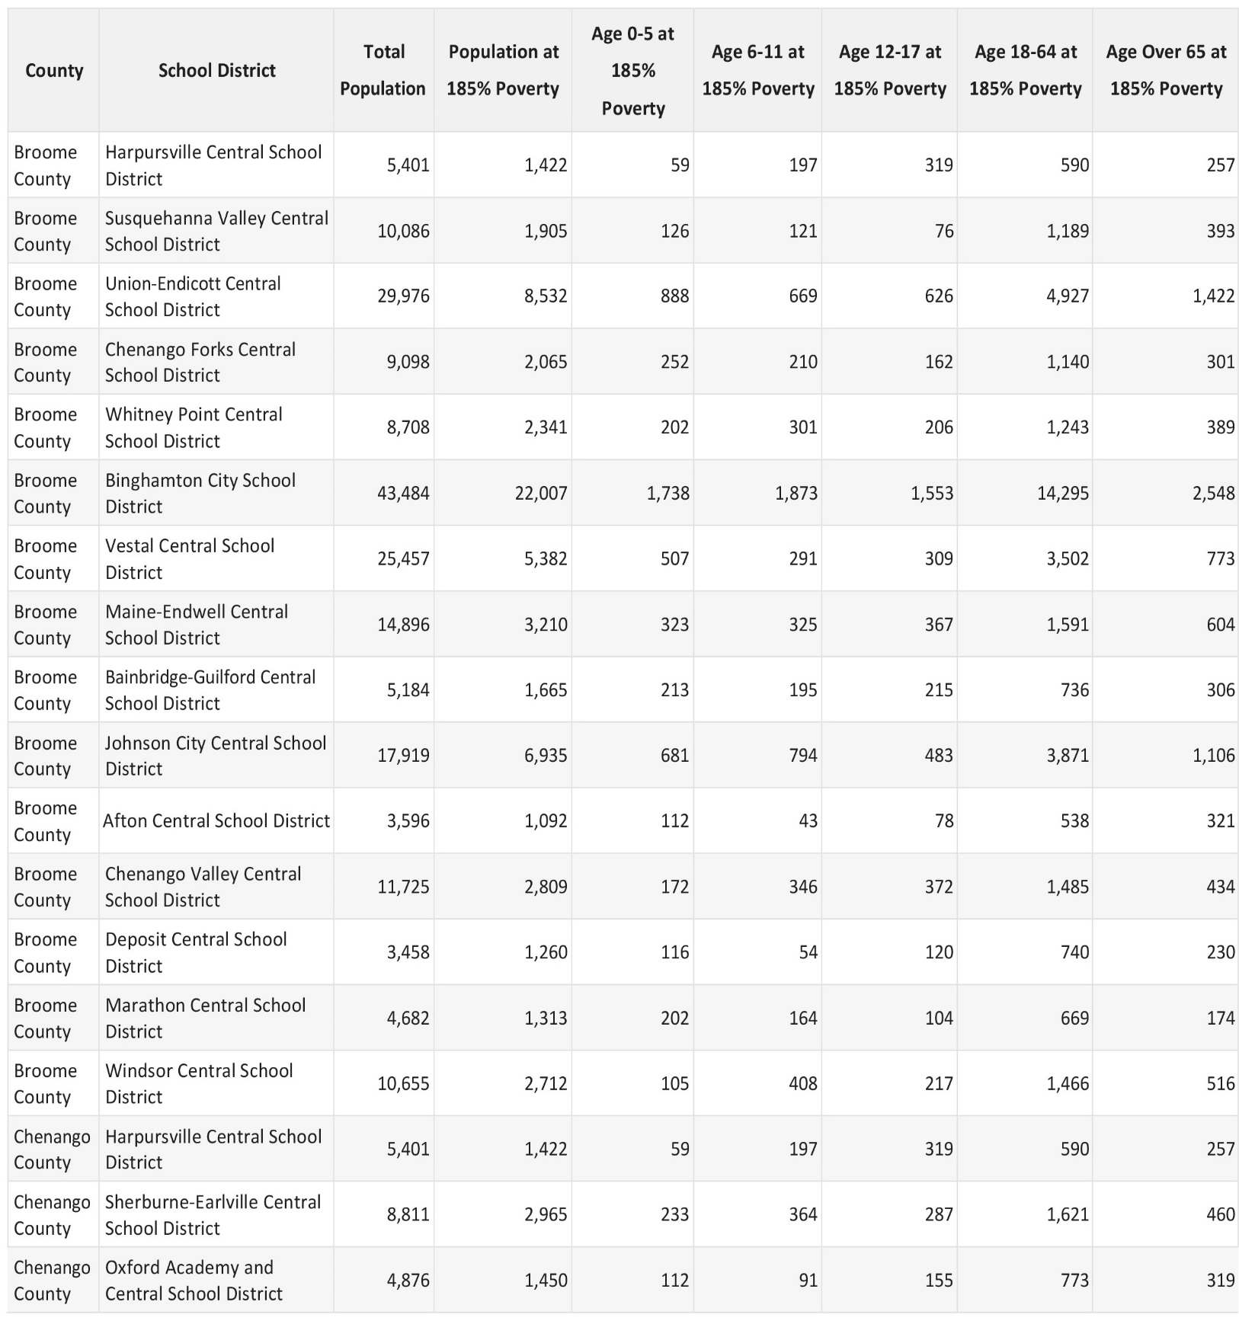

Households in Poverty

The number and percentage of households in poverty are shown in the report area. In 2019, it is estimated that there were 15,758 households, or 15.9%, living in poverty within the report area.

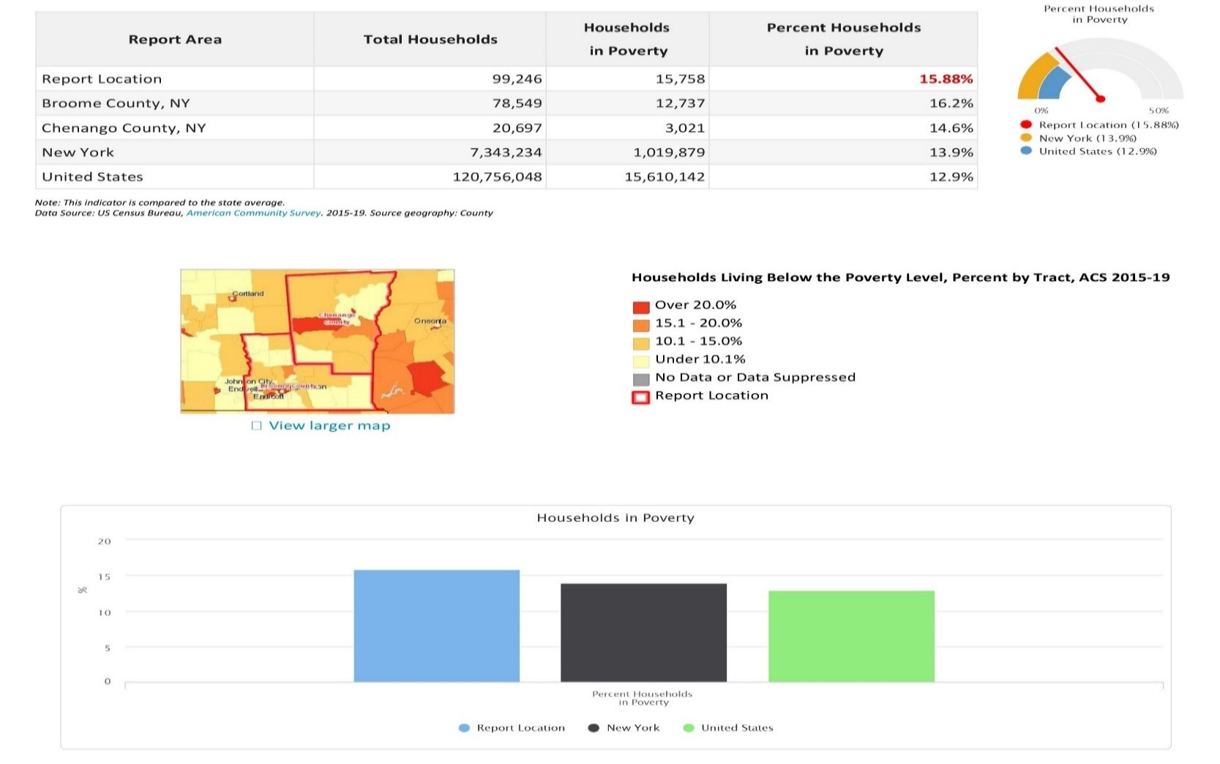

Families in Poverty by Family Type
The number of families in poverty by type are shown in the report area. According to ACS 2015‐2019 5-year estimates for the report area, there were 6,213 families living in poverty.
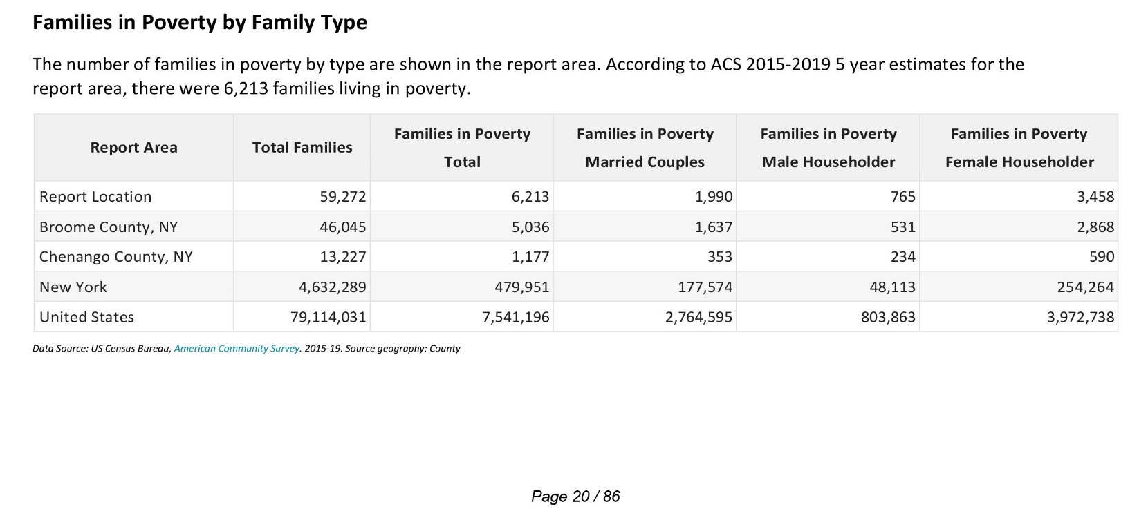

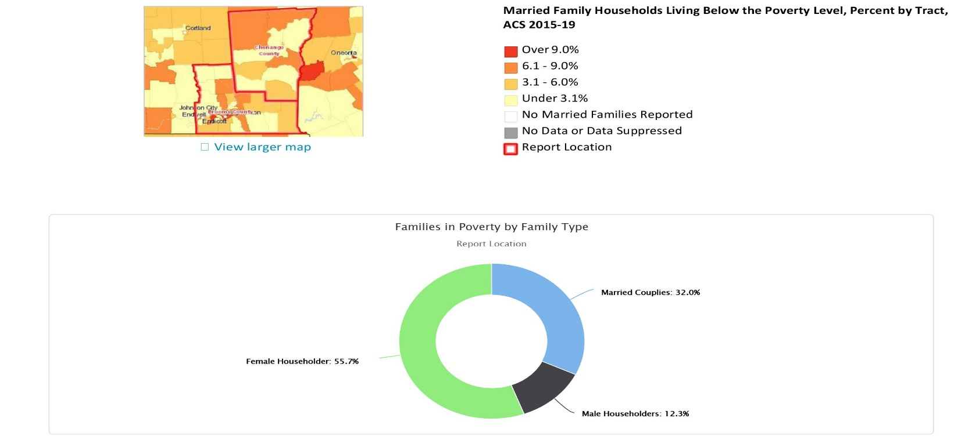
Family Poverty Rate by Family Type
The percentage of households in poverty by household type are shown for the report area. It is estimated that 10.5% of all households were living in poverty within the report area, compared to the national average of 9.5%. Of the households in poverty, female headed households represented 55.7% of all households in poverty, compared to 32.0% and 12.3% of households headed by males and married couples, respectively.
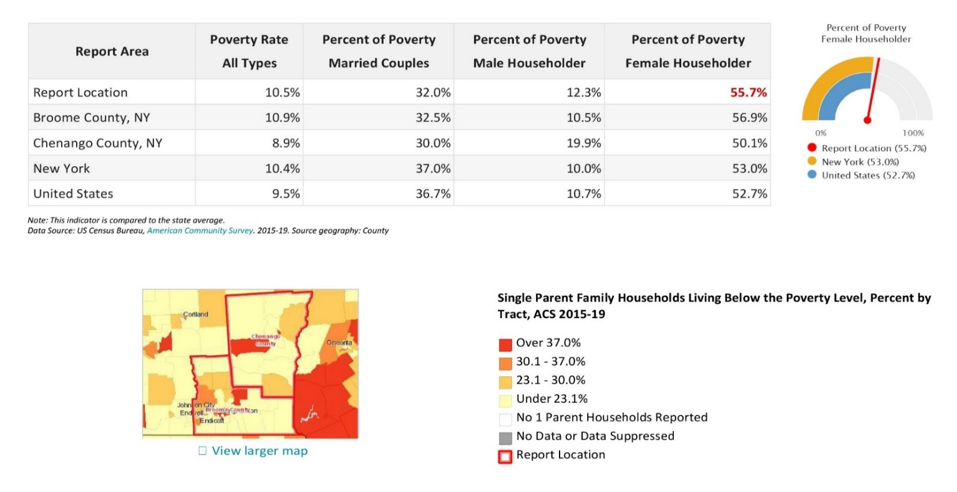
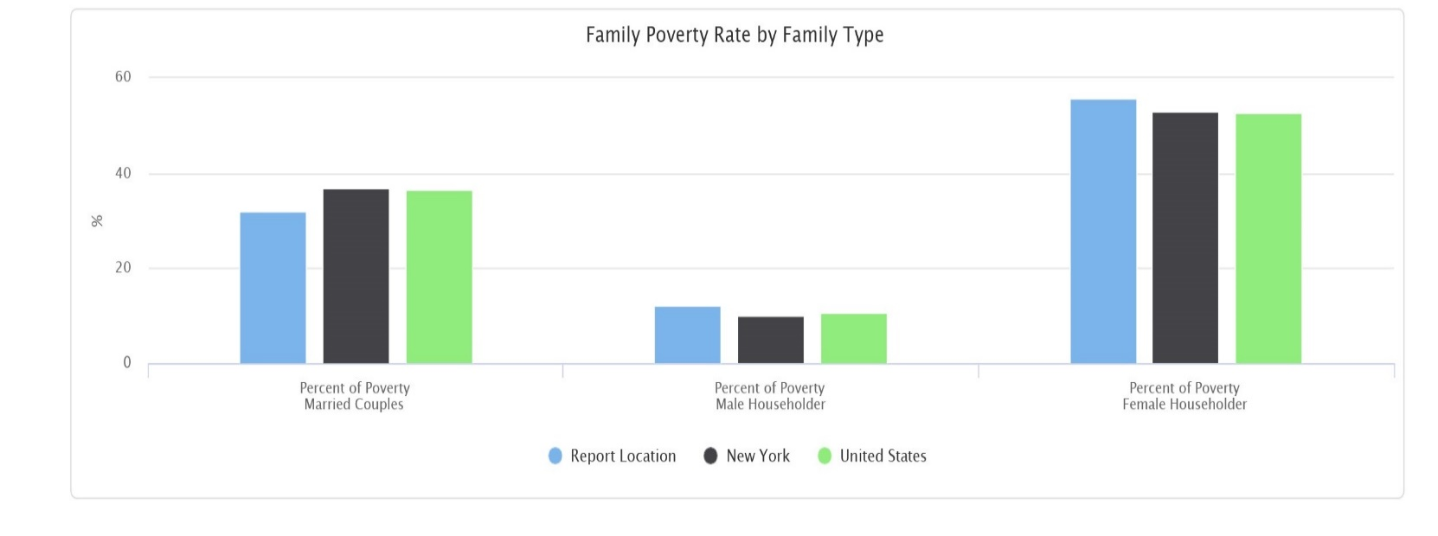
Poverty Rate Change
Poverty rate change in the report area from 2010 to 2019 is shown below. According to the U.S. Census, the poverty rate for the area was 17.0% in 2019 and was 16.4% in 2010.

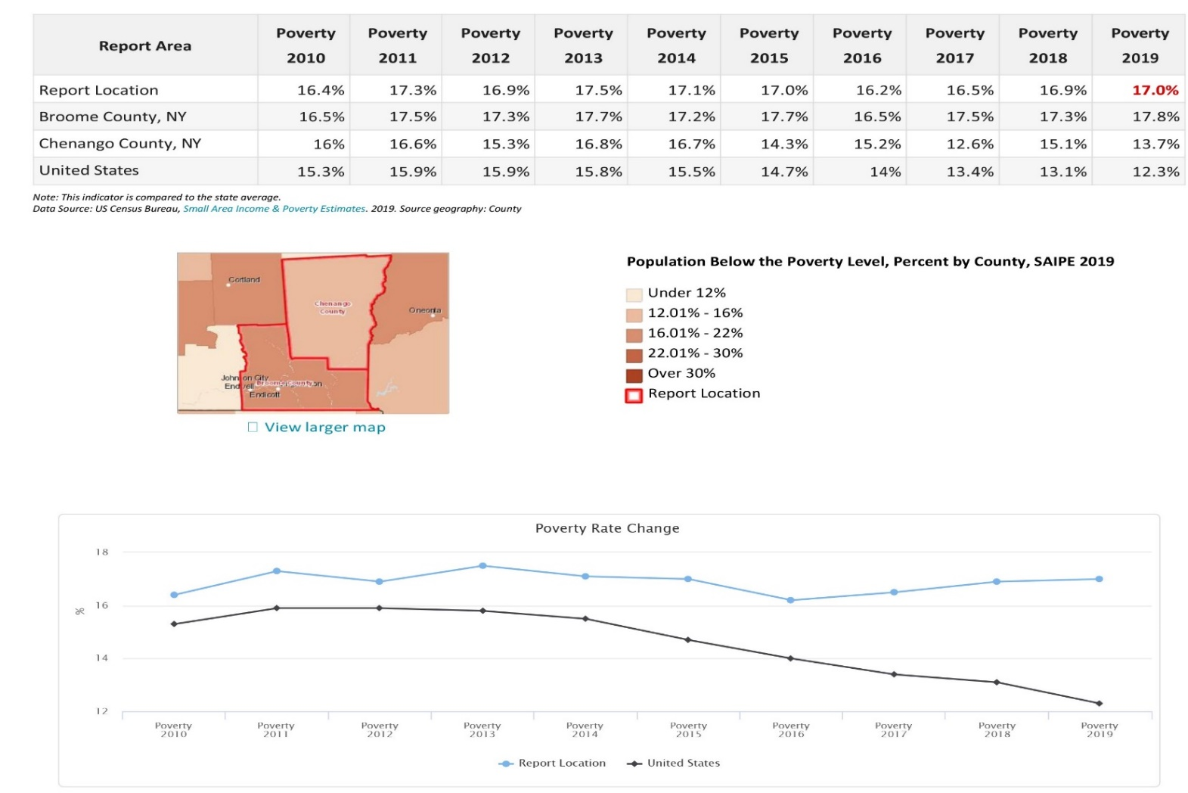

Child Poverty Rate (ACS) Ages 0‐17
Population and poverty estimate for children age 0‐17 are shown for the report area. According to the American Community Survey 5-year data, an average of 22.6% percent of children lived in a state of poverty during the survey calendar year. The poverty rate for children living in the report area is less than the national average of 18.5%.
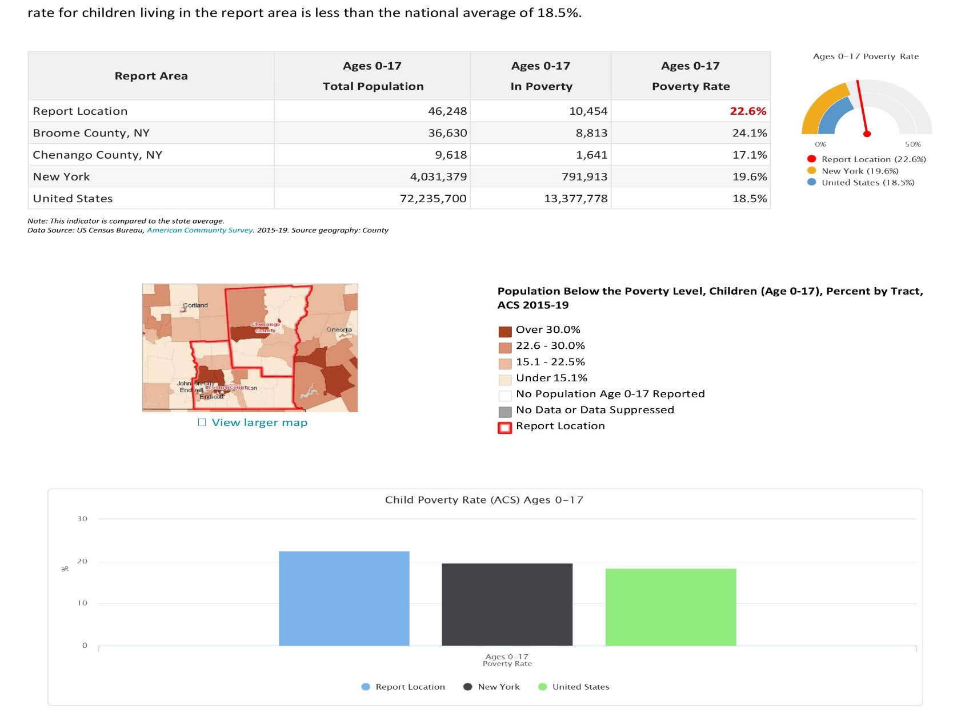
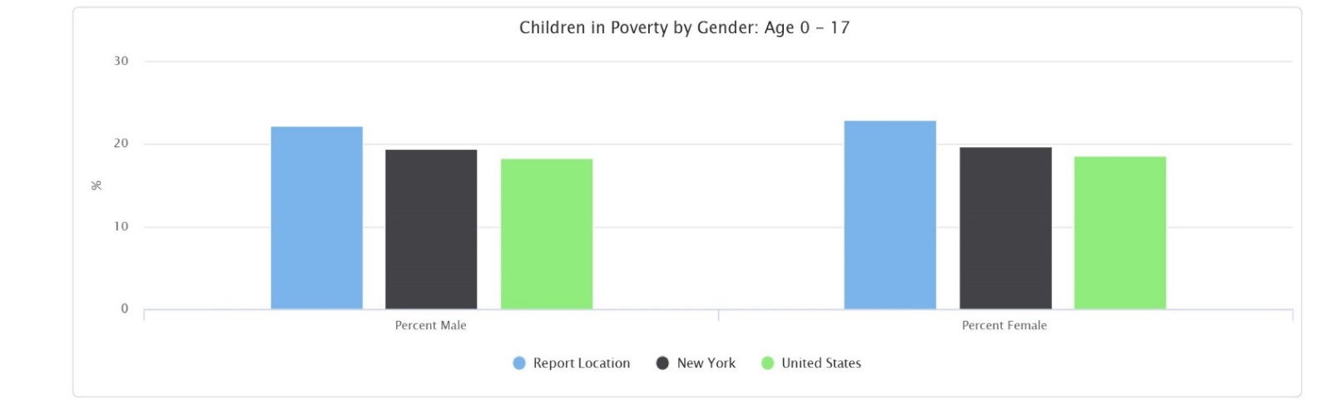
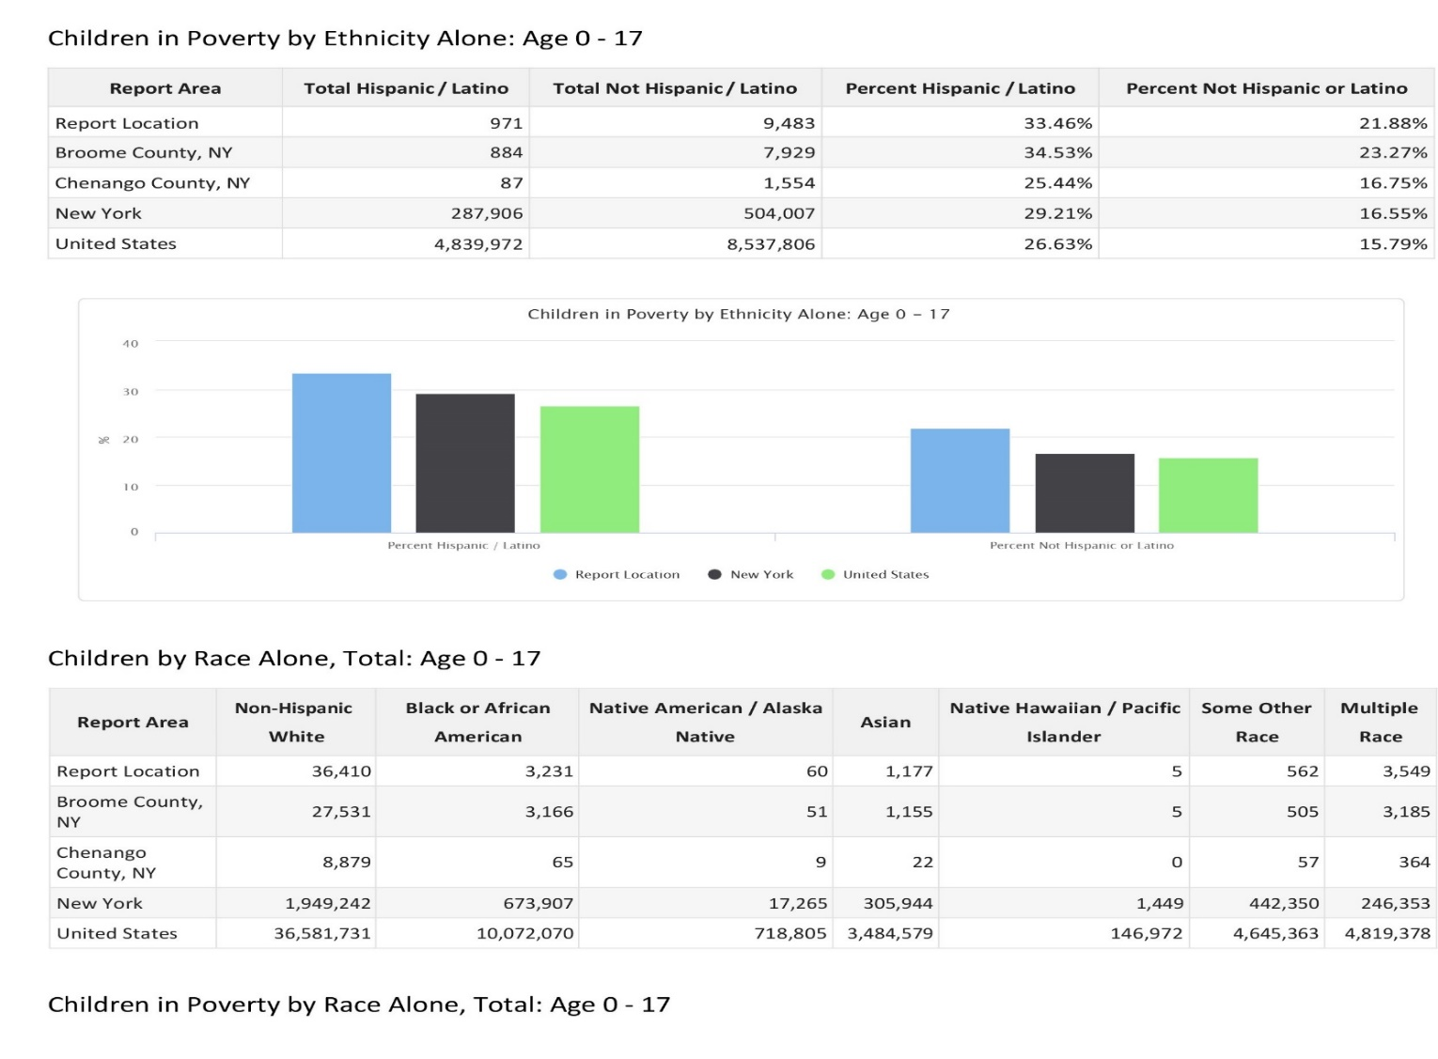
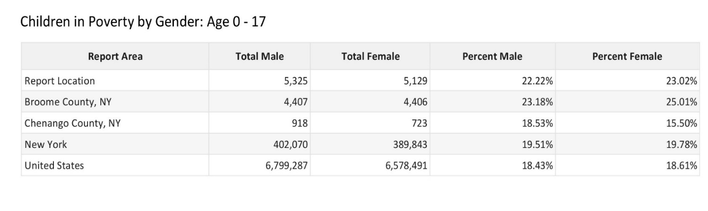
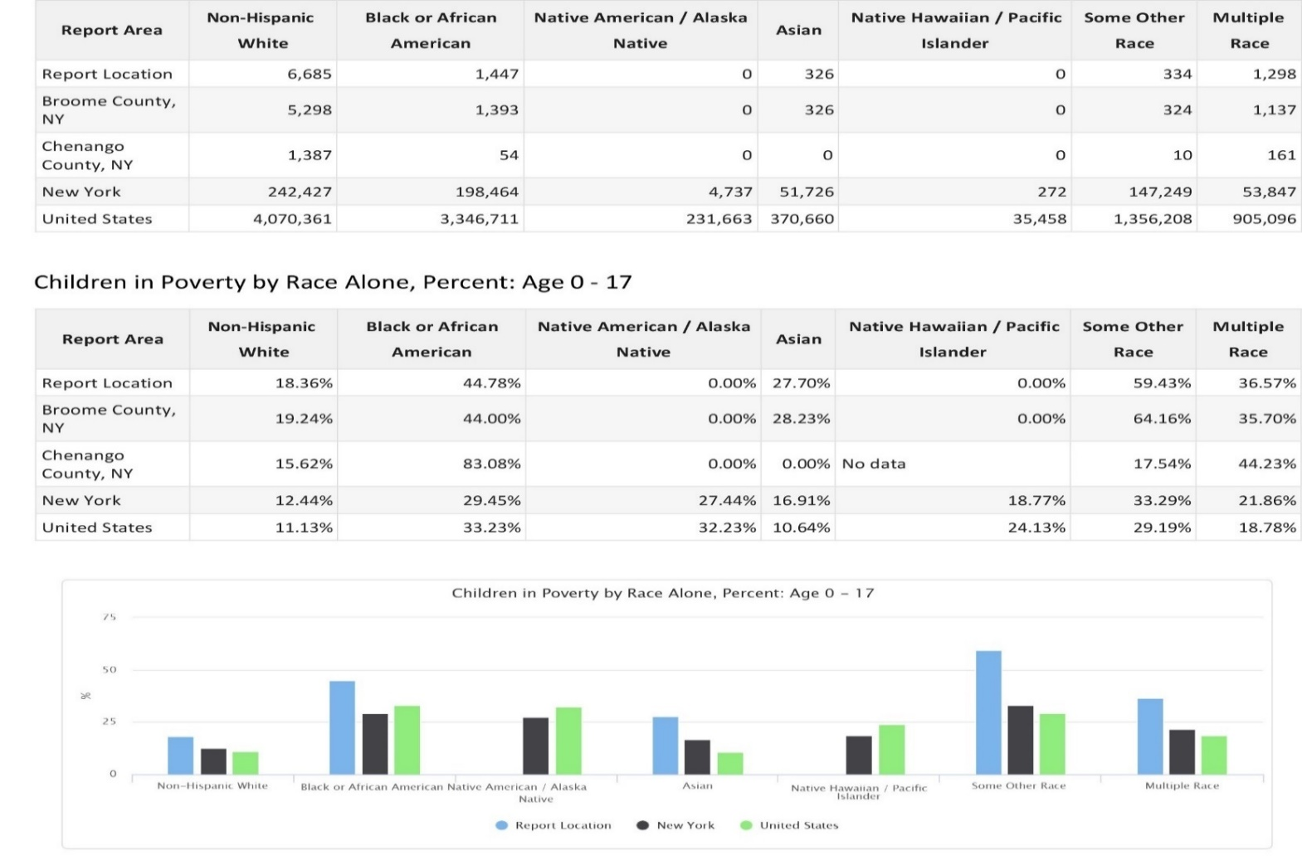

Poverty Rate Change Age 0‐17
%
Poverty rate change for children ages 0 ‐ 17 in the report area from 2010 to 2019 is shown below. According to the U.S. Census, the poverty rate for the area was 23.9% in 2019 and was 23.4% in 2010.
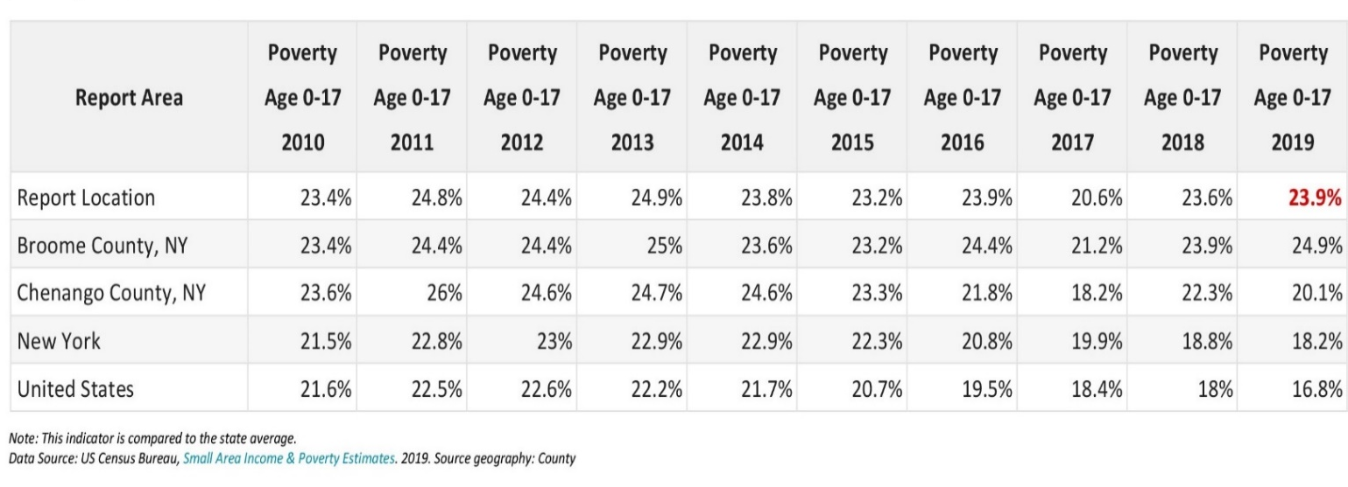
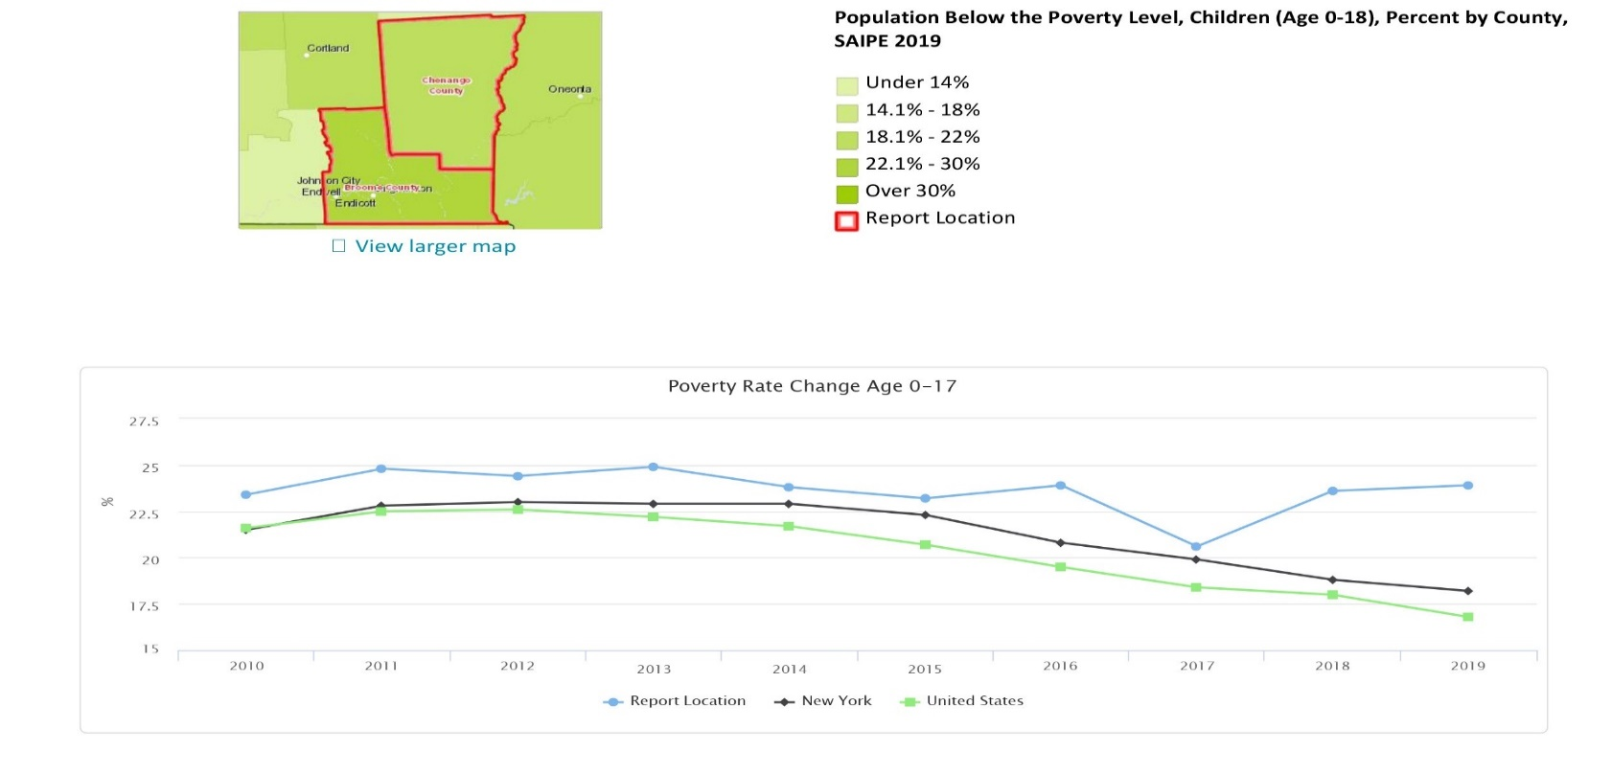

Child Poverty Rate (ACS) Ages 0‐4
Population and poverty estimate for children age 0‐4 are shown for the report area. According to the American Community Survey 5-year data, an average of 25.5% percent of children lived in a state of poverty during the survey calendar year. The poverty rate for children living in the report area is than the national average of 20.3%.
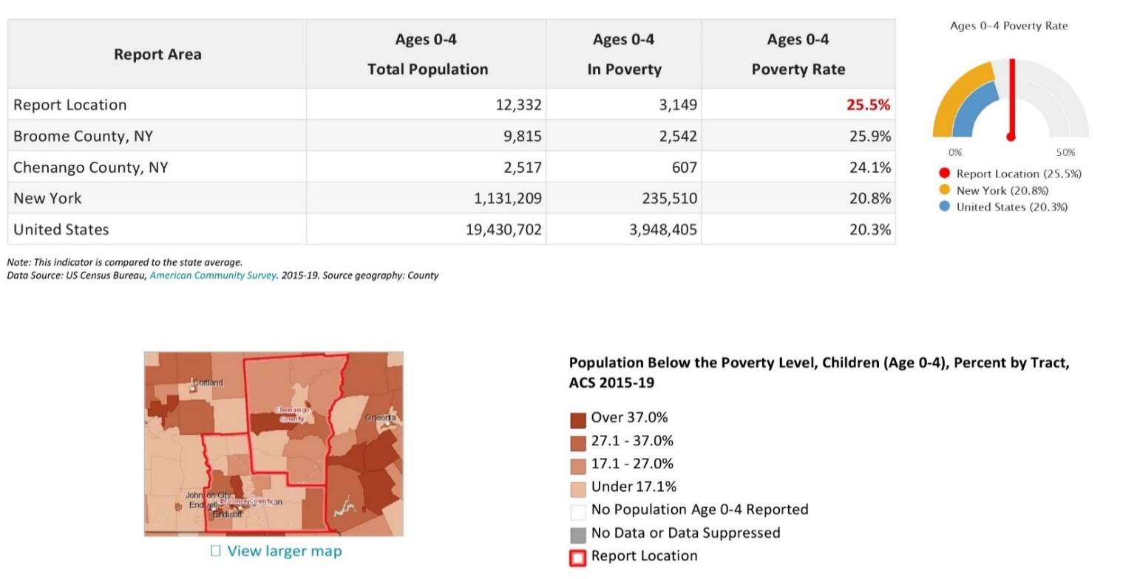

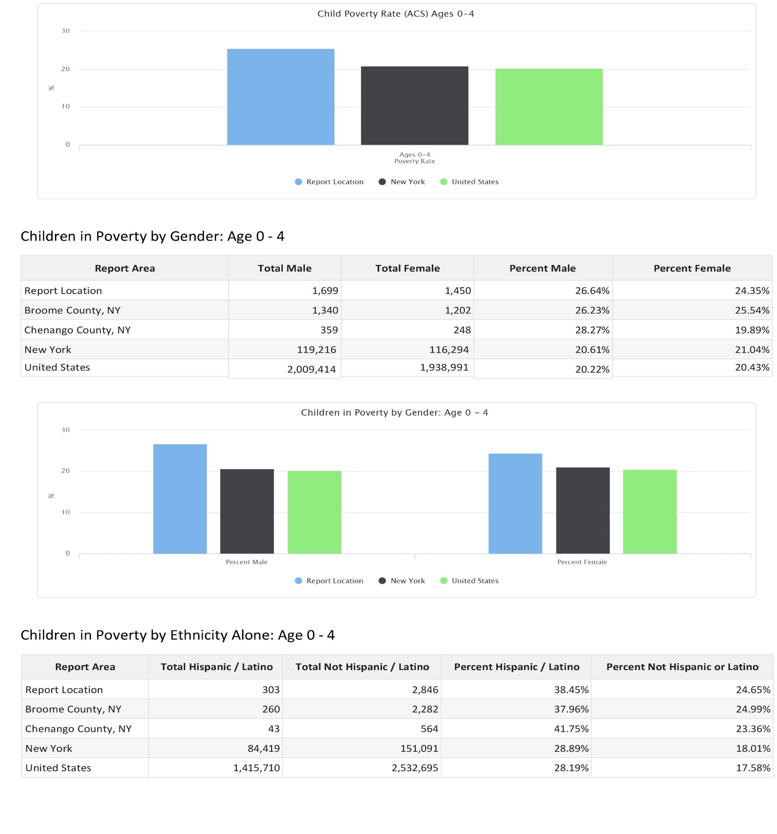
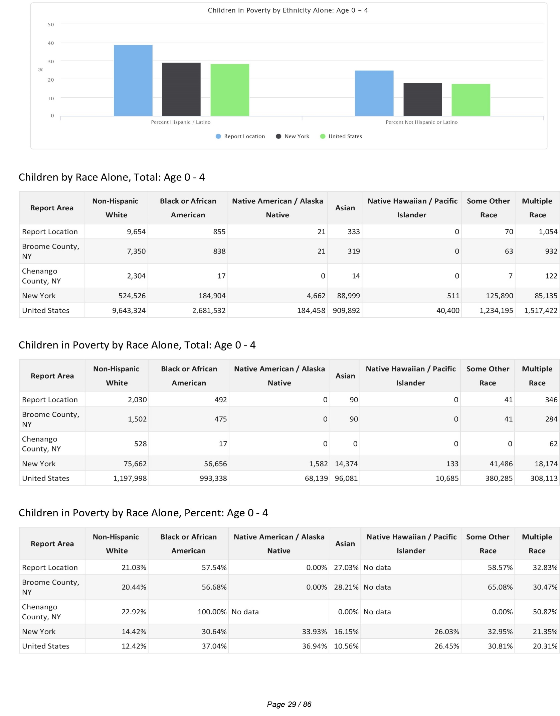
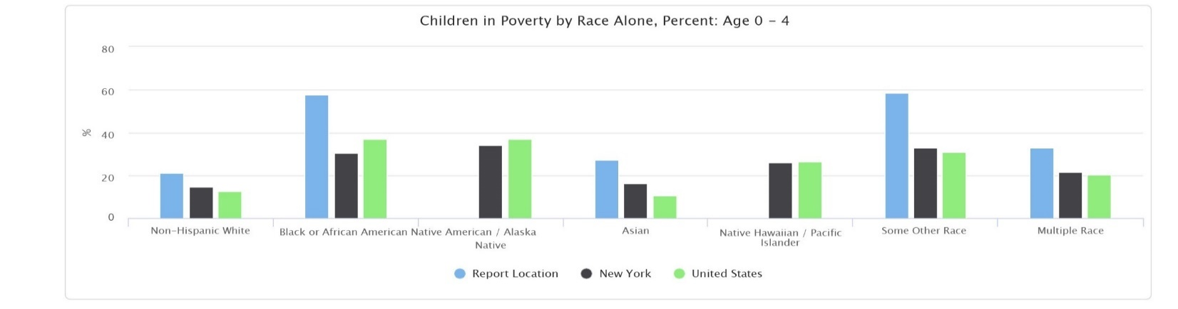
Child Poverty Rate (ACS) Ages 0‐5
Population and poverty estimates for children age 0‐5 are shown for the report area. According to the American Community Survey (ACS) 5-year data, an average of 25.6% of children lived in a state of poverty during the survey calendar year. The poverty rate for children living in the report area is greater than the national average of 20.2%.
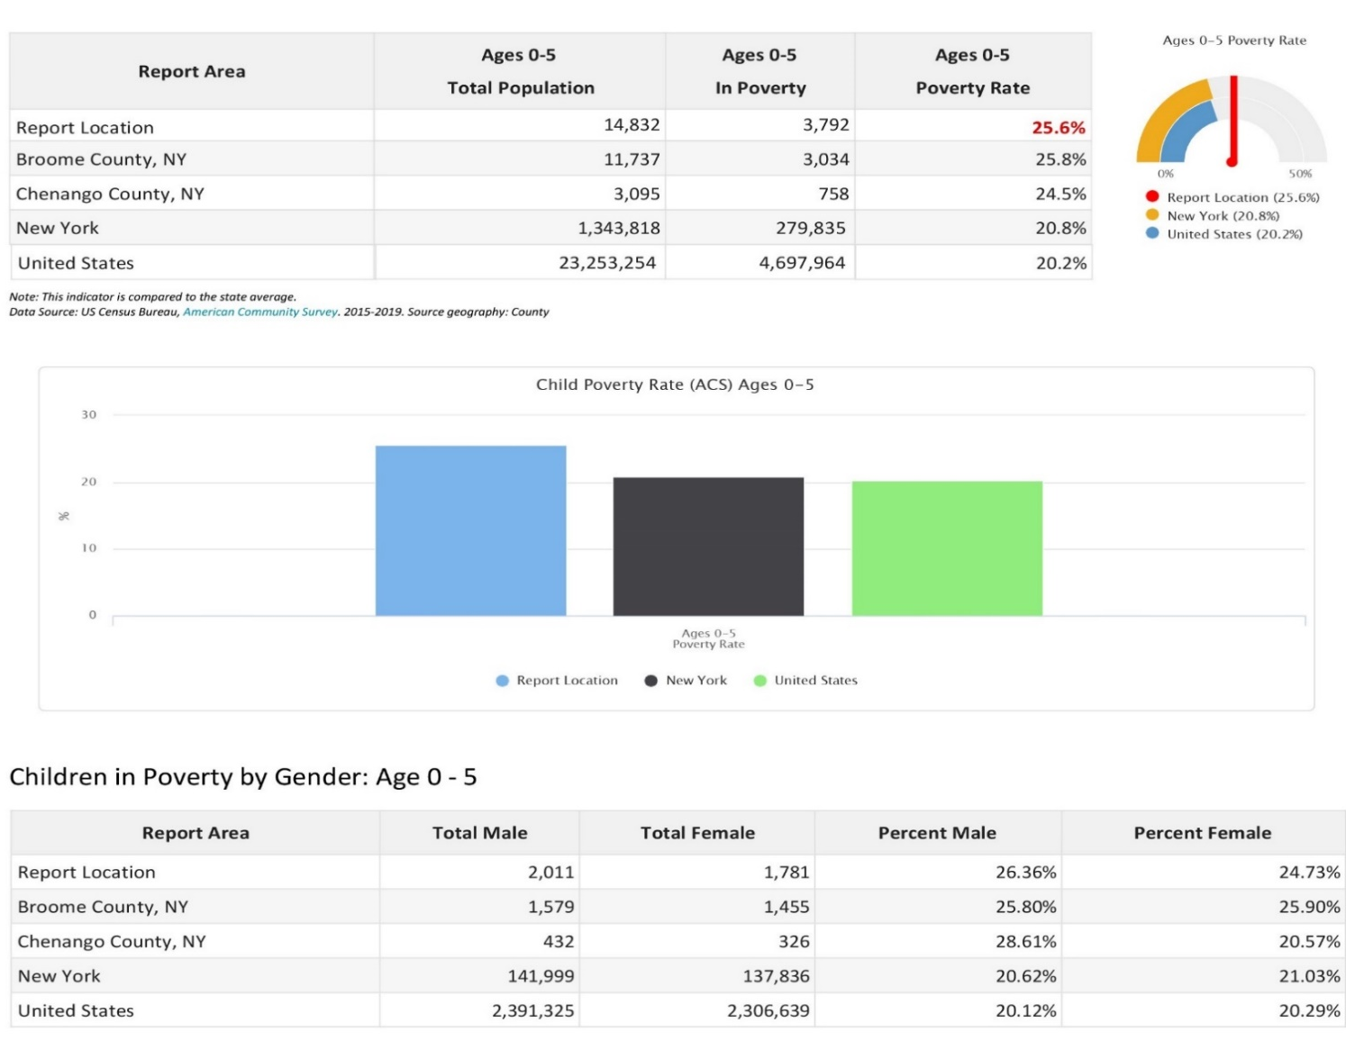
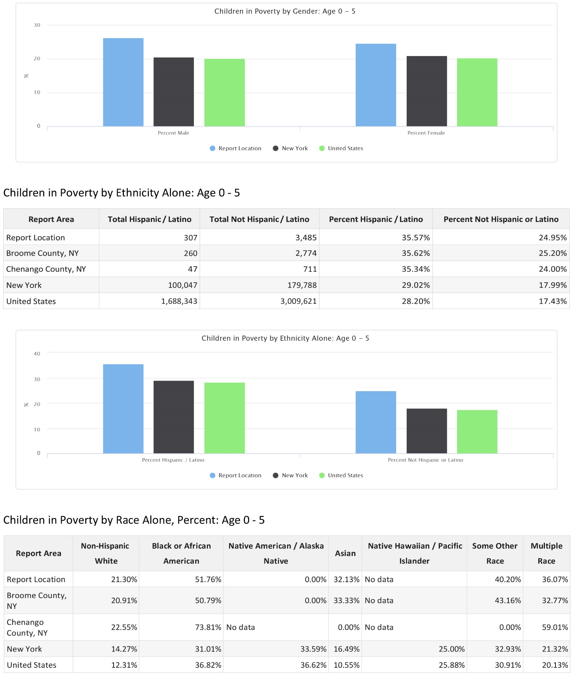
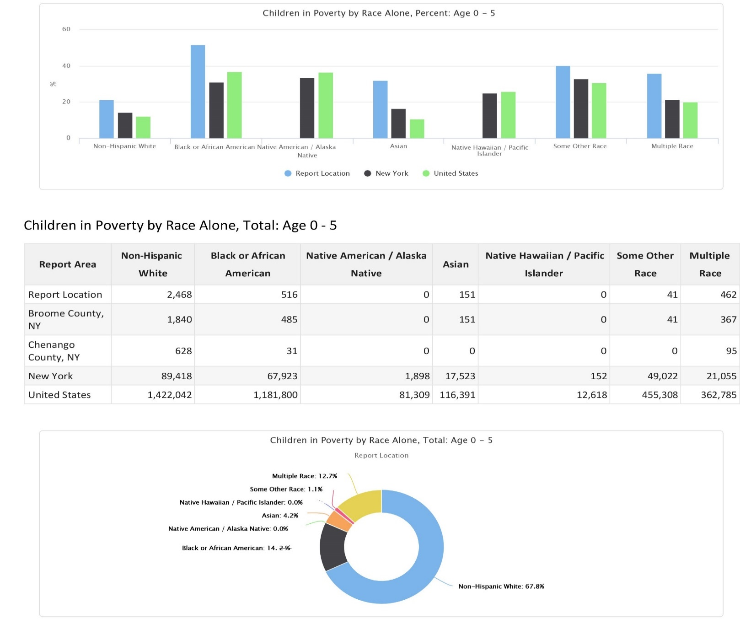

Child Poverty Rate (ACS) Ages 5‐17
Population and poverty estimates for children age 5‐17 are shown for the report area. According to the American Community Survey 5-year data, an average of 21.5% percent of children lived in a state of poverty during the survey calendar year. The poverty rate for children living in the report area is greater than the national average of 17.9%.

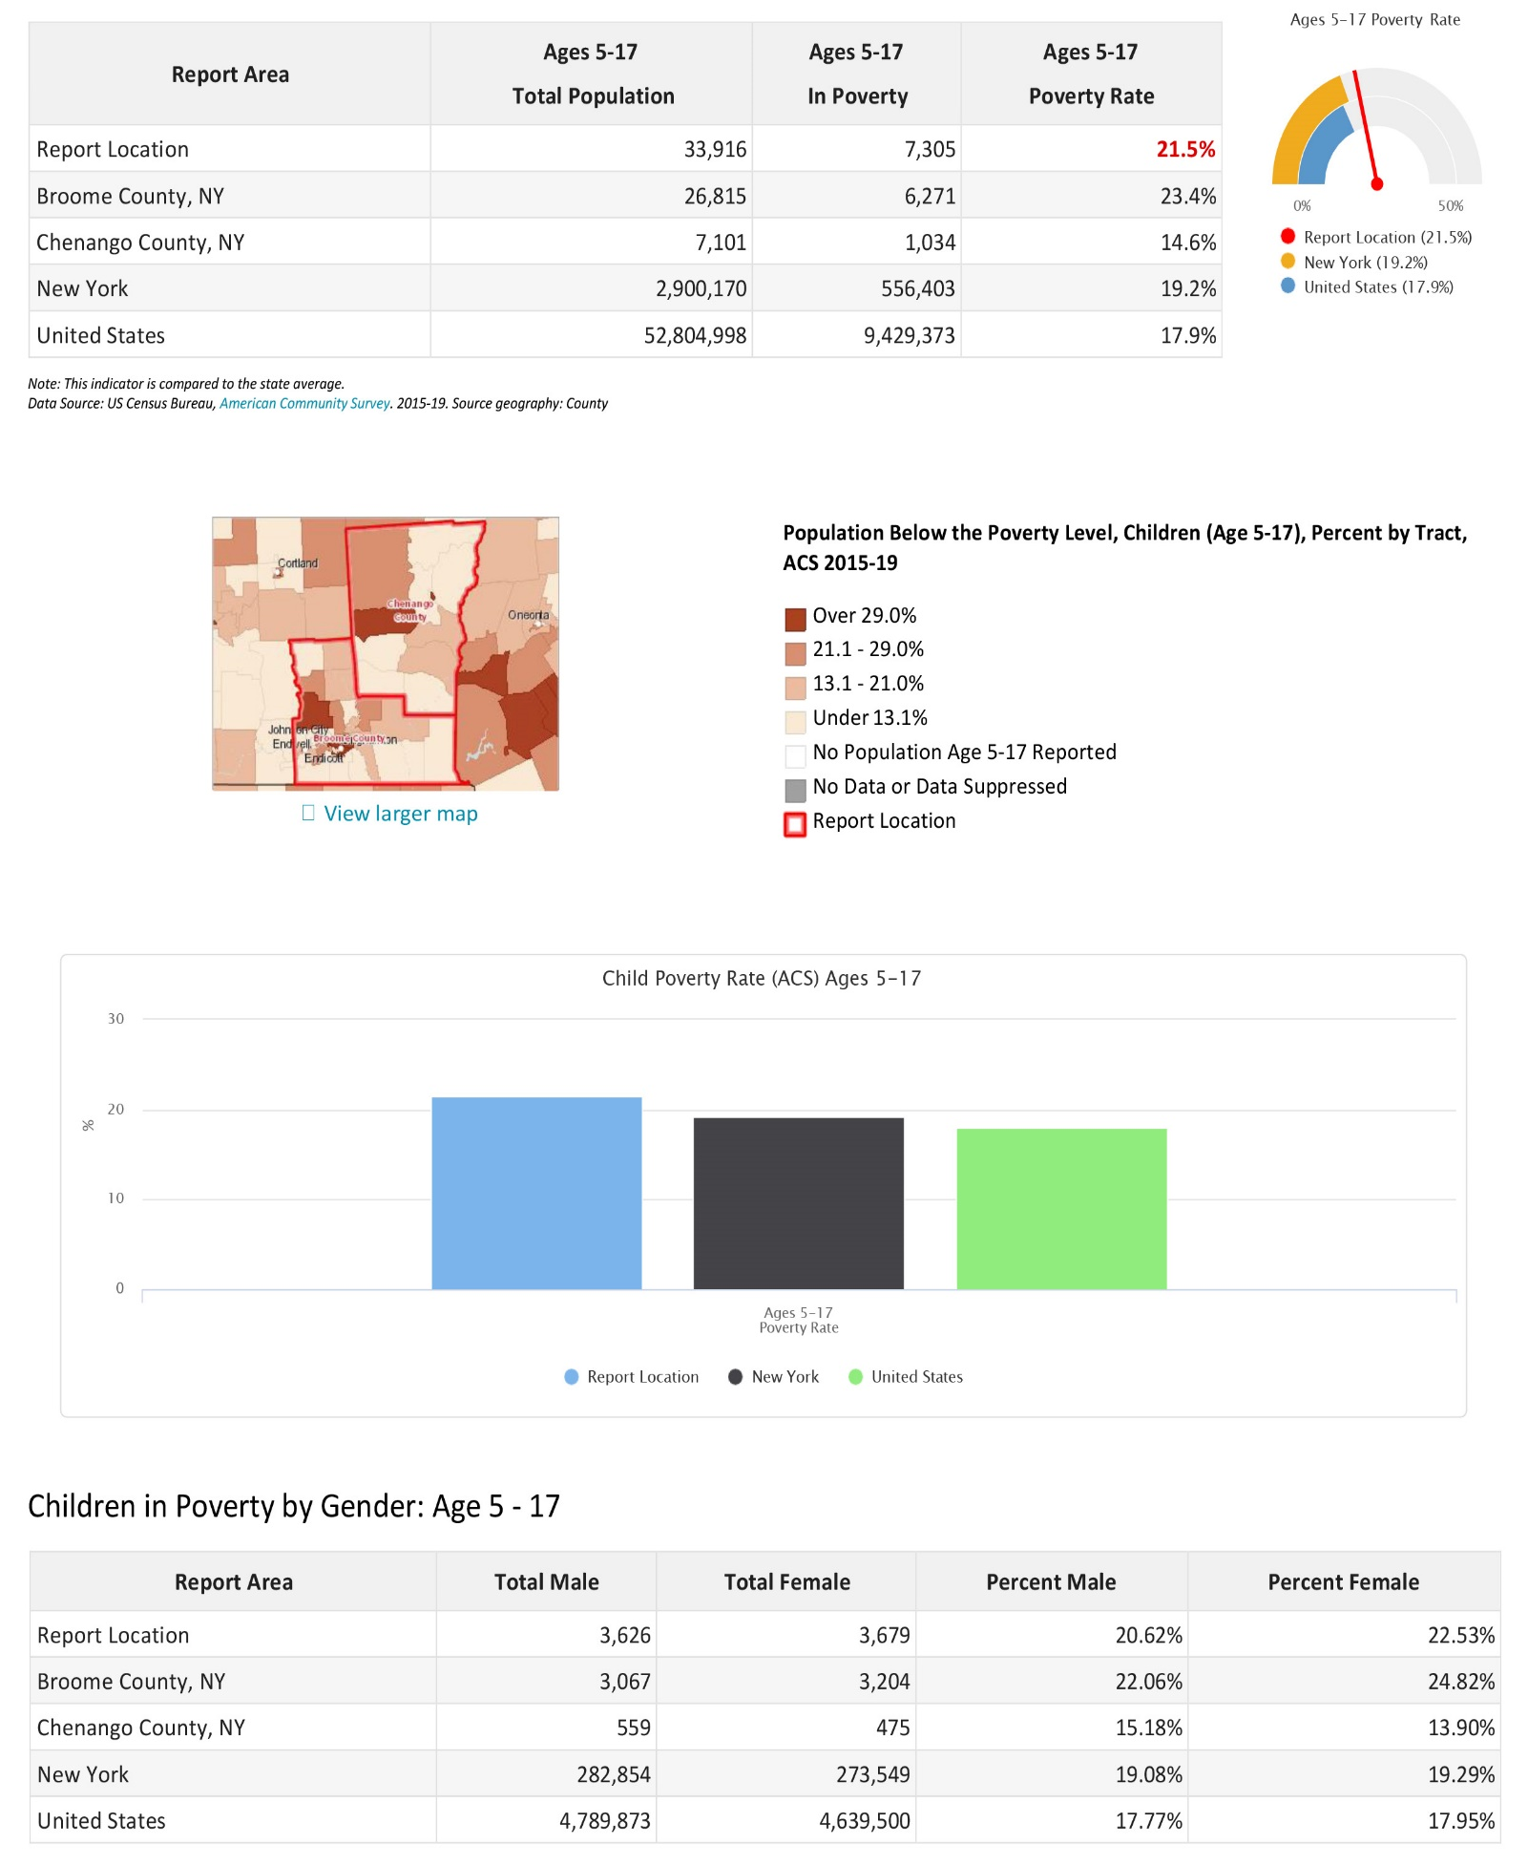
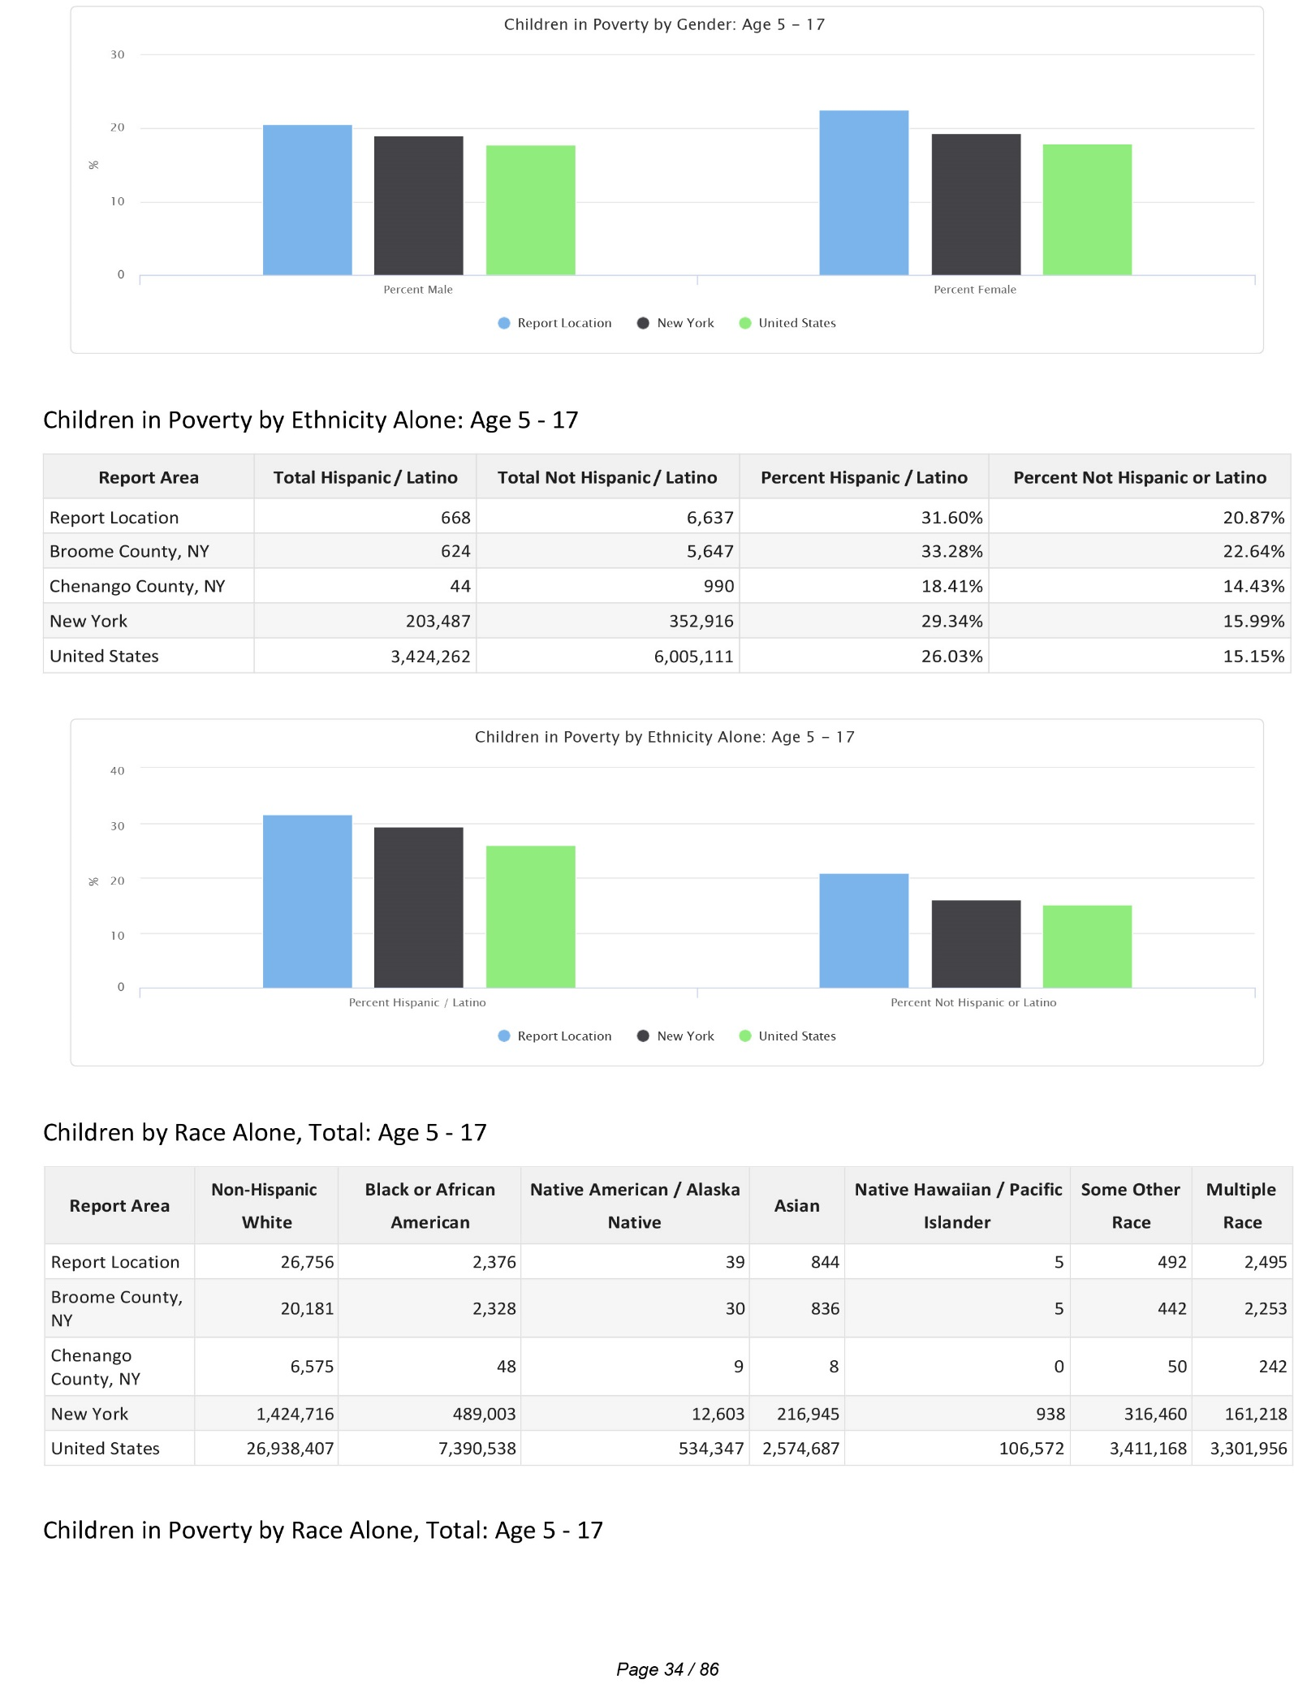
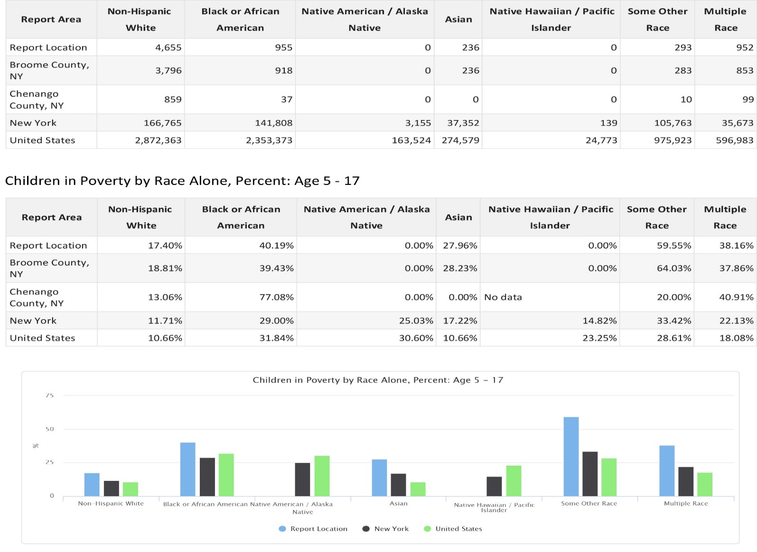

Poverty Rate Change Age 5‐17
Poverty rate change for children ages 5‐17 in the report area from 2010 to 2019 is shown below. According to the chart, the poverty rate for the area was 21.6% in 2019 and was 21.3% in 2010.

Poverty Rate (ACS) Ages 18‐64
According to the American Community Survey (ACS) 5-year data, an average of 17.3% of children lived in a state of poverty during the survey calendar year. The poverty rate for children living in the report area is less than the national average of 12.6%.
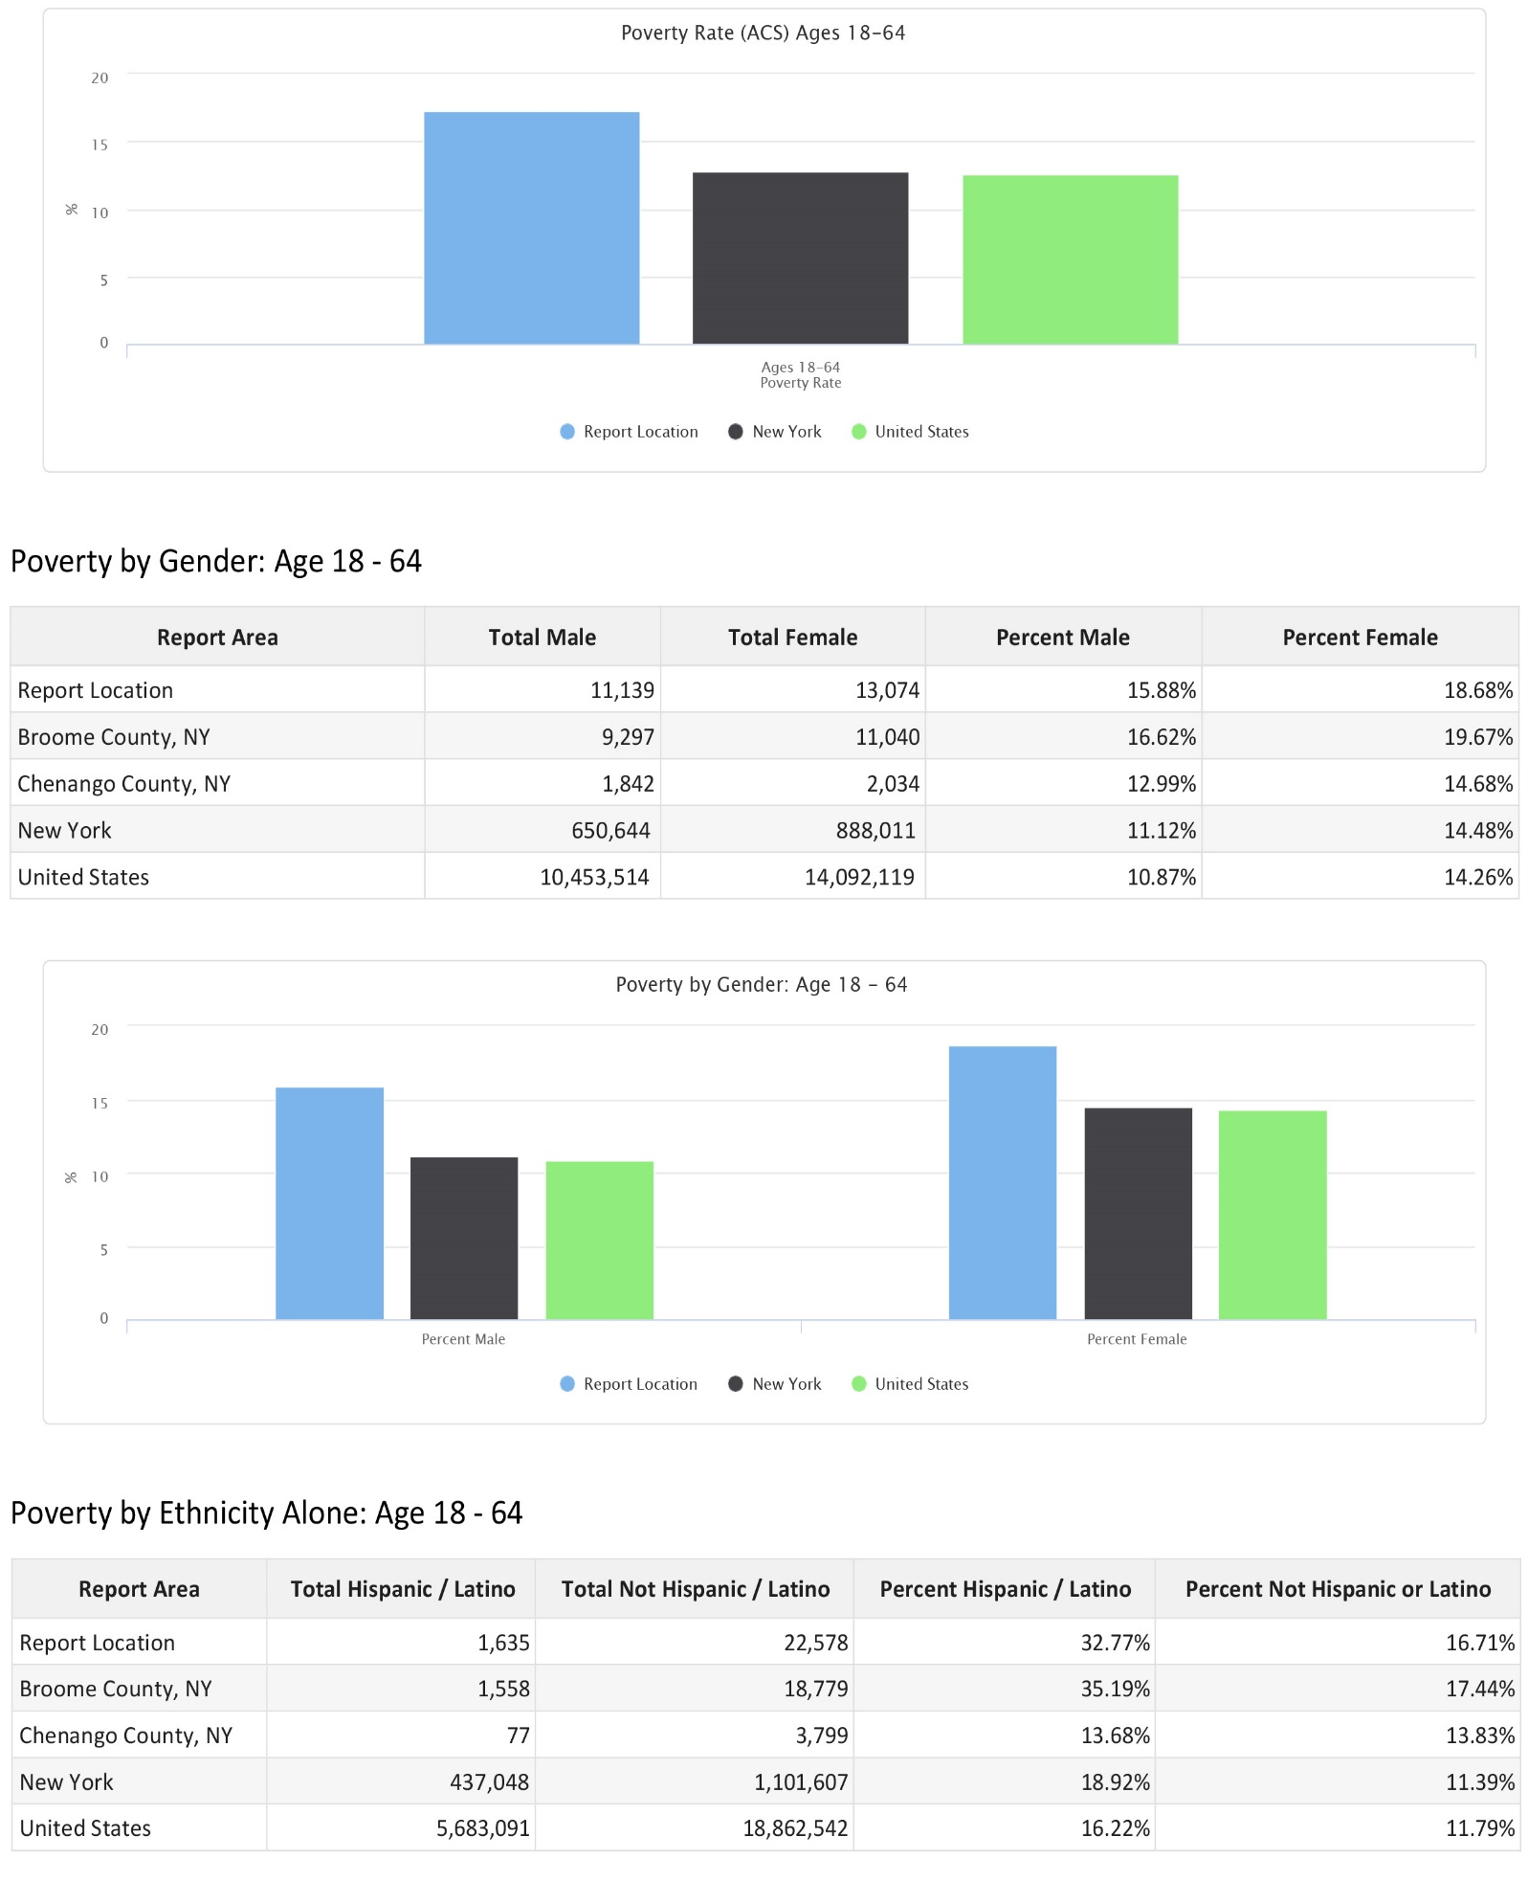
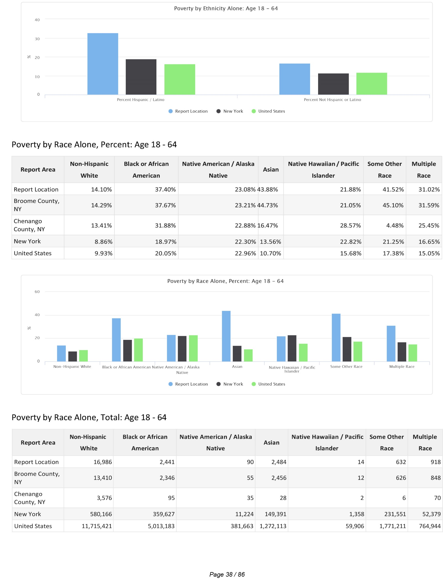
Poverty Rate (ACS) Ages 65 and Up
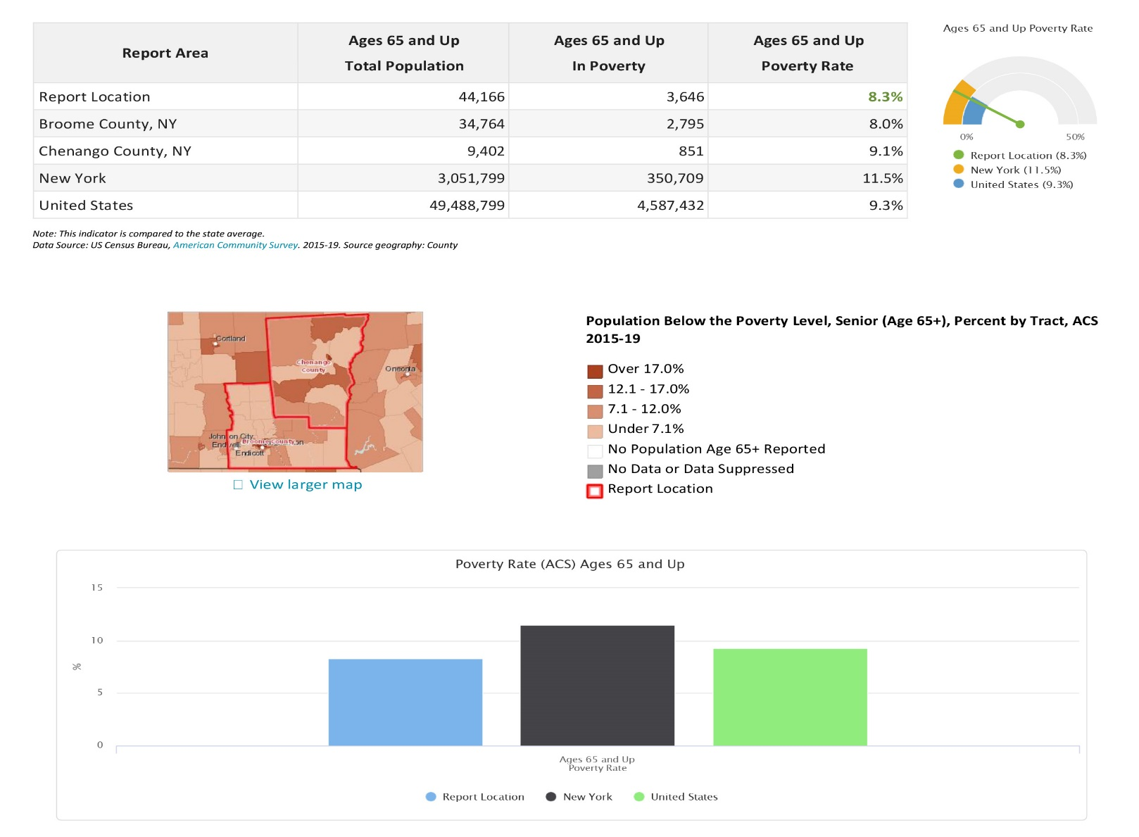
Population and poverty estimates for persons age 65 and up are shown for the report area. According to the American Community Survey (ACS) 5-year data, an average of 8.3% of people lived in a state of poverty during the survey calendar year. The poverty rate for people living in the report area is less than the national average of 9.3%.
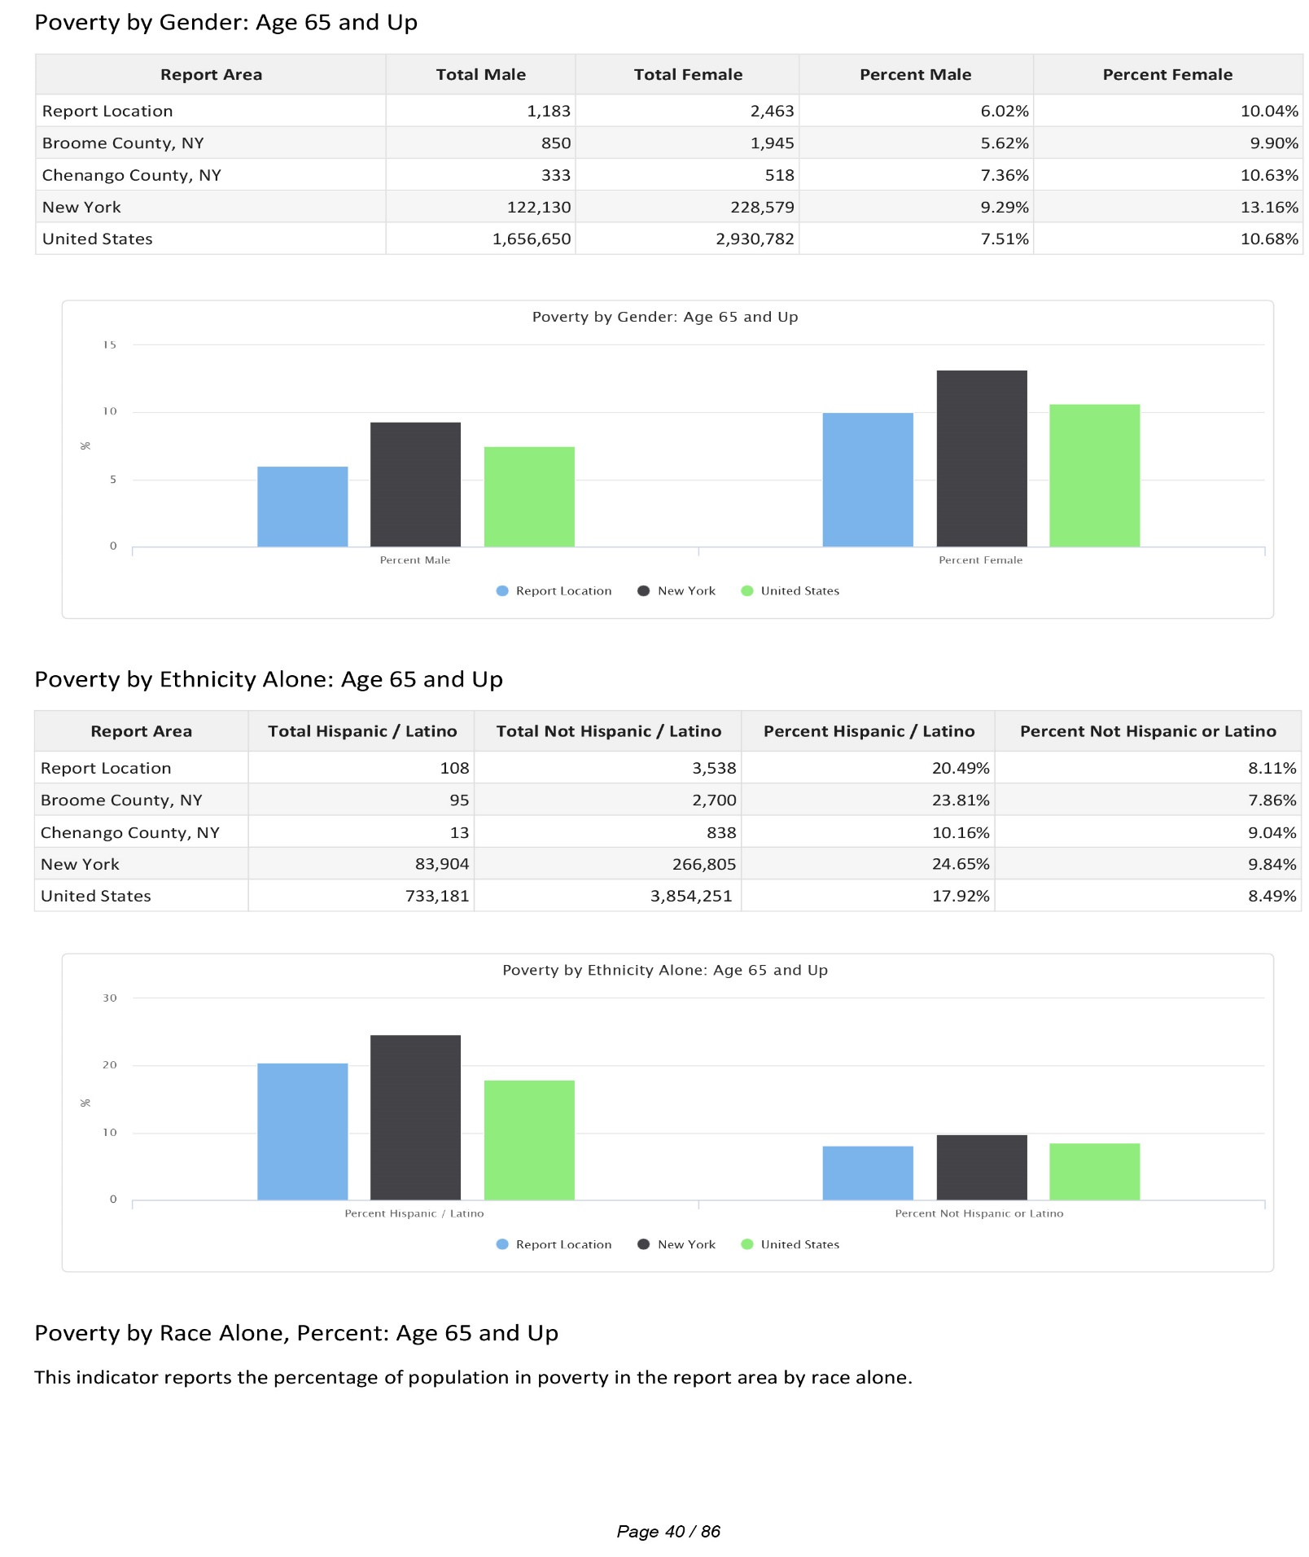

Poverty by Race Alone, Percent: Age 65 and Up
This indicator reports the percentage of population in poverty in the report area by race alone.
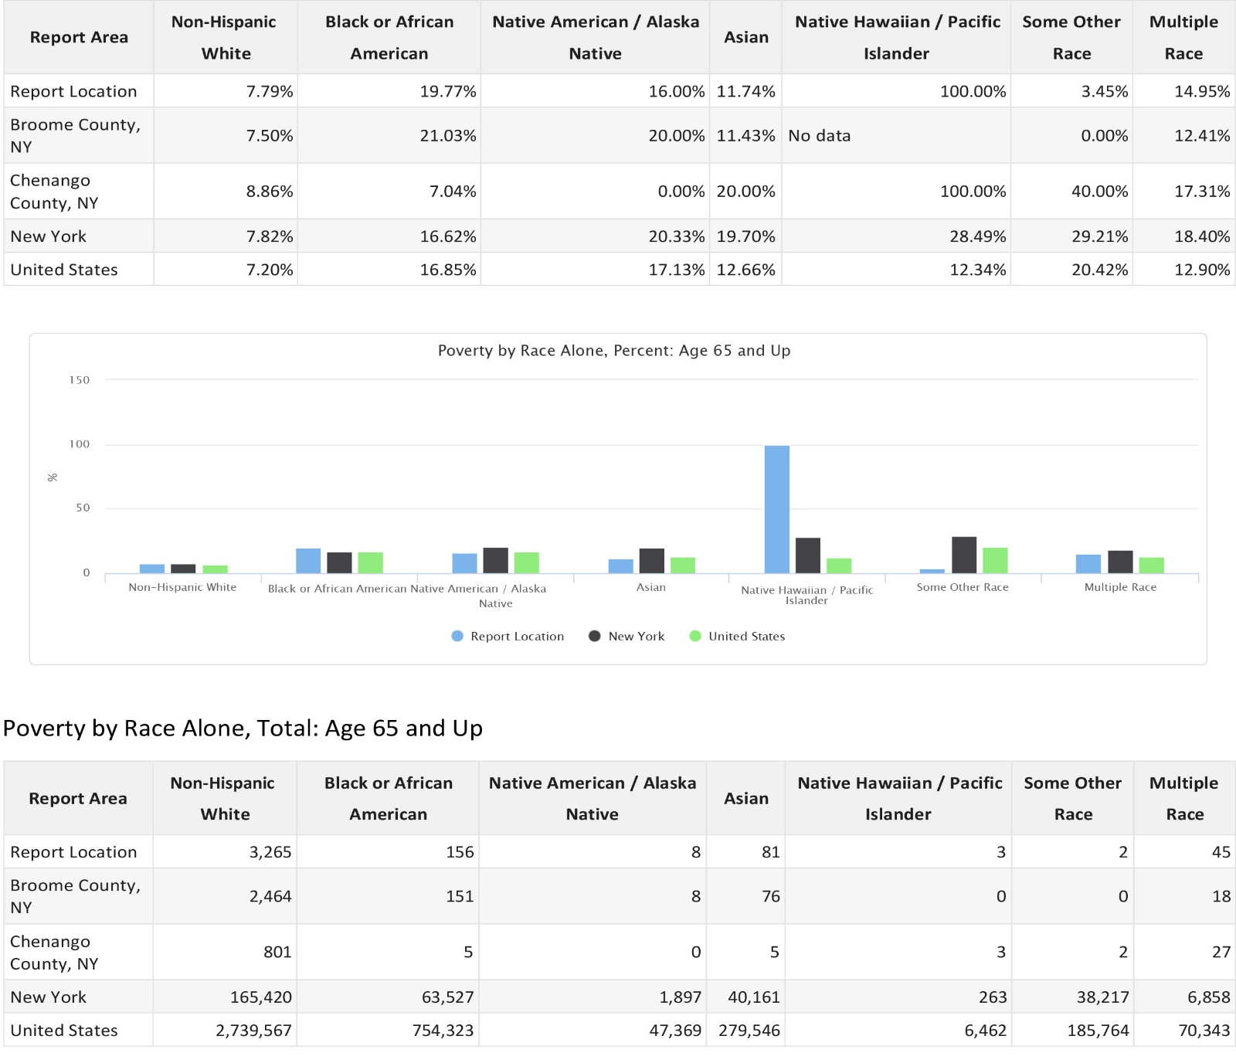

Key Findings-Update 2023
In 2023, the poverty rate in Broome County was 18.7% and 12.2% in Chenango County. Broome County had the second highest poverty in New York in 2023, with Chenango County being ranked 12th in the state. The poverty rate in the United States continues to be highest among people between the ages of 18 and 24 years old, with a rate of 17.1% for male Americans and a rate of 21.35% for female Americans. According to the NYS State Comptroller Poverty Report, poverty rates are much higher for children than for adults in New York State. 9 More than 4 in 10 children live in a household struggling to meet basic expenses, and between 7 million and 11 million children live in households in which they are unable to eat enough due to higher cost of living. Families with female heads of household experience poverty at more than two times the rate of all families and four times the rate of married couples. The financial hardships faced by a parent(s) can often result in less access to healthy food and quality medical care, as well as chronic stress in the family, impacting a child’s cognitive development and ultimately the child’s ability to thrive independently as an adult.

The elderly population have traditionally been a subset of the population that has been vulnerable to poverty due to many living on fixed incomes that do not increase with increases in the cost of living. Per the State Comptroller Poverty Report, poverty rates have increased for seniors while decreasing for all other populations between 2010 and 2021. The COVID-19 pandemic has only exacerbated the elderly population’s risk for living in poverty as this population was expected to keep themselves safe at home to avoid the risk of contracting the virus, but many of them were still dependent on going out to work in order to supplement their retirement income. Loss of income, paired with difficulty in accessing resources, lack of social supports, and lack of access to technology, such as tablets and cell phones, has made the elderly even more susceptible to falling below the poverty line.

Violent Crime
Occurrences of violent crime within the report area are shown in the table below. According to the New York State Division of Criminal Justice Services reporting system, a total of 7 murders, 503 aggravated assaults, 85 robberies and 178 rapes took place within Broome and Chenango County in 2020.

Property Crime
Occurrences of property crime within the report area are shown in the table below. According to the New York State Division of Criminal Justice Services reporting system, a total of 814 burglaries, 4,135 incidents of larceny, and 243 automotive thefts were recorded in 2020 within Broome and Chenango County.

Average Daily Population Counts in Area Jails

The average daily number of people held in county jails are shown in the selected report area. An average total of 300 people were held in Broome County jails and average total of 72 people were held in Chenango County Jail in 2021.

Citizenship Status
The table below shows the numbers and percent of population by citizenship status for the report area. According to the latest American Community Survey (ACS), the report area has a total of 6,312 non‐Citizens, or 2.62% of the total population of 241,097 persons, in contrast to the state average of 9.63% of the population and the national average of 6.83% non‐Citizens living in the United States.

Hispanic or Latino Citizens
This indicator reports the citizenship status of the Hispanic or Latino population within the report area.
Hispanic or Latino Non‐Citizens: Citizenship Status

Employment, Unemployment, and Labor Force
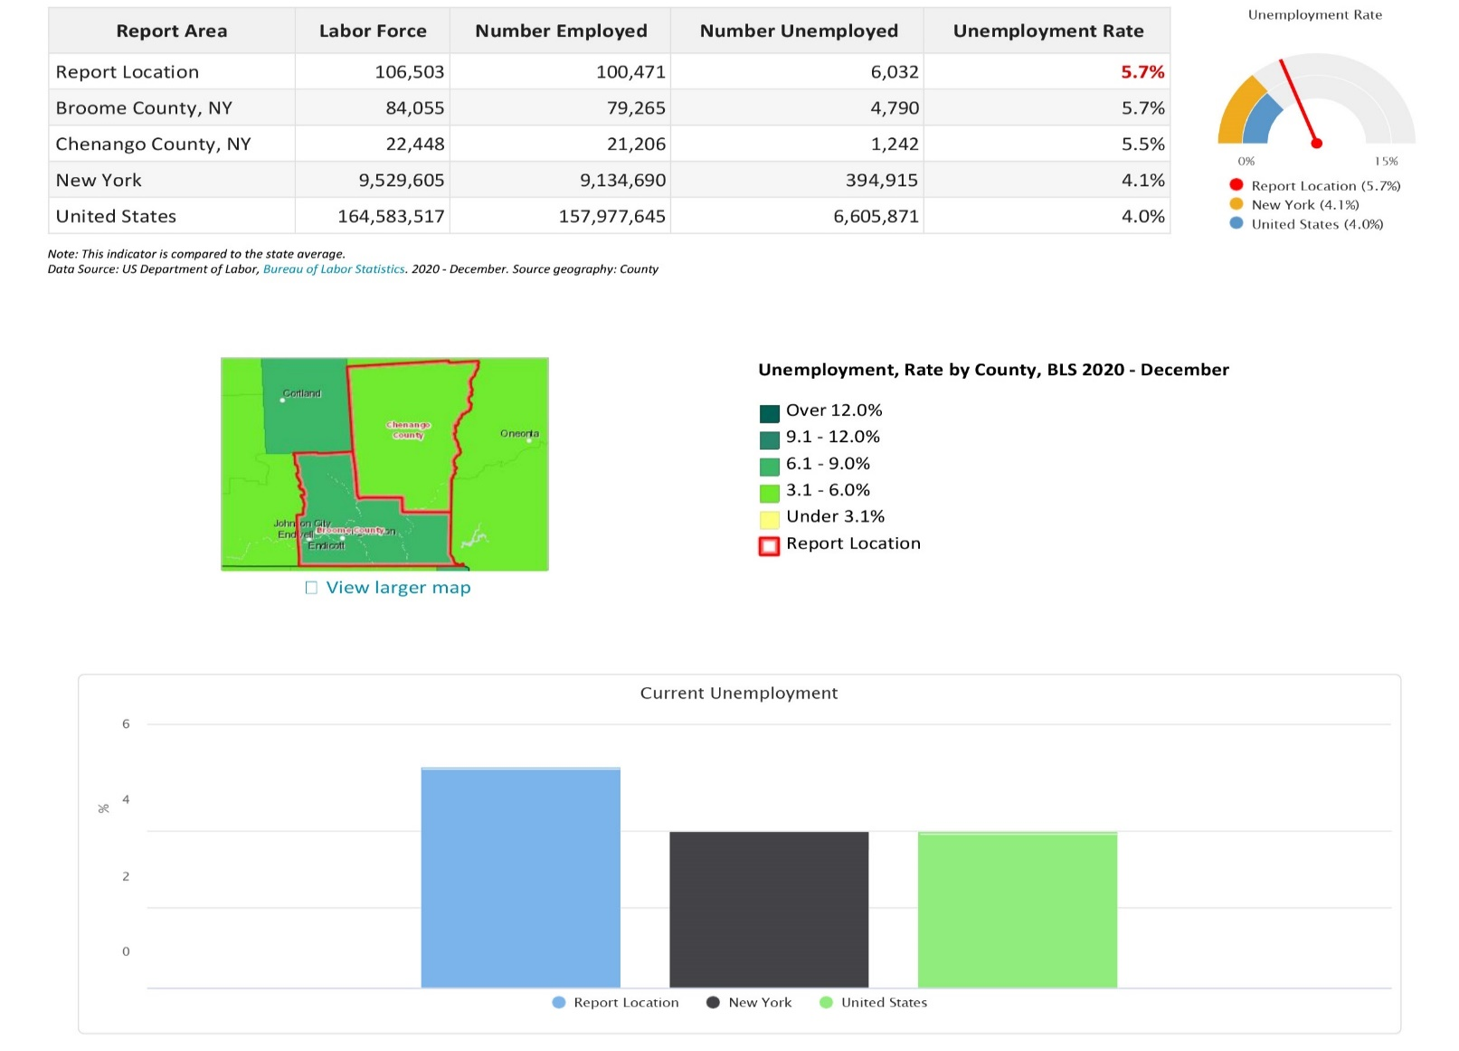
Labor force, employment, and unemployment data for each county in the report area is provided in the table below. Overall, the report area experienced an average 5.7% unemployment rate in December 2020.

Unemployment Change
Unemployment change within the report area from December 2019 to December 2020 is shown in the chart below. According to the U.S. Department of Labor, unemployment for this thirteen-month period fell from 5.8% to 5.7%.
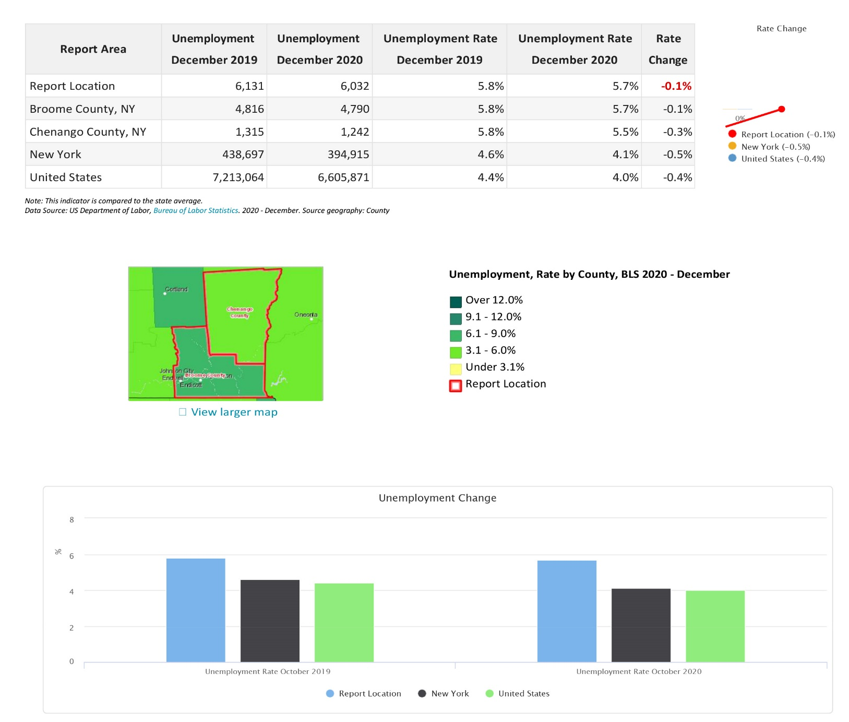

Thirteen Month Unemployment Rates
Unemployment change within the report area from December 2019 to December 2020 is shown in the chart below. According to the U.S. Department of Labor, unemployment for this thirteen-month period grew from 5.4% to 5.4%. Unemployment change within the report area from December 2019 to December 2020 is shown in the chart below. According to the U.S. Department of Labor, unemployment for this thirteen-month period grew from 5.0% to 6.2%.
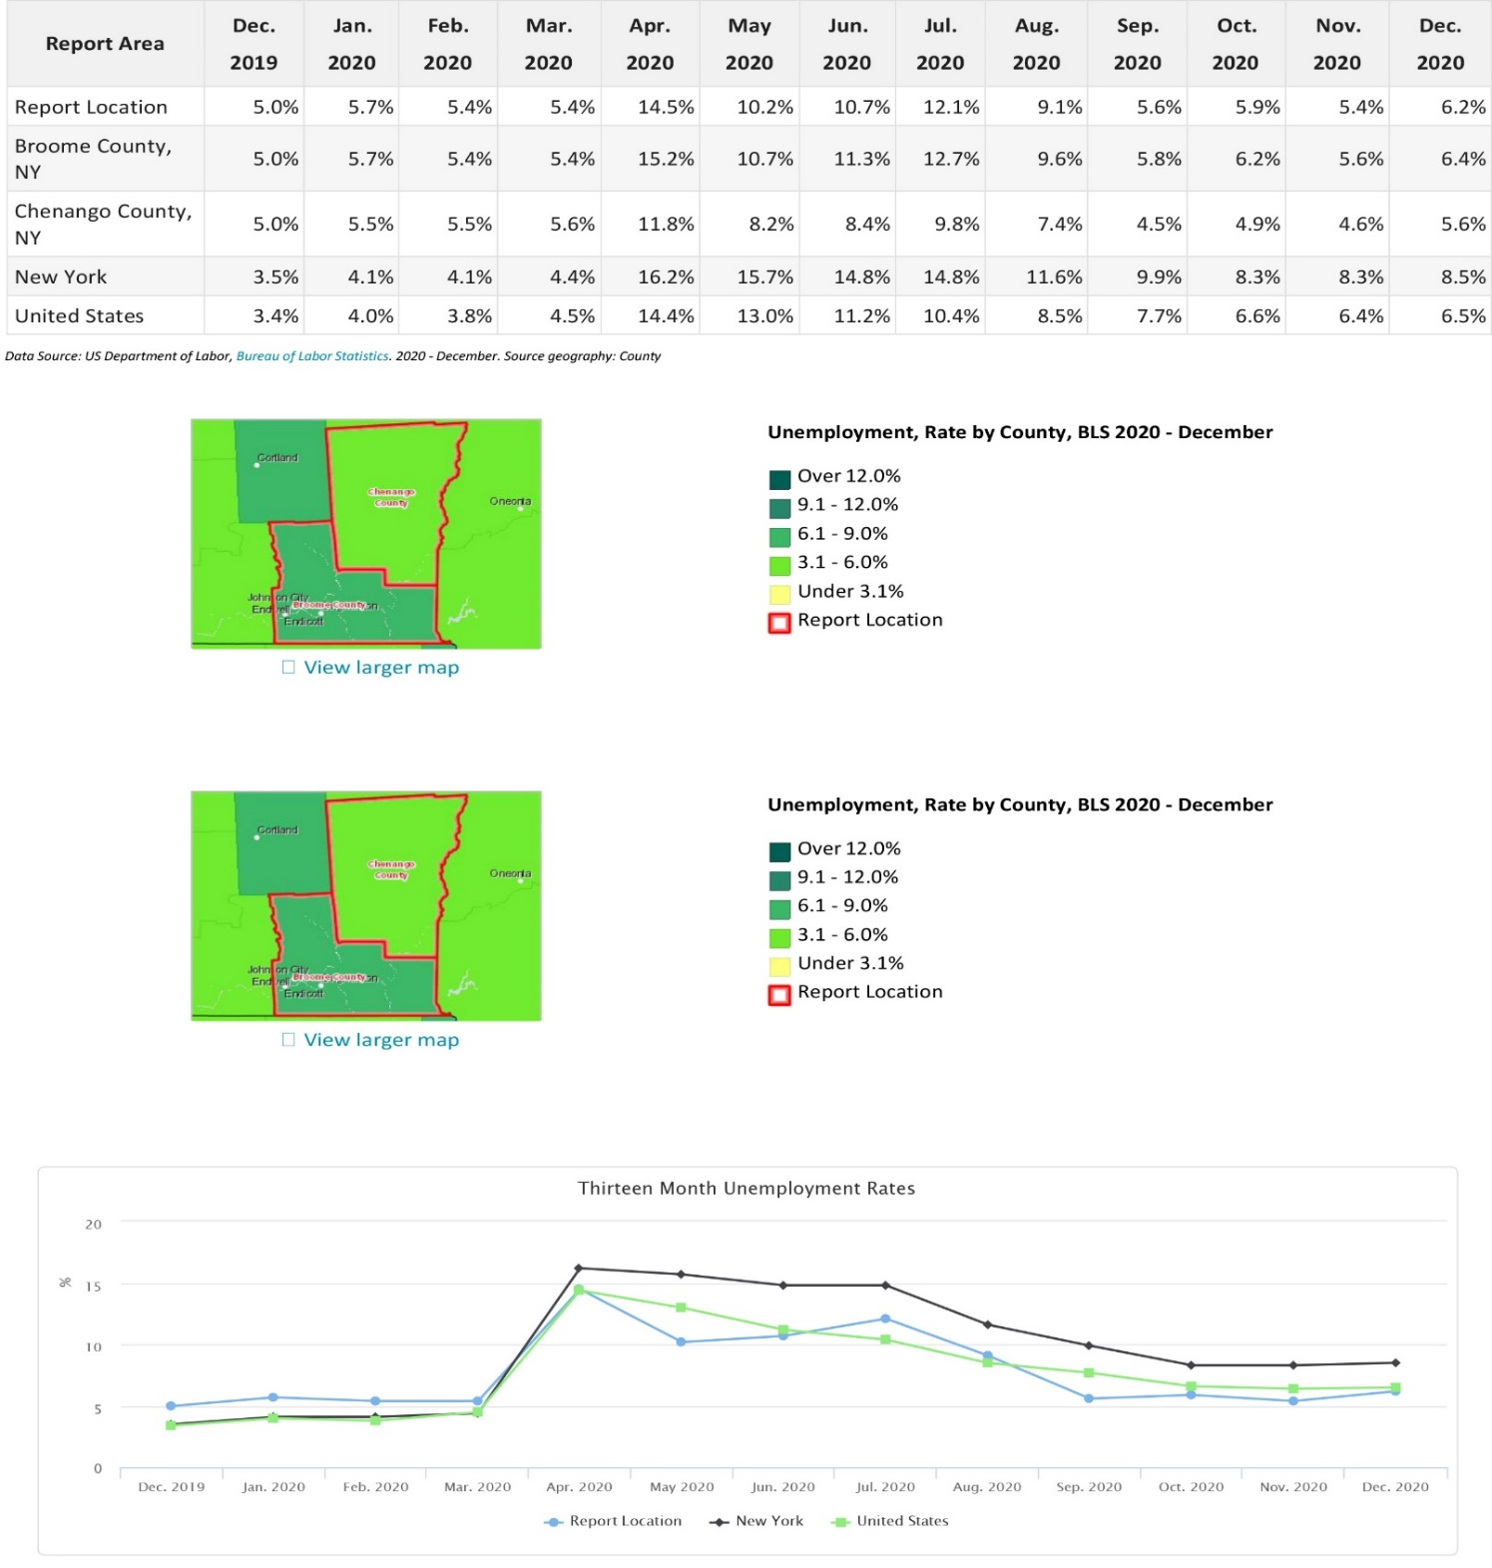
Five Year Unemployment Rate
Unemployment change within the report area from December 2016 to December 2020 is shown in the chart below. According to the U.S. Department of Labor, unemployment for this five-year period fell from 6.2% to 5.7%.
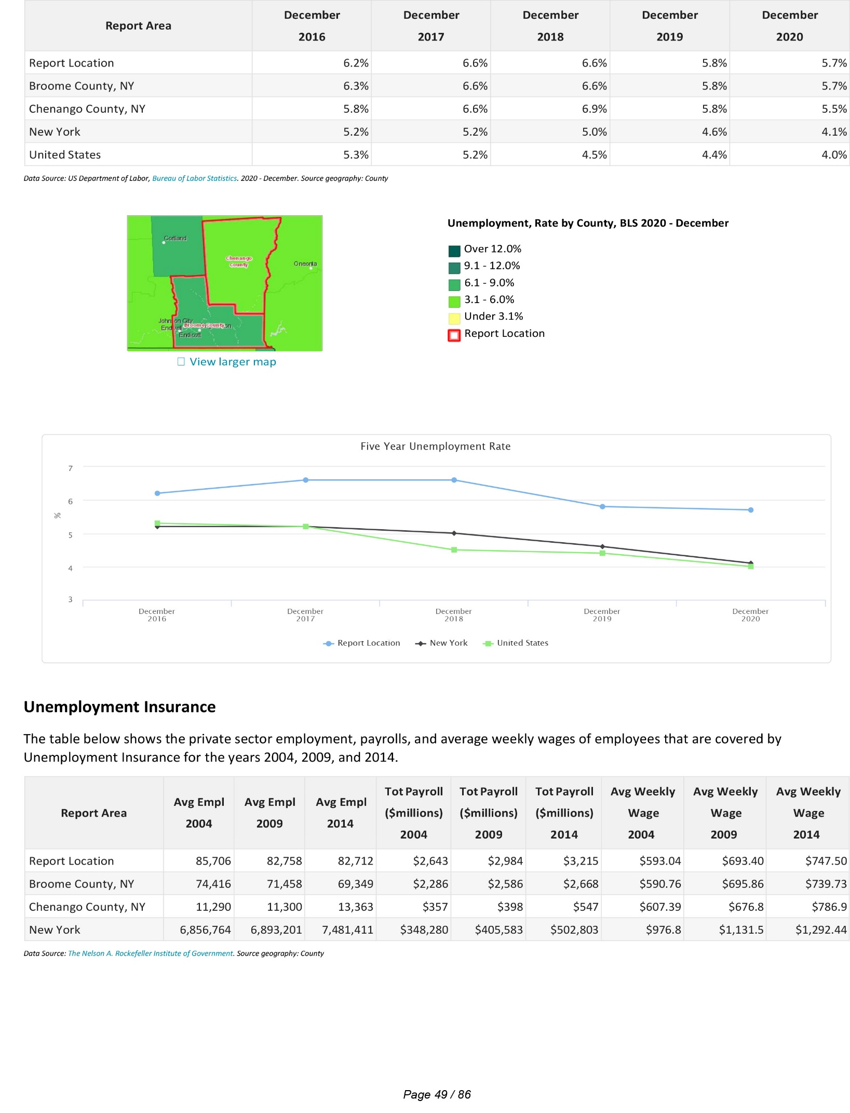

Unemployment Insurance
The table below shows the private sector employment, payrolls, and average weekly wages of employees that are covered by Unemployment Insurance for the 2018. (Rockefeller Institute of Government-Employment Statistics, 2021)

Wages
Average weekly wages for the report area during the period of December 2019 are provided below. Wage and employment figures are shown by county of employment. The report area has an average weekly wage of $925.87.
Living Wage

The living wage shown is the hourly rate that an individual must earn to support their family, if they are the sole provider and are working full‐time (2080 hours per year). The Minimum Hourly Wage for the majority of New York counties is $15.00 in 2023.
Key Findings-Update 2023
The COVID-19 pandemic has caused significant ripples through the employment sector. Many businesses were either forced to close due to social distancing guidelines or to have people work from home, which drastically changed how companies normally did business. Many other workers were deemed essential and continued to work in hospitals and grocery stores, on garbage trucks and in warehouses, yet under new protocols to reduce the spread of the virus. The COVID-19 pandemic has impacted economic sectors disproportionately. The leisure and hospitality sector lost the largest number of jobs since January 2020, and individuals last employed in these sectors have consistently exhibited some of the highest unemployment rates. Additionally, the education and services sector and the government sector have exhibited the second and third-largest losses in jobs since January 2020, which have had previously low unemployment rates among individuals last employed in these sectors.
Due to the pandemic, Congress had supplied three rounds of stimulus checks for families, expanded nutrition assistance programs, and enacted increases in refundable tax credits. These benefits have increased families’ disposable income and have increased consumer spending, which has assisted businesses in enduring the recession. In addition, Unemployment Insurance (UI) program benefits were increased and the length of coverage was extended. There is concern this policy could directly lead to the unemployment rate remaining above what it would be otherwise because past research has shown UI extensions can disincentivize people from returning to work. However, by extending and increasing unemployment, individuals have increased spending which may insulate the labor market from further deterioration.
In 2022, there has been a trend, known as the “Great Resignation” on the part of workers, encouraged by a low unemployment rate, to quit less-desirable jobs and exercise much greater choice is regards when and where to work. Data shows that New York State ranks lowest or second-lowest among all states in job openings, hires, and quits and that New York’s pandemic jobs deficit is much greater than all other states. This demonstrates the individuals in our state are looking for work to the same degree they were before the COVID-19 Pandemic, but they are finding jobs in much smaller numbers. In turn, employers are in a hiring crisis as they have open positions, but cannot find individuals that either want positions offered or are unqualified for the positions.
Even prior to the pandemic, over half of the regions in New York State were losing workers. The Southern Tier, where Broome and Chenango County are located, experienced double-digit declines over the last 10 years, with the Southern Tier losing 39,800 workers or 12.6 percent of its labor force. Although unemployment rates are currently low in both Broome and Chenango Counties, 3.10% and 2.50% respectively, New York has not yet recovered all the jobs lost during the pandemic. New York lost almost 2 million jobs in early 2020, with almost two-thirds of job losses in public-facing industries, such as leisure and hospitality, retail and wholesale trade, healthcare and social assistance, and other services.11

Commuter Travel Patterns
This table shows the method of transportation workers used to travel to work for the report area. Of the 105,372 workers in the report area, 80.2% drove to work alone while 9.0% carpooled. 2.7% of all workers reported that they used some form of public transportation, while others used some optional means including 4.3% walking or riding bicycles, and 0.6% used taxicabs to travel to work.
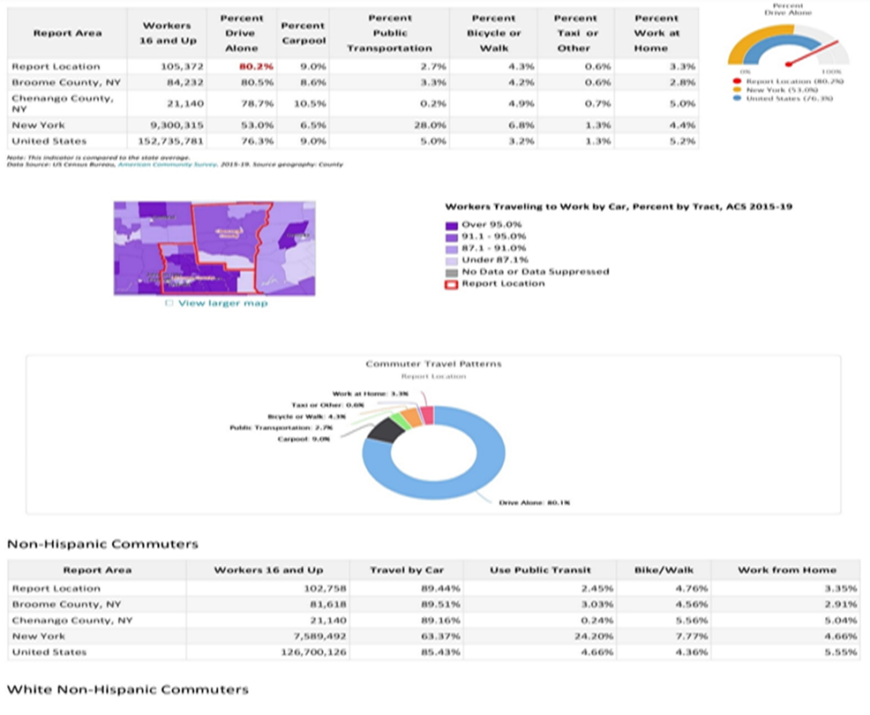
Travel Time to Work
Travel times for workers who travel (do not work at home) to work is shown for the report area. The median commute time, according to the American Community Survey (ACS), for the report area is ‐0.20 minutes shorter than the national median commute time of 26.94 minutes.

Key Findings-Update 2023
10.1% of households in Broome and Chenango Counties do not have a vehicle, a rate lower than that of the state and higher than that of the nation. A lower portion of residents opt to take public transportation, bicycle, or walk to work, especially in Chenango County where very limited public transportation currently exists. Although the larger areas in Broome County have a public transportation system (Binghamton, Johnson City, Endicott, Endwell, and Vestal), this system is not accessible to those living in the rural areas of the county. Due to the fact that public transportation is extremely limited in the rural areas in both counties, individuals and families must prioritize owning a vehicle in order to work and have access to services. Due to many families having limited budgets, more often than not, their vehicles are often bought used with higher miles and mechanical issues. This leads to individuals and families having to pay a larger percentage of their income on vehicle maintenance in order to maintain employment and access needed resources.
The pandemic has further exacerbated the transportation issue within both counties. Due to the limited public transportation options in rural areas, those with larger families have to pay more for taxi services to go grocery shopping or attend appointments as they were required to be picked up in a larger vehicle which has a higher rate per mile. Additionally, vulnerable populations, such as the elderly and those living in poverty, continue to have difficulty in obtaining consistent transportation in order to attend medical appointments. Fortunately, some local community-based agencies are able to assist with transportation in attending medical appointments. For example, Getthere is a mobility management program of the Rural Health Network of South-Central New York serving Broome, Chenango, Delaware, Otsego, and Tioga Counties. Getthere seeks to improve transportation access and coordination in rural communities and is a one-stop source of help for those seeking assistance with transportation and mobility. With the cost of transportation continuing to rise, Greater Opportunities will need to advocate for and seek partnerships with agencies that can assist low-income families in accessing reliable transportation.

Education

Education can be a strong determinant of socioeconomic status and health outcomes. When an area makes concerted efforts to increase the educational level in a population, there will be a decrease in poverty and improvement to the overall population health. Data has shown that on average, those with more than 12 years of education have a higher life expectancy than those with 12 or fewer years of education. Individuals with lower levels of education often have less income and reduced access to health insurance and other resources they may need to attain self-sufficiency.

School Enrollment
The below table shows the total public-school enrollment in the selected region. Totals were updated to reflect counts for the 2019/2020 school year.
Report Area | Total Enrollment | Male Enrollment | Male Enrollment % | Female  Enrollment | Female Enrollment %
Report Location | 31,899 | 16,323 | 51% | 15,576 | 49%
Broome County, NY | 24,982 | 12,811 | 51% | 12,171 | 49%
Chenango County, NY | 6,917 | 3,512 | 51% | 3,405 | 49%
New York | 2,598,921 | 1,345,240 | 51.3% | 1,277,639 | 47.8%

Report Area | American Indian or Alaska Native | Black or African American | Hispanic or Latino | Asian or Native Hawaiian/ Other Pacific Islander | Caucasian | Multiple  Races
Report Location | 87 | 2,464 | 1,935 | 953 | 24,697 | 1,803
Broome County, NY | 57 | 2,362 | 1,761 | 900 | 18,209 | 1,693
Chenango County, NY | 30 | 102 | 174 | 53 | 6,488 | 110
New York | 18,105 | 448,499 | 708,319 | 252,191 | 1,133,631 | 62,134

High School Dropouts
The table below shows the number of Public High School dropouts in the selected region. Totals were updated to reflect counts for the 2019/2020 school year.

High School Graduates
The table below shows the number of Public High School Graduates in the selected region for the 2019/2020 academic years.
Report Area | Graduates Total | Male Graduates | Female Graduates | Graduation Rate Total | Graduation Rate Male | Graduation Rate  Female
Report Location | 2,585 | 1,379 | 1,206 | 87% | 87.5% | 86.5%
Broome County, NY | 2,033 | 1,109 | 924 | 86% | 83% | 89%
Chenango County, NY | 552 | 270 | 282 | 88% | 92% | 84%
New York | 208,436 | 107,129 | 101,307 | 85% | 81% | 89%
Educational Attainment
Educational attainment shows the distribution of the highest level of education achieved in the report area, and helps schools and businesses to understand the needs of adults, whether it be workforce training or the ability to develop science, technology, engineering, and mathematics opportunities.
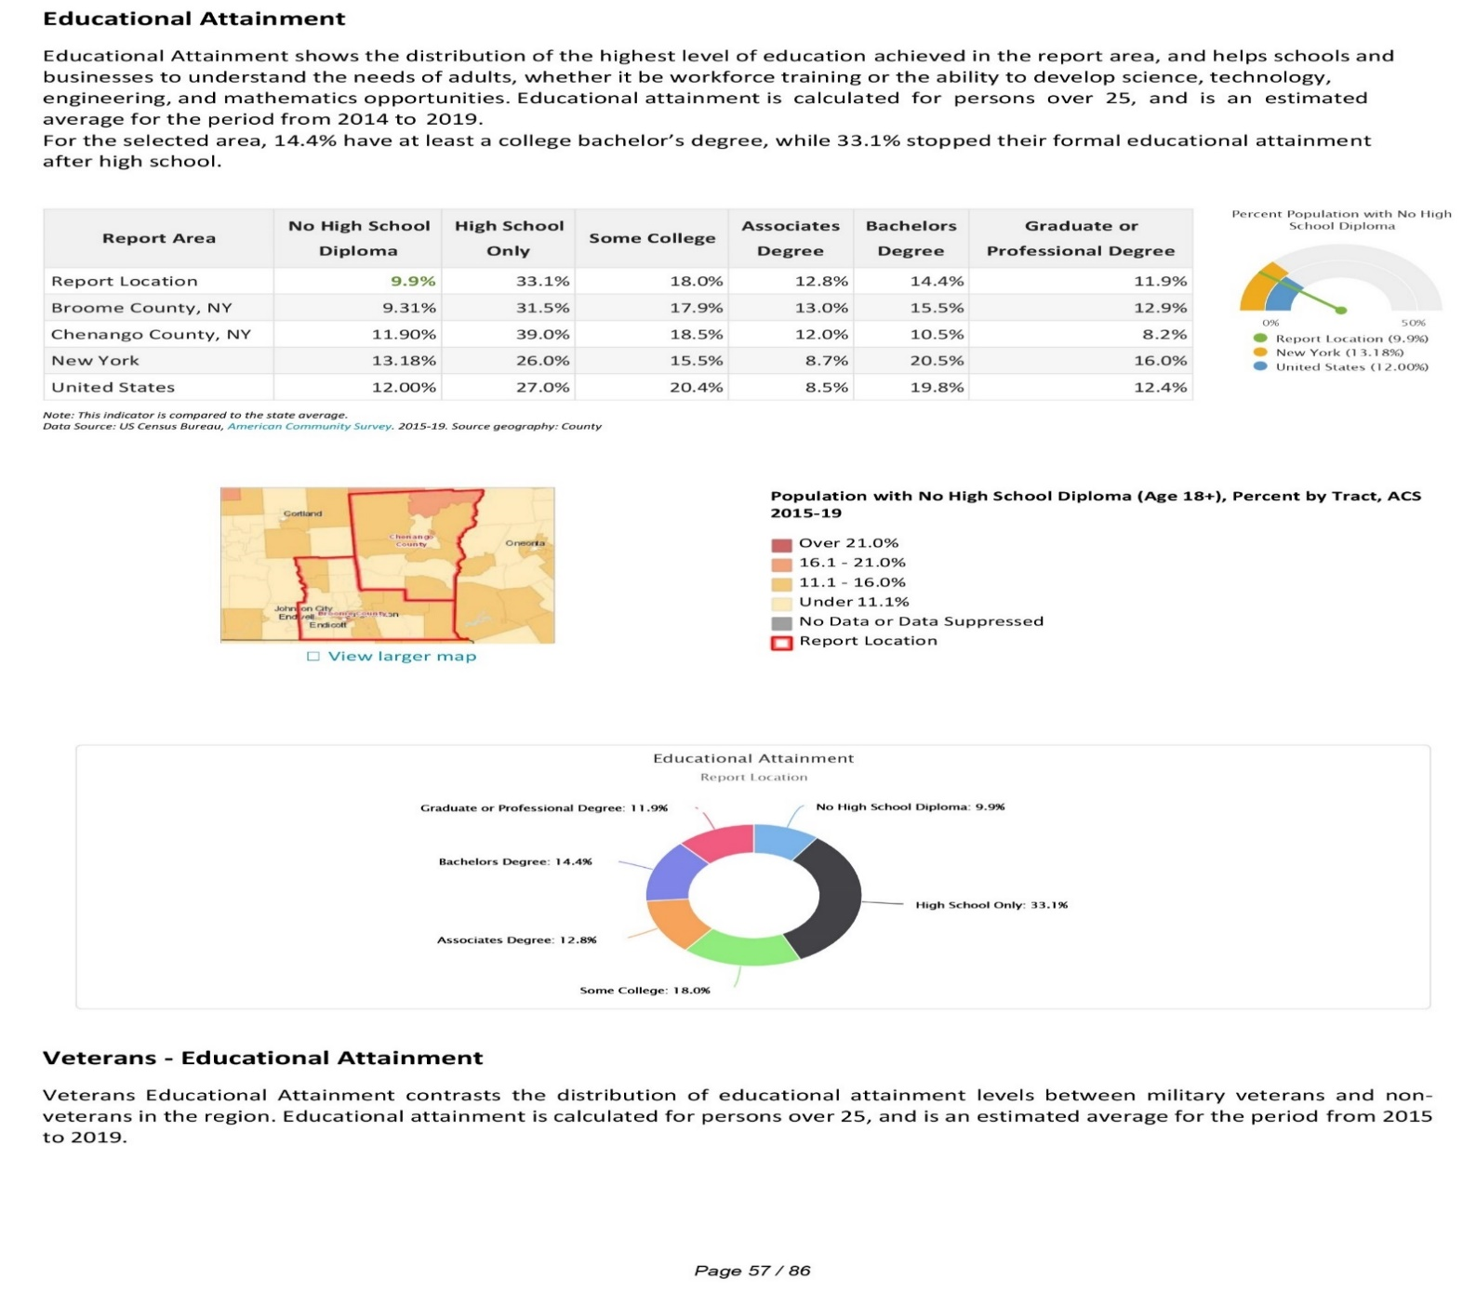

In the service area counties of Broome and Chenango, the U.S. Census Bureau estimates that of the population over aged 25 years, 35% have attained at most a high school diploma, which is higher than the state of New York (26.1%). Additionally, 12.9% of the service area population has attained at most a bachelor’s degree, which is lower than the state (20.2%).

Graduation Rate
Black/African American residents had the lowest graduation rate in Broome and Chenango counties, with 69% graduating in the combined service area.
Graduation Rate by Race/Ethnicity 2020 (NYSED, 2021)
Race/Ethnicity | Broome County | Chenango County
Asian | 96% | 88%
Black/African American | 71% | 100%
White | 88% | 88%
Hispanic/Latino | 74% | 92%
.

Adult Literacy Rate
Within the service areas of Broome and Chenango County, adults have a higher literacy rate than the state and nation.
Adult Literacy (National Center for Education Statistics, 2021)
Report Area | Lacking Literacy Skills
Broome County | 11.0%
Chenango County | 12.0%
New York | 22.0%
United States | 14.6%

Key Findings
From kindergarten through adulthood, access to education sets people up for a lifetime of success, whether it be in school or in the job market. However, the American education system has started to bend to inequality, with the United States trailing nearly all other industrialized nations when it comes to educational equality, according to the Organization for Economic Cooperation and Development annual report of educational statistics from around the world. A low percentage of American adults are achieving a higher level of education than their parents did, especially among 25- to 34-year-olds, where only 20 percent of men and 27 percent of women, both out of school, have achieved a higher level of education than their parents. This situation only gets bleaker for those with less education as only one in 20 Americans aged 25 to 34 whose parents didn’t finish high school has a college degree. This particularly hurts the poor as the graduation rate of youths in the poorest fourth of the distribution increased to 9 percent from 5 percent; among the richest fourth it rose to 54 percent from 36 percent.13
Childhood experiences directly influence who a child becomes as an adult. Every piece from their early life affects their future path and careers they will choose. For low-income families, it is easy to veer off the path towards educational attainment. This may include long travel times for people using public transportation for work commutes; lack of access to affordable childcare; underdiagnosed or untreated mental health issues; and lack of confidence and trust in the education system among caregivers that may have had poor experiences in elementary and high school. Head Start and Early Head Start programs are uniquely positioned in that the two-generation service model is particularly impactful at developing and empowering families, so they are able to lift themselves out of poverty and towards self-sufficiency. Increasing participation in educational programs is critical in this endeavor as it is vital at an early age to instill in children, as well as their parents, the importance of learning and education.
The COVID-19 pandemic continues to impact the American educational system, as evidence shows that the pandemic has negatively affected academic growth, while widening pre-existing disparities. In primary subjects like math and reading, there are concerns that some students might be falling even further behind pre-pandemic expectations. The COVID-19 pandemic has also impacted the access and opportunity facing many students, including technological and other barriers that make it harder to participate in virtual classrooms. Furthermore, for students with disabilities, COVID-19 has significantly disrupted the education and services needed to support academic progress and prevent regression.13 Greater Opportunities programs provide vital resources in supporting individuals and families in obtaining education and career training to improve their financial security.

Early Care and Education-Update 2023

During the early years of children’s development, rapid brain growth occurs and important bonds with caregivers are formed. Supporting children’s learning and health during this time influences the degree to which they will be prepared for kindergarten and a lifetime of success. Some research indicates that a month of early childhood learning is equal to an entire year of adult learning. Additionally, children who fall behind in this stage of development often fail to catch up as they move through the elementary education system, making high quality early childhood education all the more important. To mediate these discrepancies, early care and education needs to be of the highest quality possible. Because of the amount of time children spend in out-of-home arrangements, the quality of the setting can either significantly harm or support development and health. Unfortunately, obtaining adequate early education and support can be an insurmountable barrier for parents and children due to several factors related to the cost, quality, and availability of care. This section of the community assessment examines the landscape of early care and education programs for low-income families in the counties of Broome and Chenango and offers suggestions for how Head Start can be leveraged to fill gaps and support child development and health for vulnerable children.
Number of Programs by Type
Type | Broome County | Chenango County | New York
Day Care Centers | 39 | 8 | 2066
Family Day Care Homes | 27 | 15 | 2576
Group Family Day Care | 23 | 16 | 7873
School Age Child Care Programs | 21 | 6 | 2767
Total | 110 | 45 | 15,282

www.ocfs.ny.gov/programs/childcare/looking/ccfs-search.php
Quality Disparities for At-Risk Children
Evidence from the NICHD Study of Early Child Care suggests that children in disadvantaged and racial/ethnic minority families disproportionately experience poor quality childcare. The NICHD study also found that school readiness systematically varies across different types of childcare settings.
Using data from the Longitudinal Survey, Birth Cohort study, in Quality Disparities in Child Care for At-Risk Children: Comparing Head Start and Non-Head Start Settings the authors demonstrate a disparity in the quality of childcare and early education services for at-risk children that mirrors the NICHD study. According to the data, African American children were found to experience the lowest quality care across all types of childcare settings. Being placed in lower quality childcare was associated with less maternal education and African American and Hispanic ethnicity. Data from the study also illustrated that center-based Head Start programs provided higher-quality care for at-risk children, which shows the need for expansion of these types of programs in areas with limited access to high-quality care for at-risk children.
Factors that contribute to the lack of placement of children of color in high-quality childcare programs include living in a low-resource neighborhood that is racially and socioeconomically segregated that provides limited access to the full range of child care options, selection bias in which families are not aware of quality indicators, and the employment characteristics of parents influence the child care needs of families. For example, low-income working parents face several challenges related to work schedules including a greater likelihood of having part-time work, non-traditional hours, and fluctuating schedules.
Number and Percentage of QRIS-Participating Programs at the Top Level, by Program Type.

https://www.childcareaware.org/our-issues/research/ccdc/
Affordability of Child Care
According to Child Care Aware of America, in 2020, Center-based child care cost 14.7% of income for infants and 13.8% for toddlers in New York State; a large percentage of families’ income.
Work Status of Population with Children Under 6 Years Old
The service area for Broome and Chenango Counties had a lower percentage of households with both parents in the labor force for households with children under 6 years old than the State of New York. In the service area, 76.2% of female householders from single-parent households were in the labor force. Overall, 71.8% of service area children had all parents in the labor force.
Attendance and Enrollment
As of December 2020, child care attendance remains 32% down from pre-COVID attendance.
https://www.childcareaware.org/our-issues/research/ccdc/?submissionGuid=4fa2a2b4-8b99-411f-8ce8-7adaea6567c8

Greater Opportunities for Broome and Chenango
Head Start Enrollment by Age
Age | # of Children | % of Enrollment
Under 1 year | 38 | 7.78%
1 year old | 48 | 9.81%
2 years old | 63 | 12.89%
3 years old | 200 | 40.90%
4 years old | 140 | 28.63%
5 years old | 0 | 0%

Child Care Center Status

As of May, 2023 child care centers in Broome and Tioga Counties have seen an increase in the number of centers closed due to staffing struggles. There were 31 classrooms closed within licensed child care centers with 108 open classroom teaching positions. This left a total of 448 licensed child care slots not available due to staffing. 79% of licensed centers have at least 1 staff position open.

2022—2023 Head Start Family Type
Single Parent | Two Parent
223 | 215

Enrollment by Race/Ethnicity
American Indian | 0%
Asian | .81%
Bi-Racial | 13.39%
Black/African American | 5.07%
Other | 0.41%
Unspecified | .20%
White | 80.12%

Head Start/Early Head Start Languages Spoken at Home
Language | New York State | Broome & Chenango County  Head Start/Early Head Start | United States
English | 69.6% | 97.14% | 78.1%
Spanish | 15.2% | 1.22% | 13.5%
Other | 15.6% | 1.64% | 8.4%

Head Start and Early Head Start Enrollment by Eligibility Type
Below FPL | 26.52%
Public Assistance | 48.79%
Foster Child | 3.24%
Homeless | 5.06%
Over Income | 8.50%
100-130% FPL | 7.90%

Family/Fatherhood Involvement
Family/Fatherhood Involvement | Total Involved
Received At Least One Family Service | 273
Fathers Who Engaged in the Family Assessment | 79
Fathers Who Engaged in Family Goal Setting | 76
Fathers Who Engaged in Child's HS Experience | 103
Fathers Who Engaged in Program Governance | 5
Families Who Received Parenting Education | 10

Head Start Staff Race and Ethnicity
American Indian/Alaska Native | 1.7%
Black/African American | 1.7%
White | 93.2%
Asian | 1.7%
Biracial | 1.7%

Head Start and Early Head Start Staff Languages
Language | Broome & Chenango Head Start Staff | New York | United States
English | 96.6%% | 64.47% | 78.2%
Spanish | 1.70% | 19.4% | 13..4%
Other | 1.70% | 39 | 5

Head Start Staff Educational Attainment
Location | Advance Degree in ECE | CDA | BA in ECE | AA Degree in ECE | No ECE Credential
Broome and Chenango | 3.4% | 22% | 25.4% | 35.6% | 13.6%
New York | 34% | 6% | 17% | 4% | 38%

https://www.ccf.ny.gov/files/4915/7773/1159/nysb5_na_report.pdf
https://www.zippia.com/head-start-teacher-jobs/demographics/

Housing-Update 2023

Housing Units
The number of housing units within the report area in July of each year from 2010‐2019 is shown below. According to the U.S. Census, there were a total of 117,369 housing units in the report area in 2019, an increase of 2,022 (or 1.75%) since 2010 compared to a 3.57% increase statewide.

Housing Age

American Community Survey (ACS) totals for housing units, median year built and median age in 2019 for the report area are shown in the table below.

Fair Market Rent
Fair market monthly rent for 2020 (0‐4 bedrooms) is shown below.

Housing Affordability
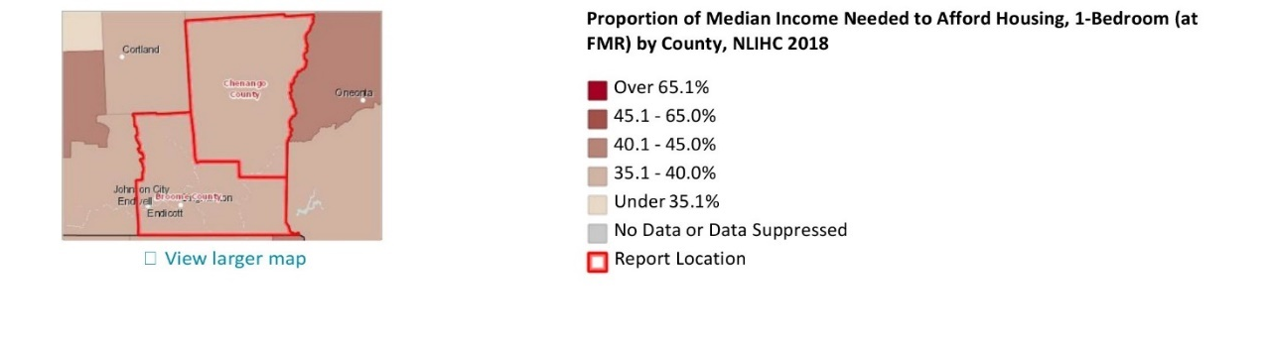
The National Low-Income Housing Coalition reports each year on the amount of money a household must earn in order to afford a rental unit based on Fair Market Rents in the area and an accepted limit of 30% of income for housing costs.
Vacancy Rates
The U.S. Census Bureau provides vacancy data based on American Community Survey 5‐year estimates (2015 ‐ 2019). Vacancy rates for the report area are reported below. Vacant non‐rental housing totals 2,055 units and includes those for sale only and sold but not occupied. For the report area, that is a non‐rental housing vacancy rate of 1.76%, in comparison the national rate is 1.39%. Vacant rental housing totals 3,589 units and includes those for rent and rented but not occupied.
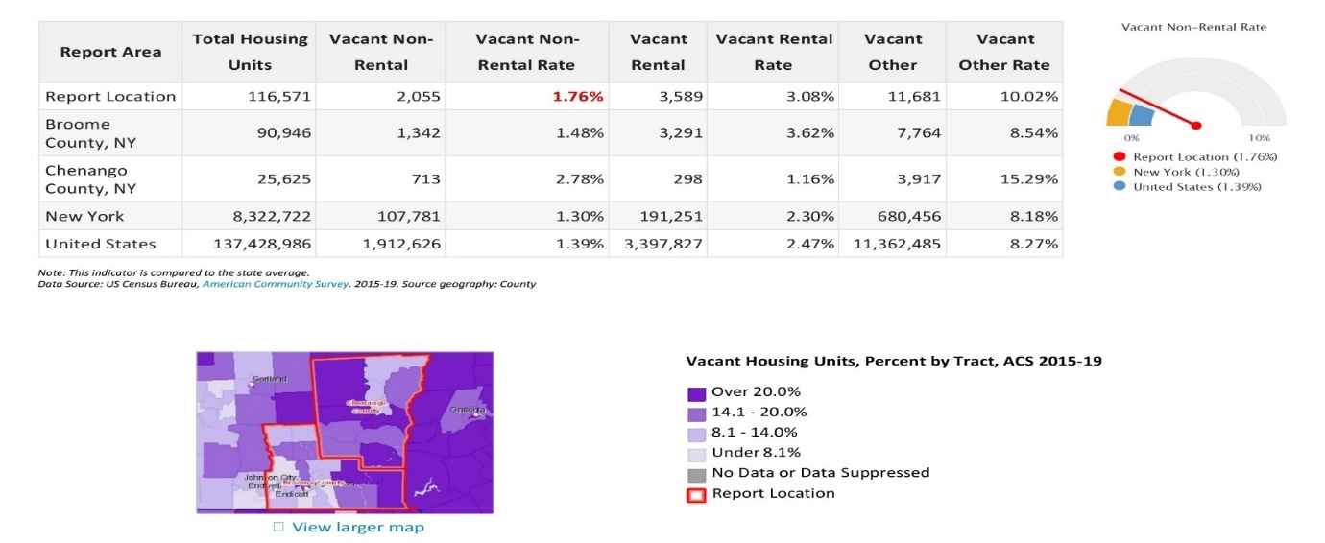
For the report area, that is a rental housing vacancy rate of 3.08%, in comparison the national rate is 2.47%. Vacant other housing totals 11,681 units and includes those used for seasonal, recreational, or occasional use, as well as units used for migrant workers. For the report area, that is another housing vacancy rate of 10.02%, in comparison the national rate is 8.27%.
Homeowners
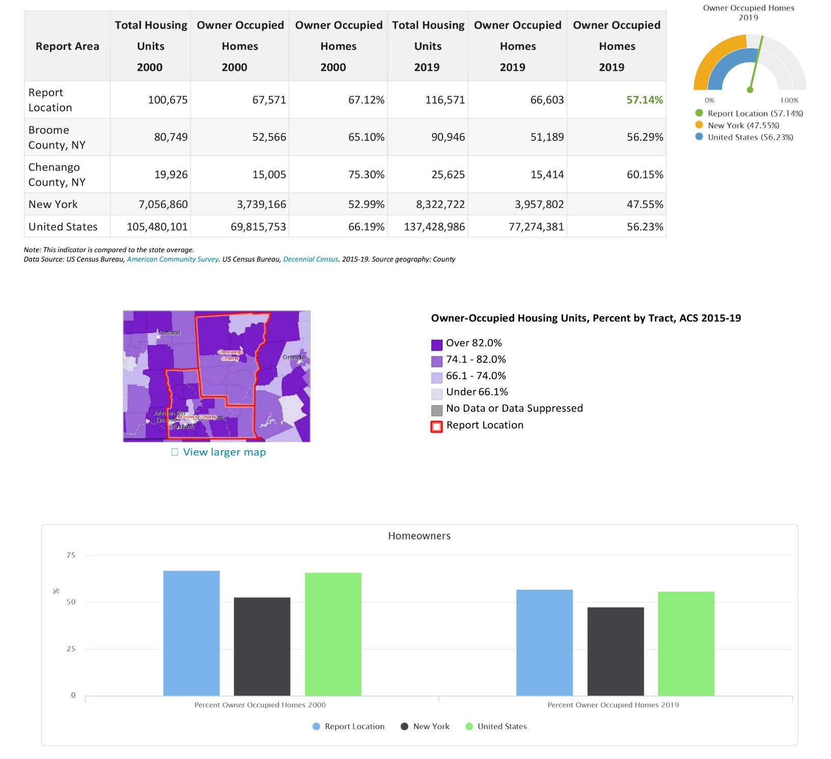
The U.S. Census Bureau estimated there were 66,603 owner occupied homeowners of the estimated 116,571 housing units in the report area in 2019. This 57.14% is a decrease over the 67.12% owner occupied homes in 2000.

Overcrowded Housing
Occupied housing units, overcrowded housing units, and percent overcrowded for 2000 and 2019 are provided for the report area below. The average for the report area for 2019 is 1.74%, compared to a statewide average of 7.46%.
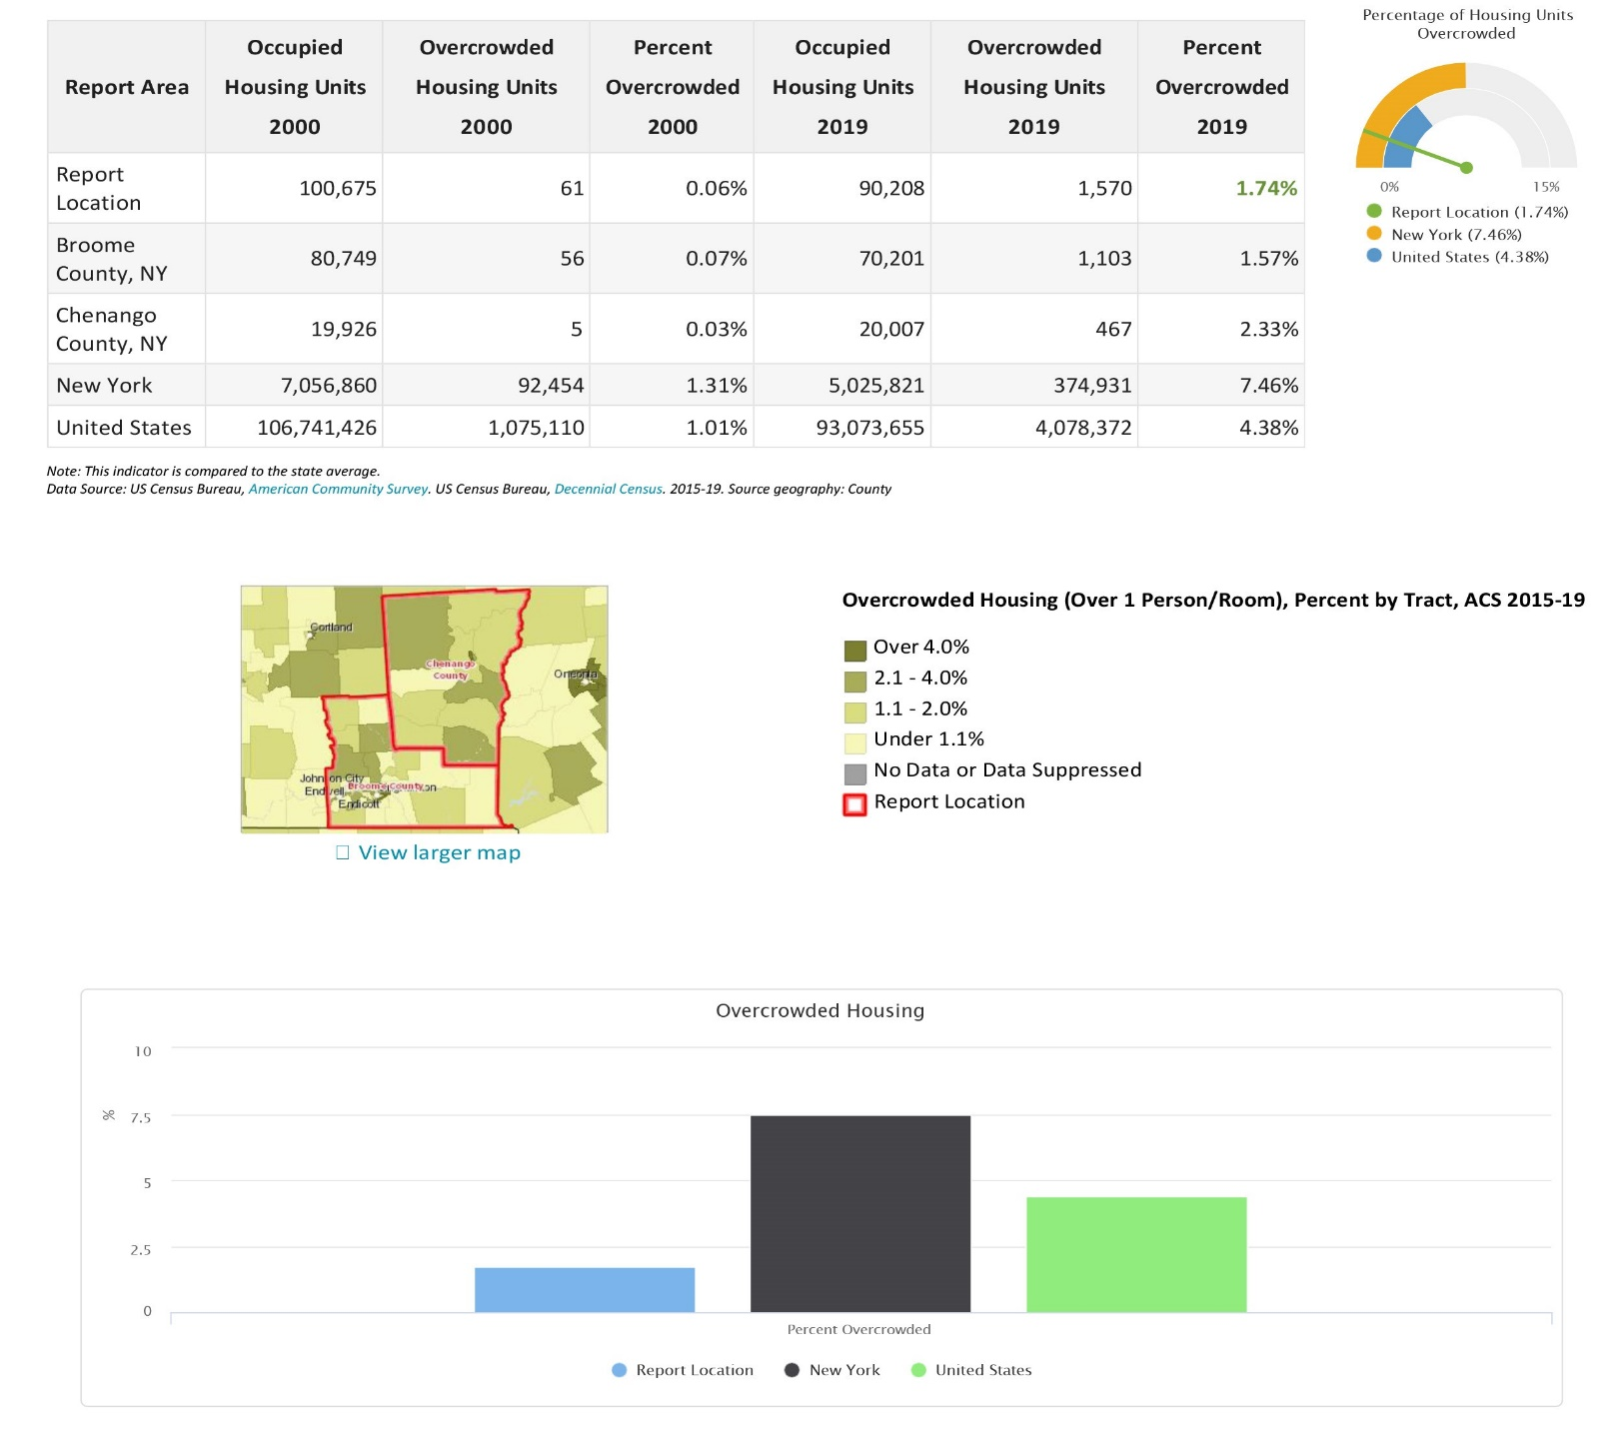

Number of Unsafe, Unsanitary Homes
The number and percentage of occupied housing units without plumbing are shown for the report area. U.S. Census data shows 482 housing units in the report area were without plumbing in 2000 and ACS 5-year estimates show 258 housing units in the report area were without plumbing in 2019.

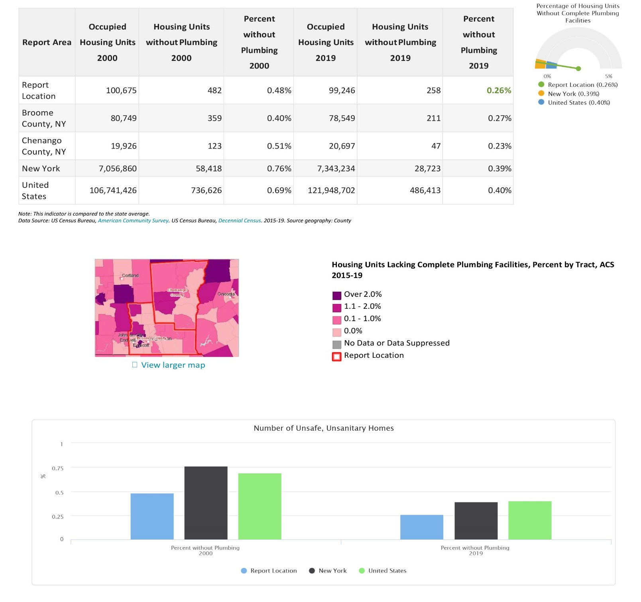

Point in Time Homeless
Point‐in‐time counts (collected January 26, 2023) were conducted by the NY-511 Continuum of Care, which serves Broome, Chenango, Tioga, Otsego, Cortland, and Delaware Counties, on behalf of U.S. Department of Housing and Urban Development (HUD). The purpose of the NY-511 CoC is to break the cycle of homelessness by assisting persons at-risk and experiencing homelessness move into permanent housing, overcome housing stability barriers, and become self-sufficient.
2023 Point-in-Time Count NY-511 Binghamton, Union Town/Broome, Otsego, Chenango, Delaware, Cortland, Tioga

Key Findings-Update 2023

Chenango County continues to struggle with many housing issues. Per the 2021 ACS, 21.2% of Chenango County's housing units are mobile homes, as compared to 2.4% in New York State and 6.5% in the nation. The median value of owner-occupied homes in Chenango County is $102,300, which is significantly lower than both the state and national average. Most residents in the county live in single family units, with only 15.6% living in multiple unit dwellings. The 2021 U.S Census Bureau estimates that there are a total of 19,753 occupied housing units within Chenango County, of which 76.3% are owner occupied and 23.7% are renter occupied. According to 2021 U.S. Census Bureau, of those units that are renter occupied, 32.3% are paying greater than 35% of their income on rent. One of the greatest challenges facing the homeless at this time is affordability. In Chenango County, the unemployment rate is currently at 2.5%, however, the average weekly wage rate for those employed in Chenango is $912.00, which is 40% lower than the average weekly wage rate of $1,499 in New York State. Homeownership in the county is high at 75.6%, including mobile homes. Of all renter households in the area, 32.3% are considered cost burdened (paying 30% or more of annual income) and 16% are designated as severely cost burdened (paying 50% or more of annual income). 92.3% of renter households are listed as having income below the federal poverty level, or of very low (50% of area median income) or extremely low income (30% of area median income). There is a relatively high home vacancy rate (19.4%), which may be reflective of poor housing conditions and the population decline in this county. The areas current economic climate has led to an increase in mortgage defaults. This is a direct result of recent layoffs, particularly in the manufacturing sector of the local economy. 1 in every 1,549 homes in Chenango County is in a stage of the foreclosure process, either pre-foreclosure, auction or bank owned.
According to the 2023 Poverty Report issued by the New York State Community Action Association (NYSCAA), there are currently 198,591 individuals residing in Broome County, with 35,372 (18.7%) of those individuals currently living under the Federal Poverty Level. Within the City of Binghamton, the total population is 47,566. Within the last 13 years, there has been a fluctuation in Broome County’s population, with the population increasing over the last 2 years. Significant changes occurred in 2006 and again in 2011, after the area was hit with two major floods contributing to families relocating around the county and out of the area. In addition, significant portions of available housing stock were eliminated or significantly damaged due to this flooding.
The 2021 U.S Census American Community Survey Report estimates that there is a total of 91,155 occupied housing units within Broome County, of which 65.1% are owner occupied and 34.9% are renter occupied. Of those units that are renter occupied, 45.6% are paying greater than 35% of their income on rent. Over 76% of the housing units within the City of Binghamton were constructed prior to 1960. The Blueprint Binghamton Comprehensive Plan of indicates that over 50% of renter occupied housing units have a housing problem and that almost of all of these units are occupied by households and individuals that fall within HUD’s low-income guidelines. Changing flood maps and the rising cost of flood insurance threaten whole neighborhoods. And these threats follow on the complete restructuring of the national housing market as a result of the subprime mortgage crisis that began in 2008.
One of the greatest challenges facing both Counties at this time is affordability. Job seekers far outnumber employment opportunities in Broome and Chenango County. To add to that, the skill sets of the available labor pool and available jobs appear largely mismatched. Of those individuals that are employed, 30.1% are considered still living in poverty. For many, housing costs are exceeding a large percentage of their monthly income, which makes it extremely difficult to maintain permanent, safe, and affordable housing.
Residents of Broome and Chenango County are also faced with constant rising gas, grocery, state and local taxes, insurance and utility costs which is making homeownership more and more financially difficult. Grocery prices have increased 5.6% which is higher than the 4.1% rate of inflation and there does not seem to be an end in sight. High state and local taxes are placing a financial burden on homeowners. Energy costs are constantly rising, with 62% of the homes in Binghamton being built prior to 1939. Older homes usually consume more energy than newer homes. For low to moderate income homeowners, energy costs place financial strains on their limited incomes.
The effects of the COVID-19 Pandemic continue to have a great impact on those individuals and families experiencing housing instability. Broome and Chenango County have different access to resources for people experiencing housing instability, especially those experiencing homelessness. Due to Chenango County being a smaller rural community, there are no homeless shelters available and those experiencing homelessness are placed in hotels for a short period of time. Due to limited capacity, the hotel is time-limited before having the individual has to return to the Department of Social Services to request a longer stay. Broome County, due to having an urban area, such as Binghamton, has emergency shelters, but not enough to meet the need of those experiencing homelessness. On top of navigating a complex service system to obtain emergency housing, the bigger challenge is finding a permanent and affordable place to live.
The COVID-19 pandemic has also affected current homeowners, as well as those looking to purchase their first home. Over 2 million homeowner households were significantly overdue on their regular housing payments as of December 2020, with 6% being delinquent for over 90 days. This places these families at heightened risk of losing their homes to foreclosure. Households with incomes below $75,000 were more than twice as likely to be behind than households with incomes above $75,000. The National Association of Realtors reported that the median price of existing homes for sale was $353,900 in November 2021, which has increased 13.9% from 2020. After reach a significant low in 2020, mortgage rates for a 30-year fixed-rate are currently at 3.93%, which has been primarily driven by the Federal Reserve holding down lending rates. More attractive interest rates motivate homeowners to think about the possibility of moving, so they can buy more house for less money. In addition, the housing stock of available homes to buy is severely limited, which has led to extensive competition between buyers, even for properties previously considered average or sub-par. For families with low-incomes looking to purchase their first home, the bidding competition has almost priced them out of the market, forcing them to look homes that need significant repairs that they cannot afford or to wait on purchasing their first home.

Income
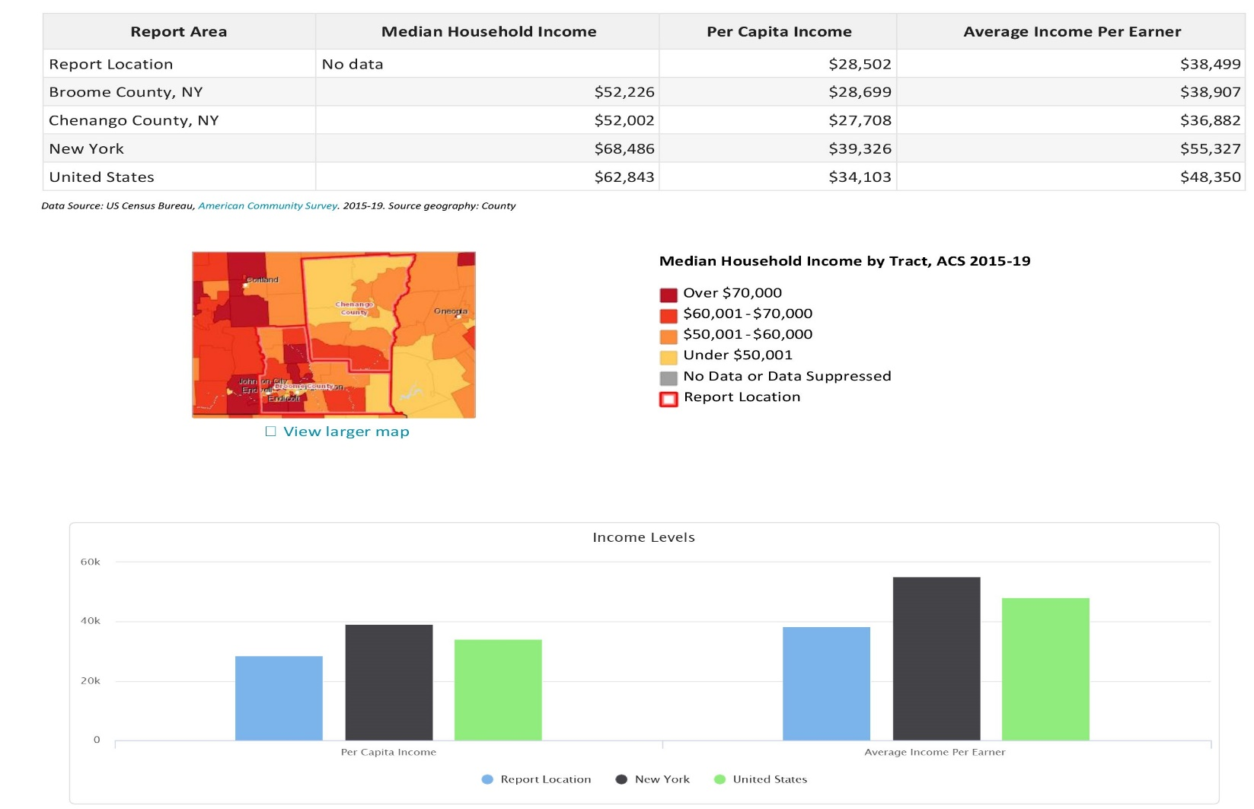
Income Levels
Three common measures of income are Median Household Income, Per Capita Income, and Average Income based on American Community Survey (ACS) estimates. All Three measures from the 2015 ‐ 2019 ACS are shown for the report area above. The Census Bureau defines an earner as someone age 15 and older that receives any form of income, whether it be wages, salaries, benefits, or other type of income.
Household Income
Median annual household incomes in the report area for 2019 are shown in the table below. Since this reports a median amount, a "Report Area" value is not able to be calculated.
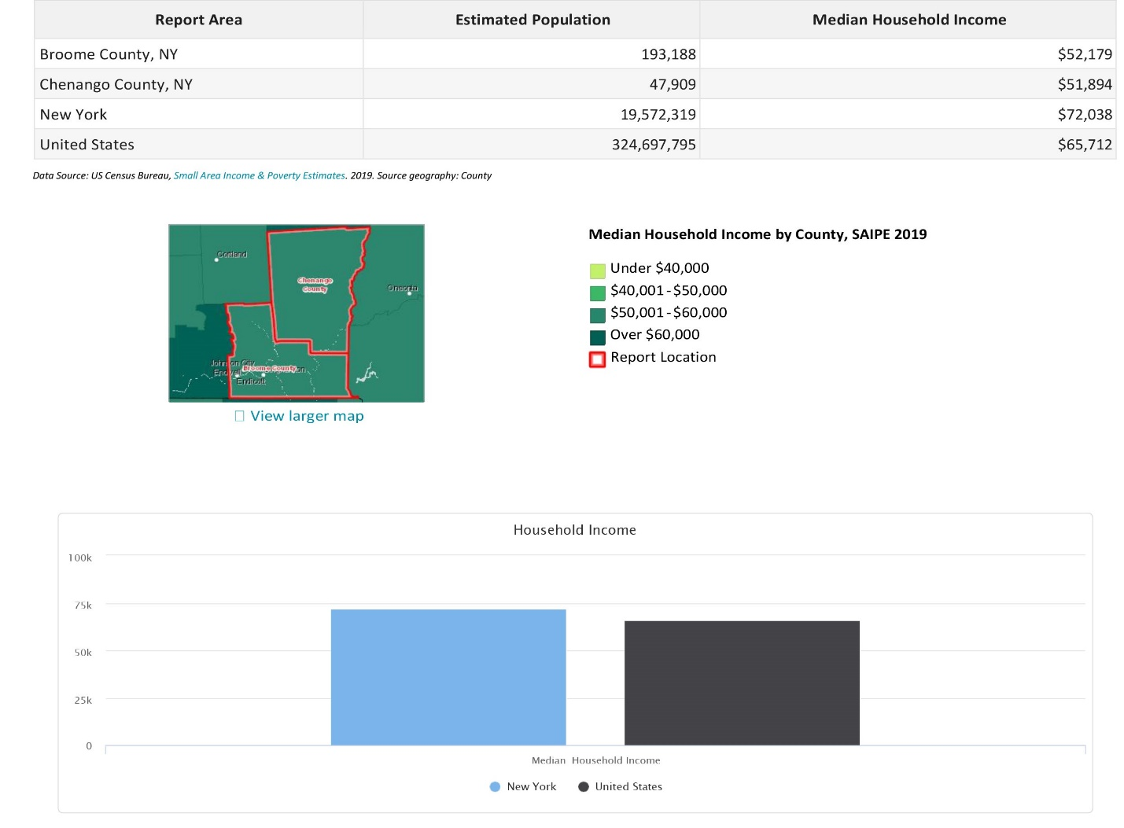

Household Income Trend
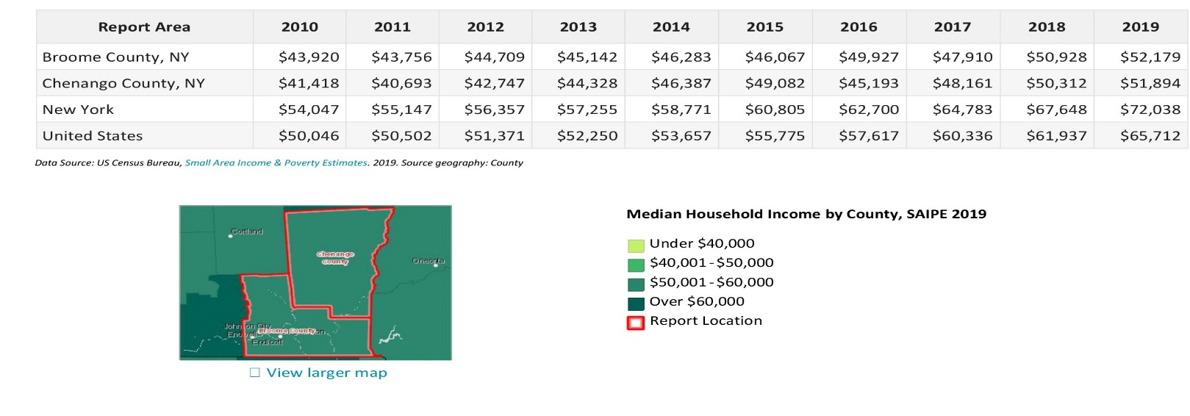
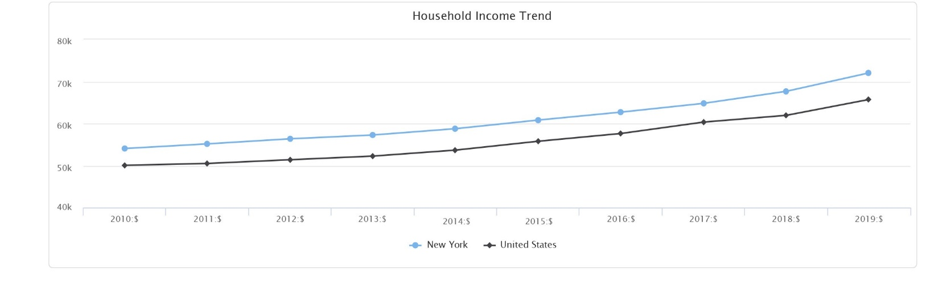
2010-2019 trend data estimates for Median Annual Household incomes are shown in the report area below.
Thirteen Month Unemployment Rates
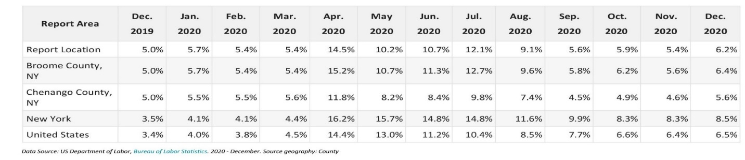
Unemployment change within the report area from December 2019 to December 2020 is shown in the chart below. According to the U.S. Department of Labor, unemployment for this thirteen-month period grew from 5.4% to 5.4%. Unemployment change within the report area from December 2019 to December 2020 is shown in the chart below. According to the U.S. Department of Labor, unemployment for this thirteen-month period grew from 5.0% to 6.2%.
Temporary Assistance for Needy Families (TANF)

The number of persons receiving TANF in January 2020, within the report area is shown in below. The New York Office of Temporary and Disability Assistance reported that 5,407 persons were receiving TANF benefits at a cost of $1,770,129, or $327.38 per recipient.
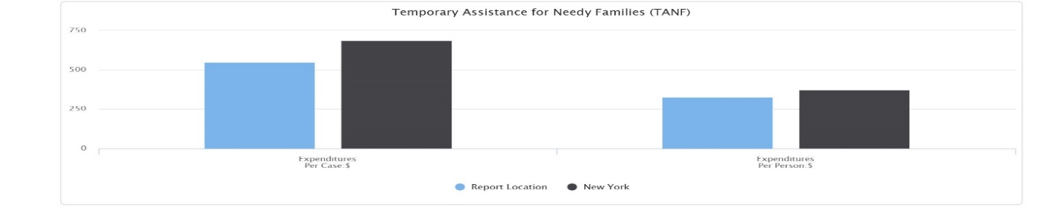

Temporary Assistance for Needy Families (TANF) Trend
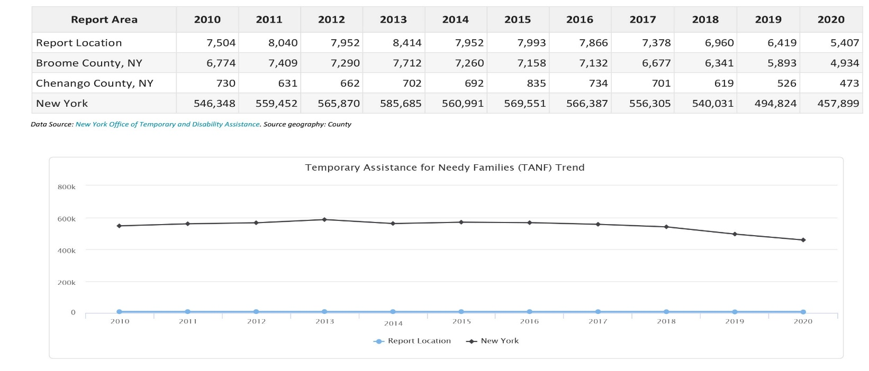
Below are trend amounts for total recipients of Temporary Assistance for Needy Families (TANF) for the selected report area. The total recipients decreased from 7,504 in 2010 to 5,407 in 2020. The data listed is for January of each year.

Free and Reduced Lunch Program by School
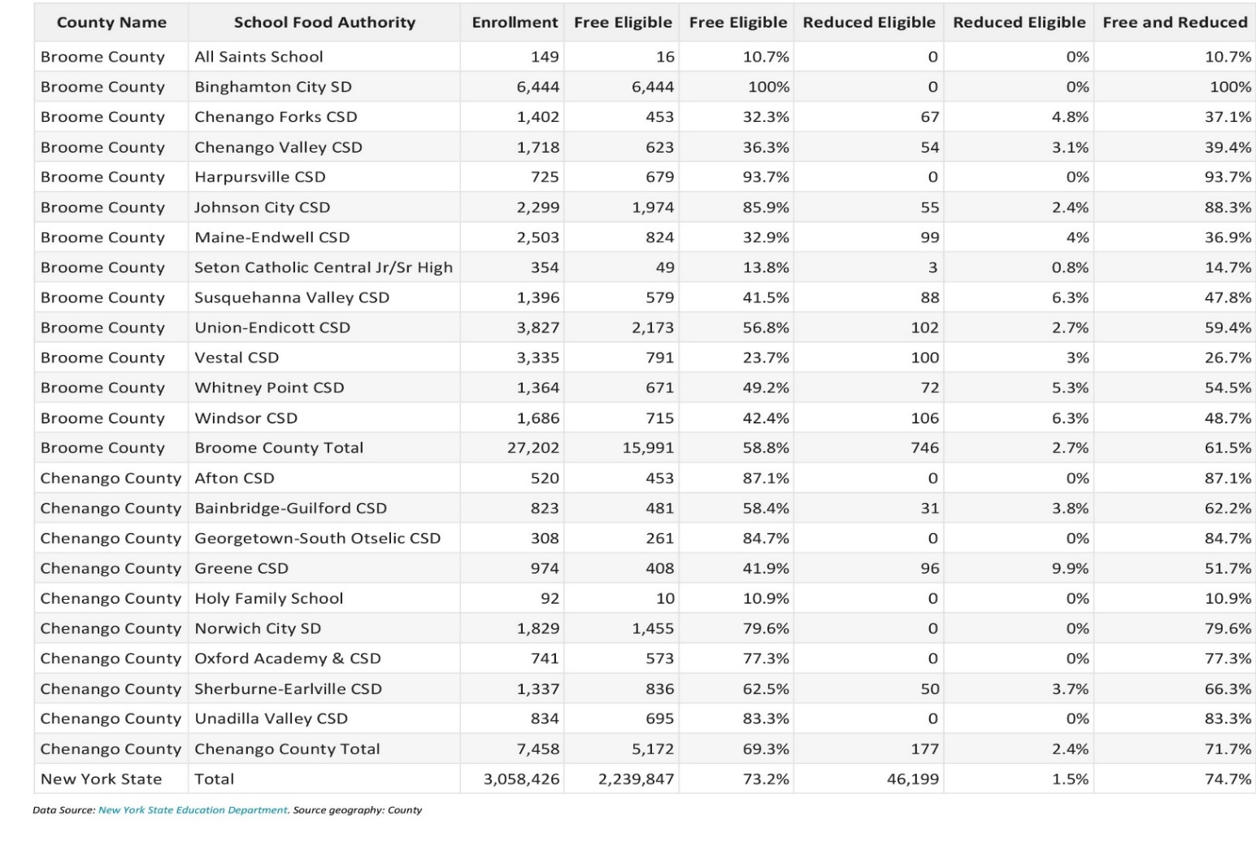
The table below shows the number of students eligible for the Free and Reduced Lunch Program during January, 2020. The figures below include all School Food Authority agencies, including public and non‐public.

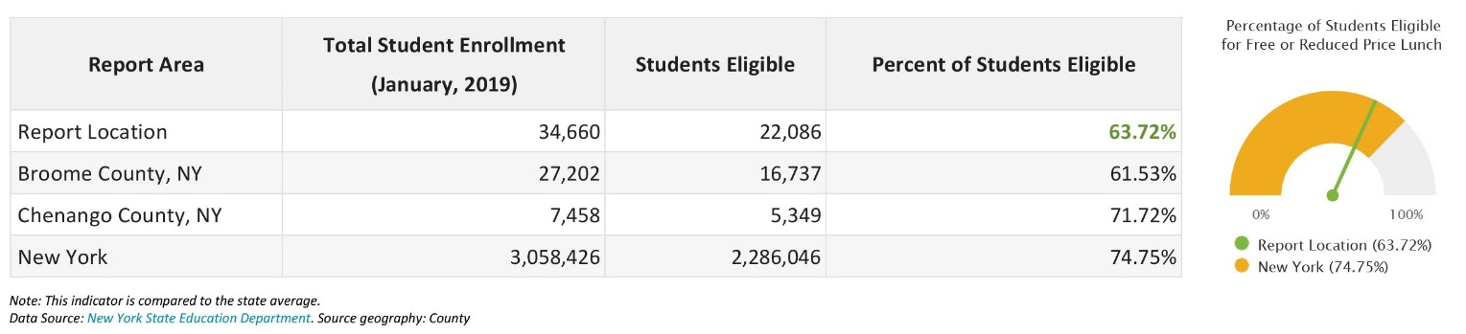

Free and Reduced Lunch Program
The table below shows the number of students eligible for the Free and Reduced Lunch Program during January, 2020. The figures below include all School Food Authority agencies. 63.72% of the students in the report area were eligible for free or reduced lunches, compared to a statewide rate of 74.75%.
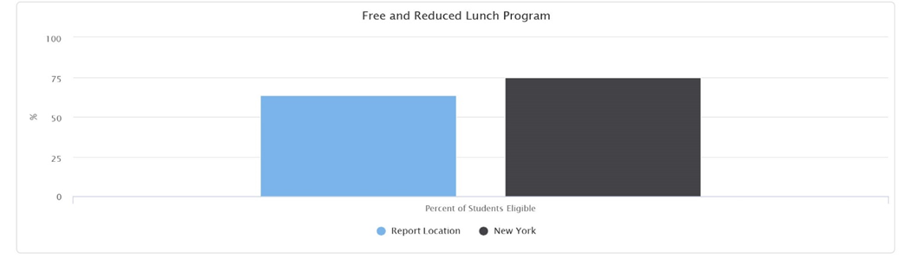
Supplemental Nutrition Assistance Program (SNAP) (formerly Food Stamp Program)
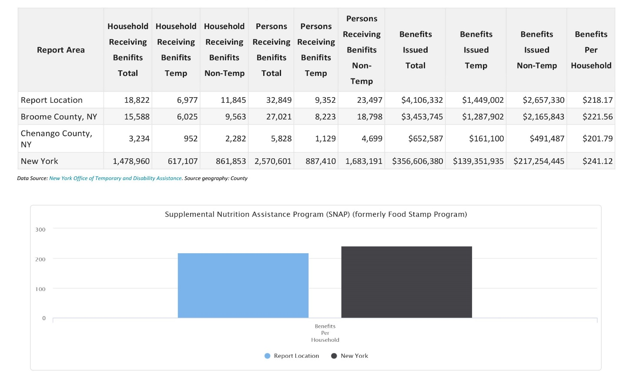
The number of persons receiving SNAP benefits and the total SNAP dollars issued per county in January 2019, within the report area is shown in below. The New York Office of Temporary and Disability Assistance reported that 18,822 households were receiving SNAP benefits totaling $4,106,332, or $218.17 per household. The amount of SNAP benefits has decreased from $276.89 to $218.17 over the last 10 years. The data listed is for January of each year.
Supplemental Nutrition Assistance Program (SNAP) Trend

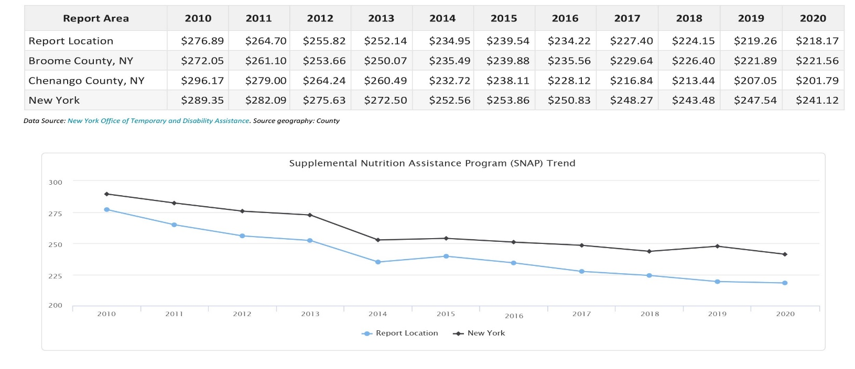
Below are trend amounts for Benefits per Household of the Supplemental Nutrition Assurance Program (SNAP) for the selected report area. The amount has decreased from $276.89 to $218.17 over the last 10 years. The data listed is for January of each year.

Supplemental Security Income
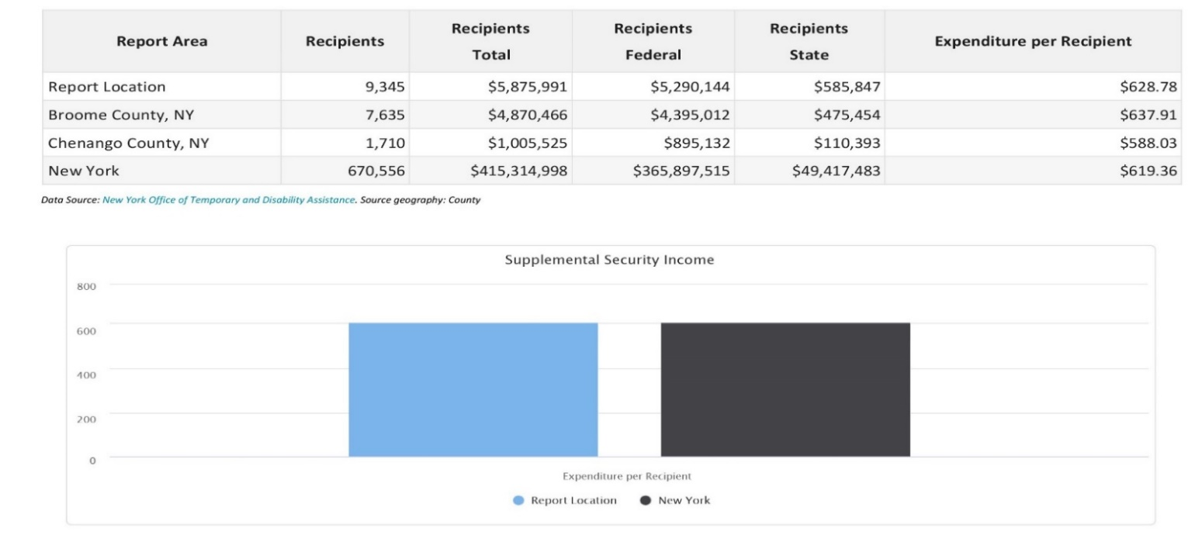
The below table shows the number of Supplemental Security Income recipients and expenditures by the state and federal governments issued per county in January 2020 for the report area. The report area average payment of $628.78 to each recipient is greater than the state average of $619.36 per recipient.
Supplemental Security Income Trend
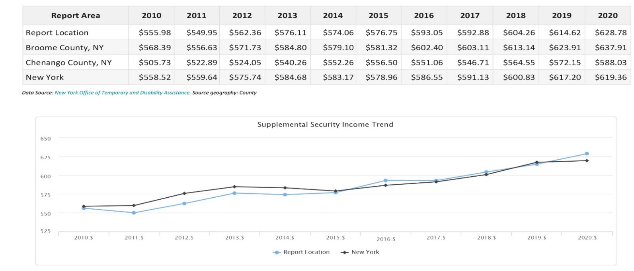
Below are trend amounts in Expenditures per Recipient of Supplemental Security Income for the selected report area. The amount has increased from $555.98 to $628.78 over the last 11 years. The data listed is for January of each year.

Family Assistance
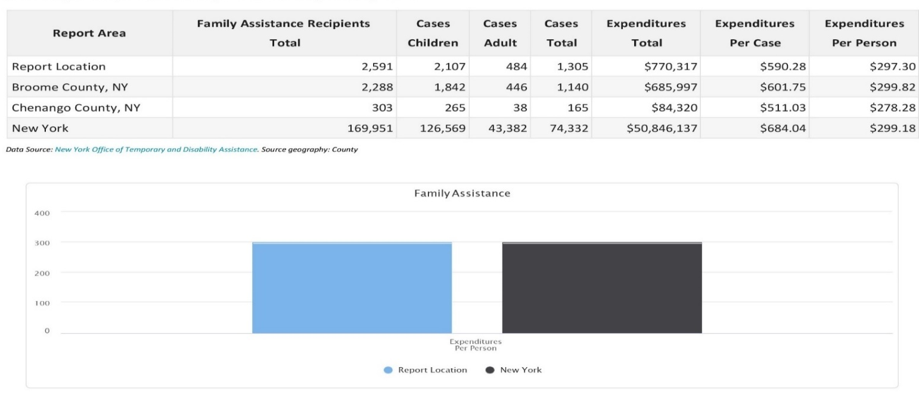
The number of persons receiving Family Assistance within the report area is shown in the table below. The New York Office of Temporary and Disability Assistance reported that 2,591 persons were receiving Family Assistance benefits at a cost of $770,317, or $297.30 per recipient, in the report area during January 2020.
Safety Net Assistance
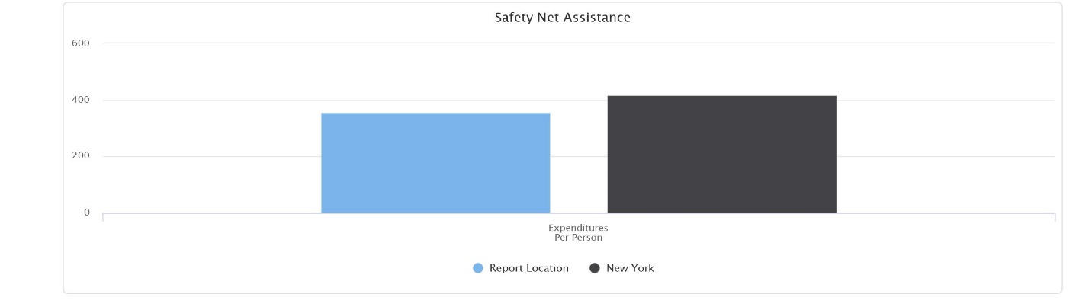
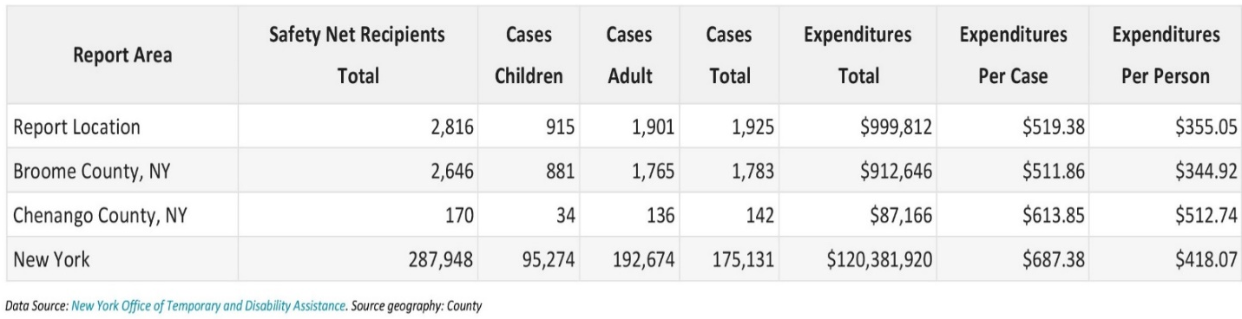
The number of persons receiving Safety Net Assistance within the report area is shown in the table below. The New York Office of Temporary and Disability Assistance reported that 2,816 persons were receiving Safety Net Assistance benefits at a cost of $999,812, or $355.05 per recipient, in the report area during January 2020.

Child Support Collections
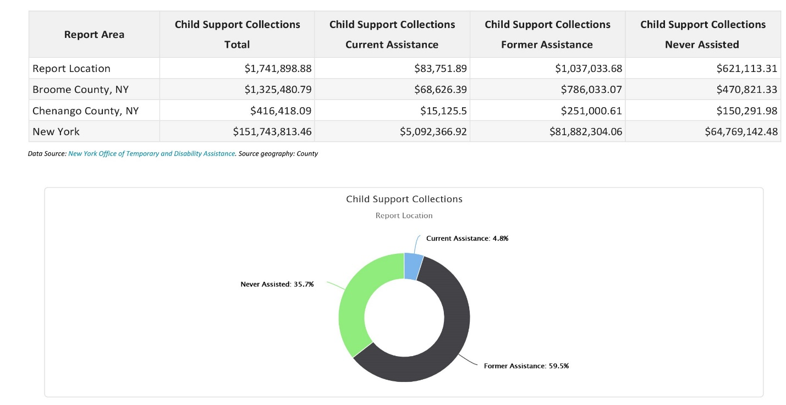
Child support collections for the report area are shown below. During January 2020, child support collections totaled $1,741,898.88.
Key Findings-Update 2023

The U. S. Department of Housing and Urban Development (HUD) defines Extremely Low Income (ELI) persons as one that earns less than 30% of the region’s median income. In Broome County and Chenango County, ELI individuals have an income of less than or equal to $17, 050 in Broome and Chenango for an individual and $30,000 for a family (4 individuals) in both counties. Based on average budgets, housing costs should not exceed 30% of income. Housing has become scarcer for those with little money. Earnings from employment and from benefits have not kept pace with the cost of housing and utilities for low-income and very low-income individuals. New York State Electric & Gas (NYSEG) has asked for substantial increases in recent years, which has made housing costs an even greater portion of a household budget. The Fair Market Rent (FMR), according to the 2023 HUD Fair Market Rents Schedule, for Broome County for a two-bedroom apartment is $964 a month, and $829 in Chenango, and a one bedroom is $758 in Broome and $696 per month in Chenango. In order to afford this level of rent, without paying more than 30% of income, a family must earn $38,500 per year and an individual must earn $28,250 respectively a year. Assuming a 40-hour work week, 52 weeks per year, this level of income translates into a housing wage of $13.58-$18.50 an hour. Although the New York State minimum wage is presently $15.00 an hour, this still falls $3.50 an hour short of the must have $18.50 an hour to meet the Fair Market Rents.

Traditionally, research has identified the opportunities for socioeconomic advancement in the form of employment opportunities and/or higher wages. Maintaining economic stability is becoming increasingly difficult, especially to those employed in the service or retail sectors. In both Broome and Chenango County, many are employed in either service and/or sales sector. The current unemployment rate in Broome County is 3.1% and 2.7% in Chenango County. Due to the COVID pandemic, many companies in both counties had to lay off a large percentage of their workforce, leaving many unemployed. The Department of Social Services reported that many applying for assistance is due to unemployment benefits ending, limited job availability, and people not having the education or skills to obtain employment. DSS continues to see people needing assistance with housing, food, and utilities. In 2022, there has been a trend, known as the “Great Resignation” on the part of workers, encouraged by a low unemployment rate, to quit less-desirable jobs and exercise much greater choice is regards when and where to work. Data shows that New York State ranks lowest or second-lowest among all states in job openings, hires, and quits and that New York’s pandemic jobs deficit is much greater than all other states. This demonstrates the individuals in our state are looking for work to the same degree they were before the COVID-19 Pandemic, but they are finding jobs in much smaller numbers. In turn, employers are in a hiring crisis as they have open positions, but cannot find individuals that either want positions offered or are unqualified for the positions.

Health Care

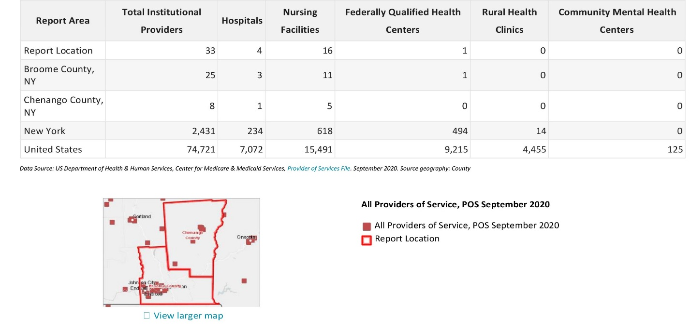
Medicare and Medicaid Providers

Total institutional Medicare and Medicaid providers, including hospitals, nursing facilities, federally qualified health centers, rural health clinics and community mental health centers for the report area are shown above. According to the U.S. Department of Health and Human Services, there were 33 active Medicare and Medicaid institutional service providers in the report area in the fourth quarter of 2019.

Persons Receiving Medicare
The total number of persons receiving Medicare is shown, broken down by number over 65 and number of disabled persons receiving Medicare for the report area. The U.S. Department of Health and Human Services reported that a total of 55,809 persons were receiving Medicare benefits in the report area in 2019. A large number of individuals in our society are aware that persons over 65 years of age receive Medicare; however, many of them are unaware that disabled persons also receive Medicare benefits. A total of 9,857 disabled persons in the report area received Medicare benefits in 2019.

Persons Receiving Medicaid
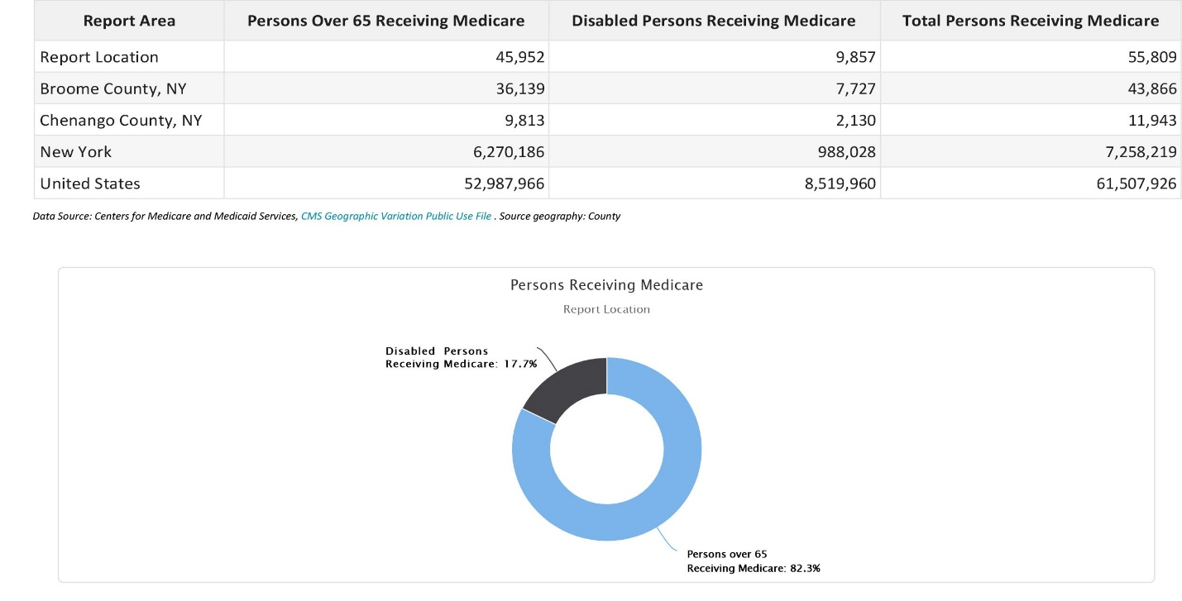
The average number of persons receiving Medicaid during 2014 is shown below for the report area. 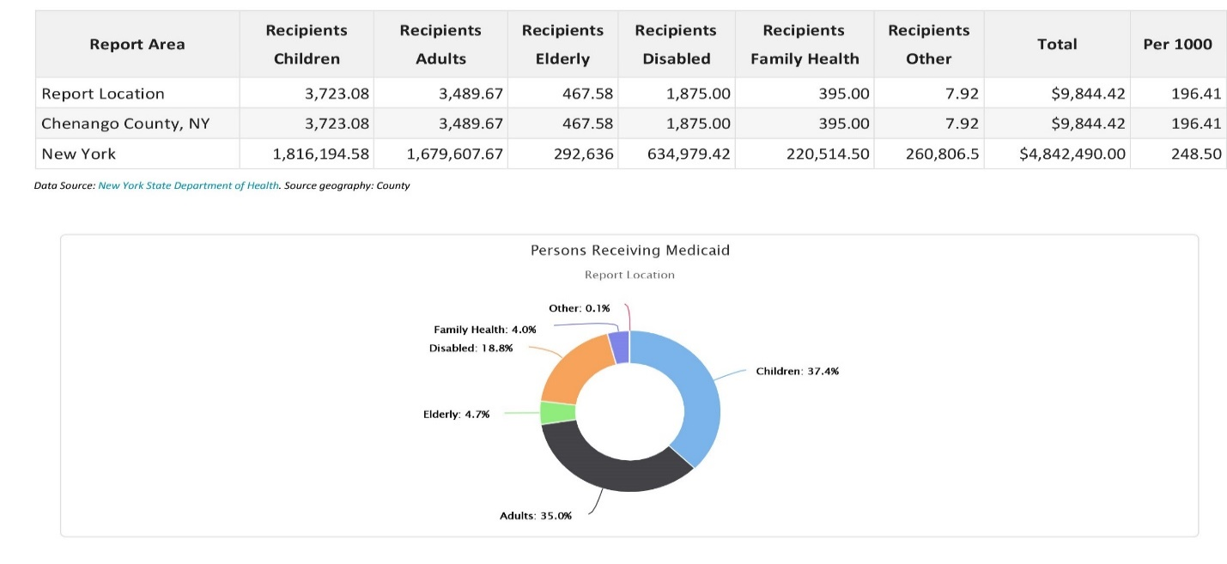
Child Health Plus
The table below shows the total enrollment for the New York Child Health Plus program for each September 2010 ‐ 2019. According to the New York Department of Health, there were 4,315 persons enrolled in the Child Health plus Program during September 2019. Between September 2010 and September 2019, enrollment decreased in the report area by ‐435 persons, or ‐9.2%.
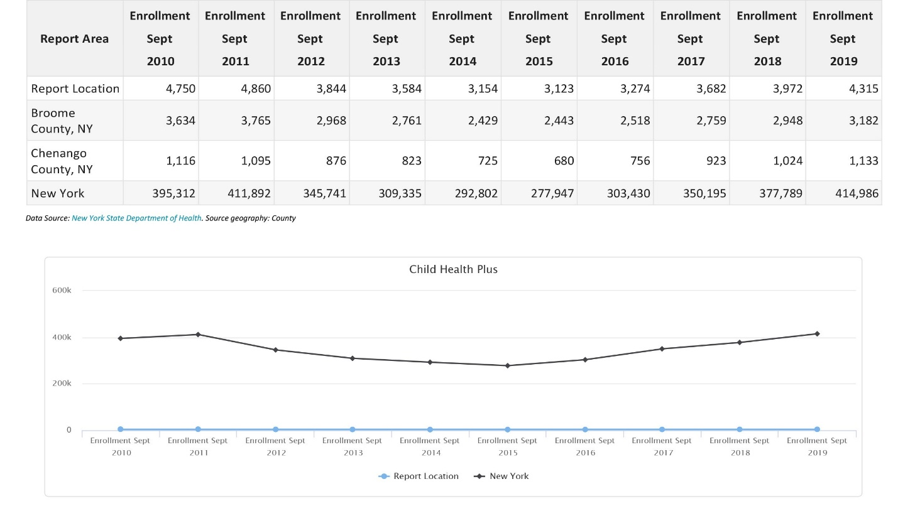

Uninsured Population

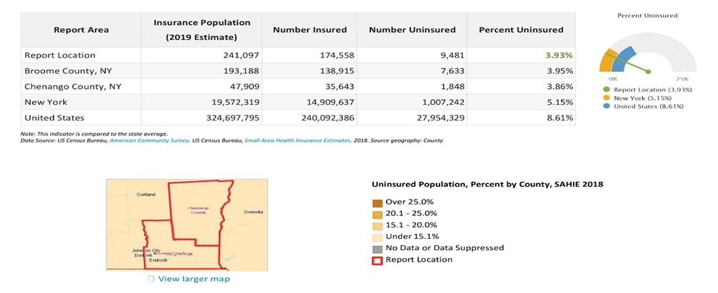
The uninsured population of 2019 is calculated by estimating the number of persons eligible for insurance (generally those under 65) minus the estimated number of insured persons.

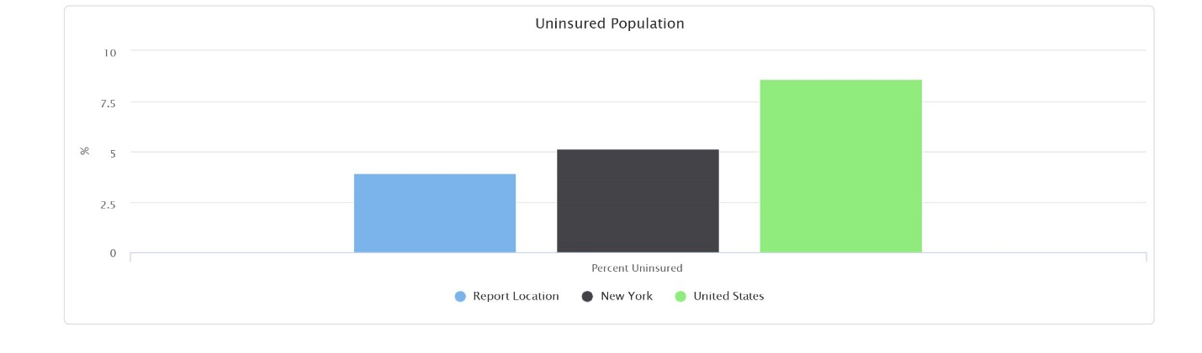
Prenatal Care

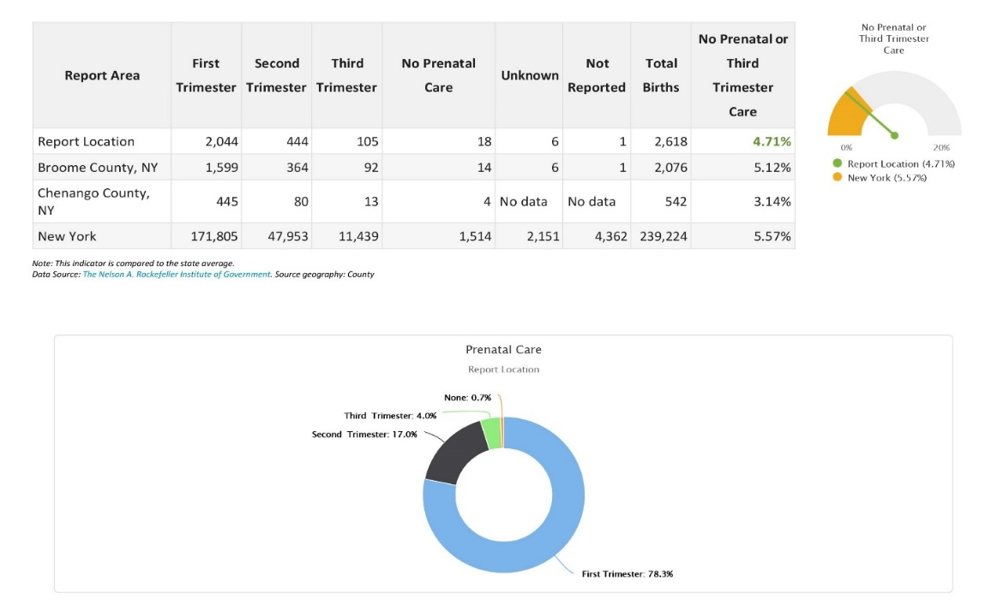
In 2017, a total of 18 women did not receive prenatal care in the report area. This figure indicates that 1% of pregnant women did not receive prenatal care during pregnancy.
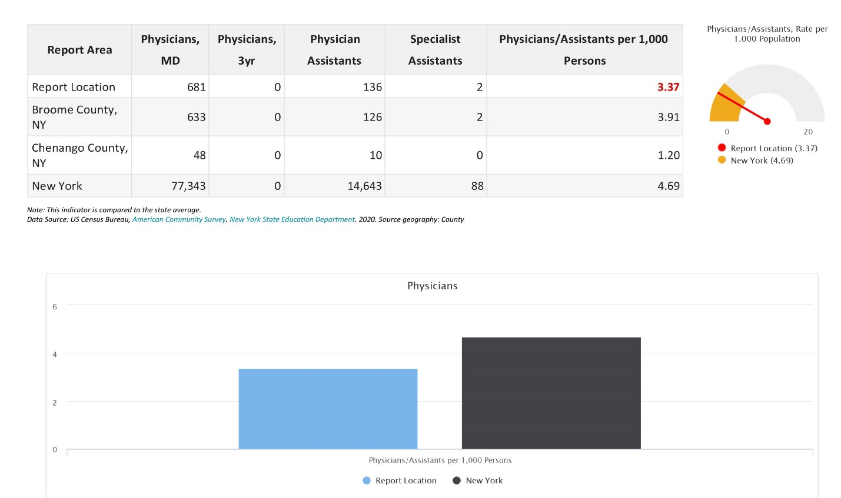
Teen Births
In 2017, there was a total of 135, or 5.48% of all births to women under the age of 20.

Physicians
The table below shows the number of Physicians, Physicians with 3‐year licenses, Physician assistants and Specialist assistants for the report area. There are 3.37 physicians per 1000 persons in the report area; the statewide average is 4.69 physicians per 1000 persons.

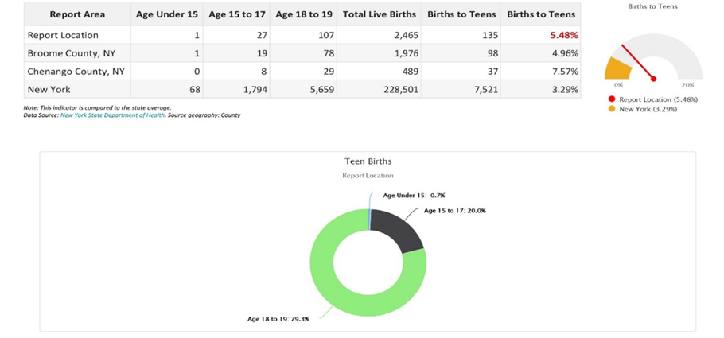

Dentists
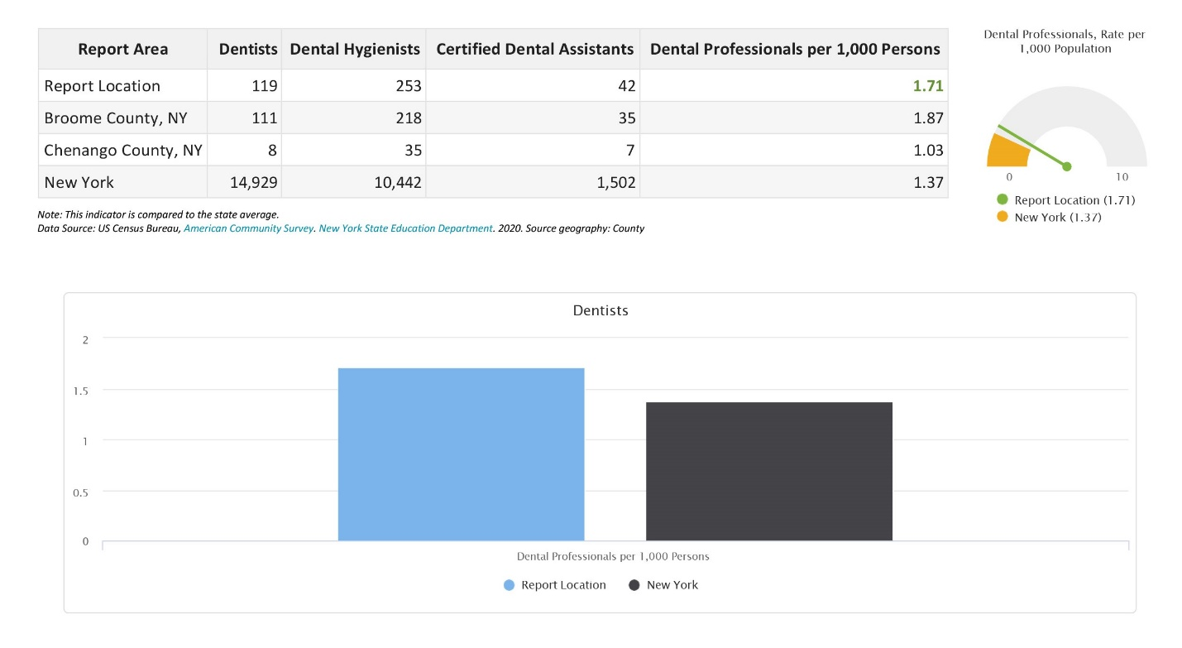
The table below shows the number of Dentists, Dental Hygienists and Certified Dental Assistants for the report area. There are 1.71 dental professionals per 1000 persons in the report area; the statewide average is 1.37 dental professionals per 1000 persons.

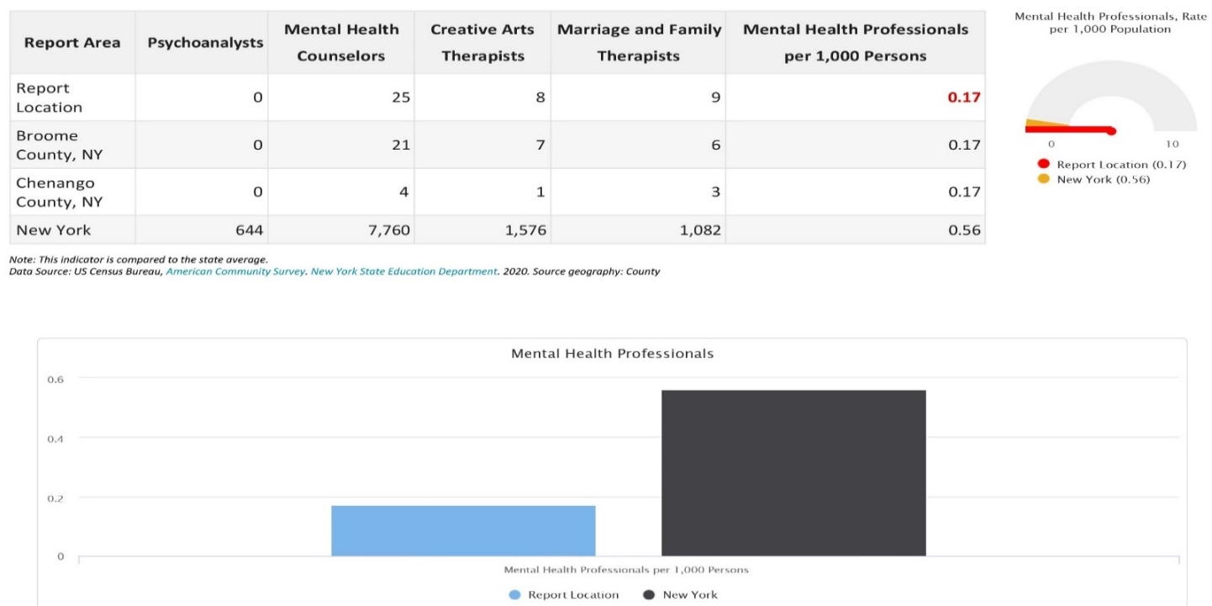
Mental Health Professionals
The table below shows the number of Mental Health Professionals for the report area. There are 0.17 mental health professionals per 1000 persons in the report area; the statewide average is 0.56 mental health professionals per 1000 persons.

Therapists
The below table shows the number of Physical, Occupational and Massage Therapists for the report area. There are 3.12 therapist professionals per 1000 persons in the report area; the statewide average is 2.82 therapist professionals per 1000 persons.
Special Health Professionals
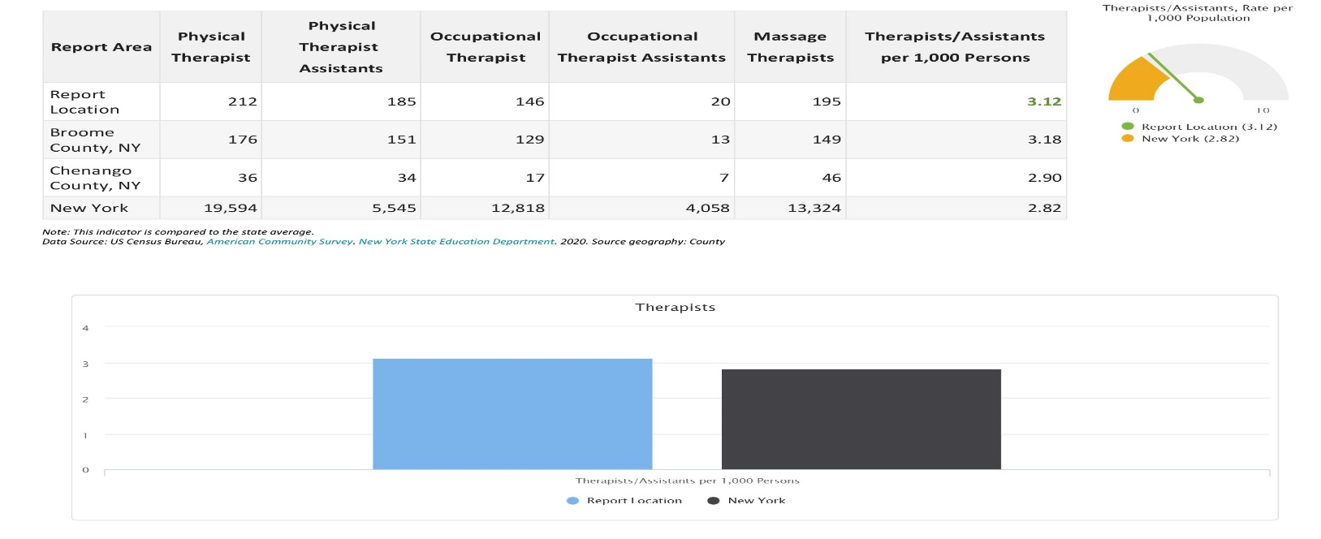
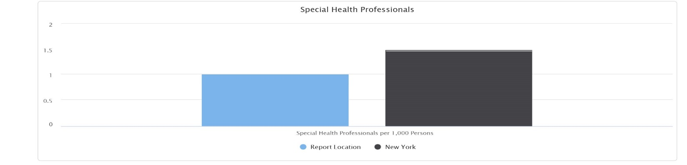
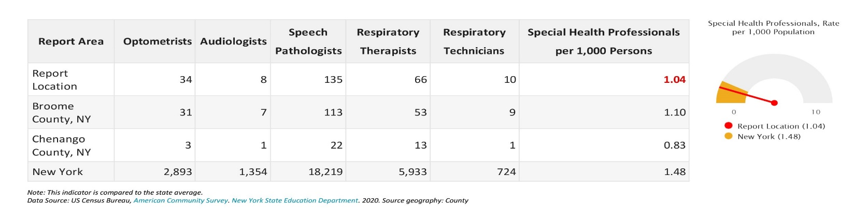
The below table shows the number of Optometrists, Audiologists, Speech Pathologists, Respiratory Therapists, and Respiratory Technicians for the report area. There are 1.04 special health professionals per 1000 persons in the report area; the statewide average is 1.48 special health professionals per 1000 persons.
Key Findings-Update 2023
When it comes to preventive care, less than 56% of Broome, and 48.5 % of Chenango, children in government sponsored health insurance programs have the recommended number of well child visits, compared with a 74.1% statewide rate. Broken out by age groups reported, 78.7% of children under 15 months, 75.7% between 3 and 6 years, and 52.7% age 12-21 received the recommended number of well visits is the service area. All of these figures are lower than statewide rates for the specified age groups, with the gap increasing for older children.
Broome and Chenango County children receive lead screenings at lower rates than peers throughout the state as well, however there has been improvement in the number of children being screened for lead, with the most significant improvements occurring in Chenango County. In 2019, New York State amended the Public Health to lower the definition of an elevated blood lead level in a child to 5 micrograms per deciliter (µg/dL) (previously 10 µg/dL), which has increased the number of children testing positive for lead. Among children born in 2015, 38.1% of children had at least two lead screenings by age 36 months, compared with a 57.3% statewide rate. Examination of trends shows substantial improvement of rates in lead screening among children (by age 36 months) with rates increasing from 31.7% in 2004 to 54.3% in 2013. However, there has been a decrease in the percentage of children receiving at least one screening by 36 months in recent years, decreasing from 67.1 in 2011 to 54.3 in 2013, and holding steady rates of about 38.0% for those receiving at least two screenings by 36 months. Simultaneously, the incidence of elevated blood lead levels among children under the age of 6 appears to be declining in most recent years, decreasing from 15.8 per 1,000 in 2015 to 7.9 per 1000 in 2016. Despite these gains, additional effort in the area of lead screening is needed to prevent lead exposure and identify children with high blood lead levels, especially when comparing Broome and Chenango County to the state of New York for the percentages of children receiving at least one or two blood lead tests by 36 months. (health.ny.gov, 2021)

Free and Reduced Lunch Program
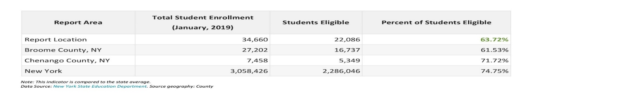
The table below shows the number of students eligible for the Free and Reduced Lunch Program during January, 2020. The figures below include all School Food Authority agencies. 63.72%% of the students in the report area were eligible for free or reduced lunches, compared to a statewide rate of 74.75%.
Free and Reduced Lunch Program by School
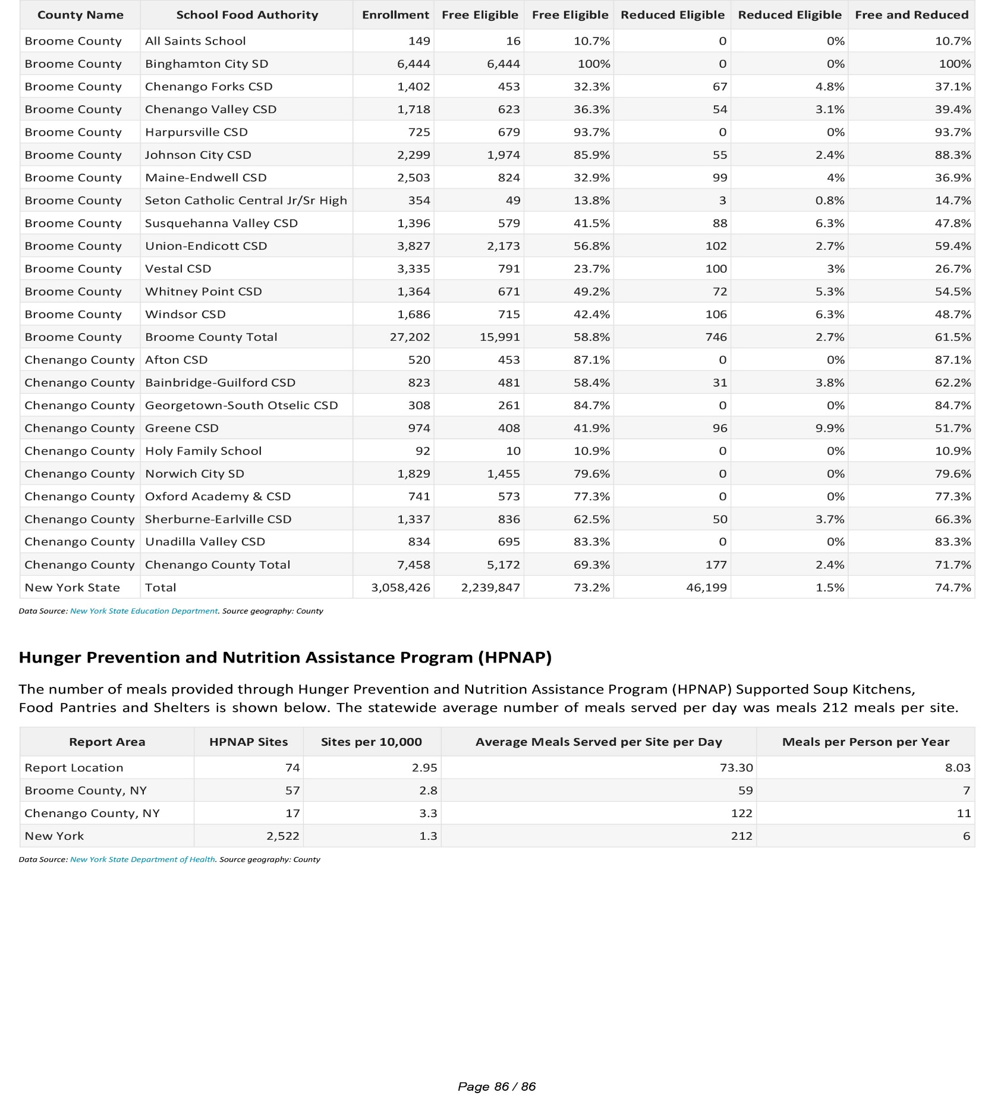
The table below shows the number of students eligible for the Free and Reduced Lunch Program during January, 2020. The figures below include all School Food Authority agencies, including public and non‐public.

Hunger Prevention and Nutrition Assistance Program (HPNAP)
The number of meals provided through Hunger Prevention and Nutrition Assistance Program (HPNAP) Supported Soup Kitchens, Food Pantries and Shelters is shown below. The statewide average number of meals served per day was meals 212 meals per site.
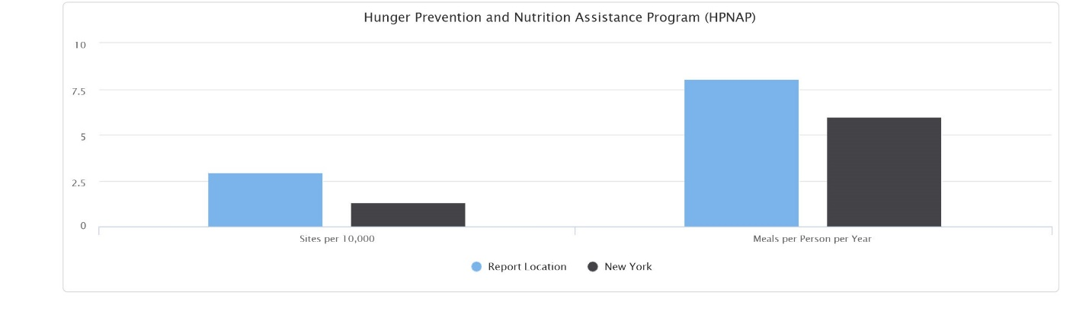
Persons Served by Soup Kitchens, Food Pantries and Shelters
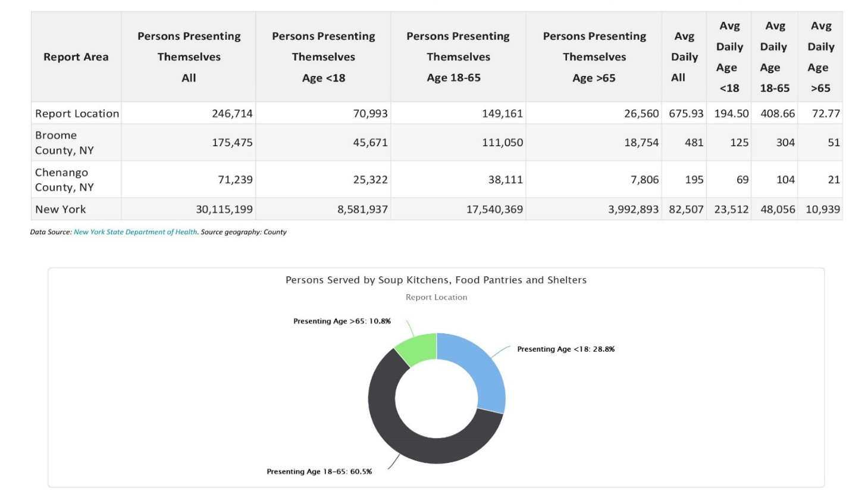
The number of persons being served at Hunger Prevention and Nutrition Assistance Program (HPNAP) Supported Soup Kitchens, Food Pantries and Shelters is shown in the table below. On average, the statewide number of people served per day was 82,507.

Supplemental Nutrition Assistance Program (SNAP) (formerly Food Stamp Program)

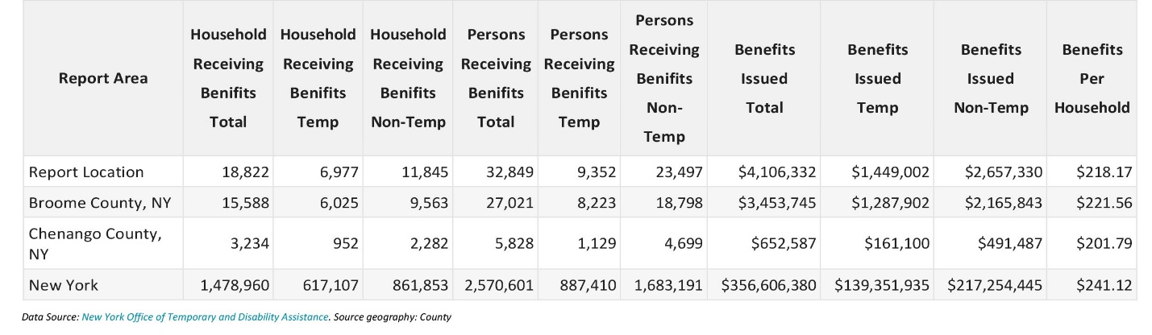
The number of persons receiving SNAP benefits and the total SNAP dollars issued per county in January 2019, within the report area is shown in below. The New York Office of Temporary and Disability Assistance reported that 18,822 households were receiving SNAP benefits totaling $4,106,332, or $218.17 per household.

Supplemental Nutrition Assistance Program (SNAP) Trend

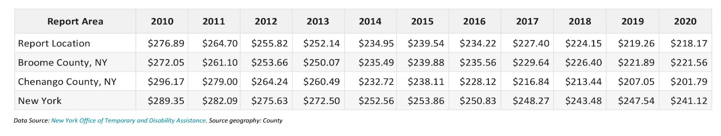
Below are trend amounts for Benefits per Household of the Supplemental Nutrition Assurance Program (SNAP) for the selected report area. The amount has decreased from $276.89 to $218.17 over the last 10 years. The data listed is for January of each year.

Households Receiving SNAP by Poverty Status (ACS)

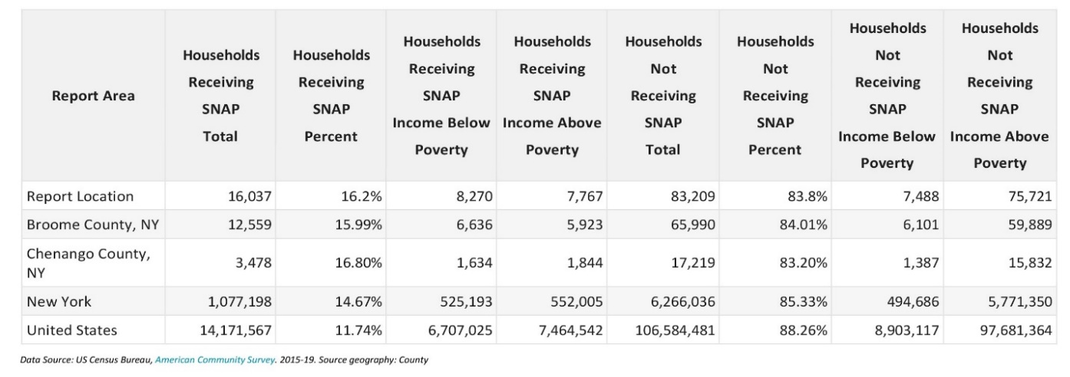
The below table shows that according to the American Community Survey (ACS), 16,037 households (or 16.2%) received SNAP payments during 2019. During this same period there were 7,488 households with income levels below the poverty level that were not receiving SNAP payments.
Key Findings-Updated 2023
There is evidence to suggest that consumption of fresh fruits and vegetables not only provides important macro- and micro-nutrients for good health, but also decreases the risk for certain types of cancers, cardiovascular disease, and stroke as well as overweight and obesity. The Dietary Guidelines for Americans 2020-2025 recommends balancing calories to manage weight, reducing/increasing specific foods and food components, and building healthy eating patterns. To manage body weight, the guidelines recommend controlling caloric intake, particularly for people who are overweight or obese, as well as increasing physical activity. Attention to healthy eating patterns at a young age can assist a person in maintaining a healthy nutritional pattern over time. The Expanded BRFSS data from 2013-2017 revealed only 31.9% of adults in NYS ate 1 or less servings of fruits and vegetables per day. This value was similar to NYS in which only 31.5% of adults consumed 1 or less servings of fruits and vegetables. Like physical activity, county-level data for nutrition among children and adolescents is currently lacking. The Youth Risk Behavior Surveillance System (YRBSS) provides one of the few sources of data about dietary intake for adolescents; however, this survey is conducted only every two years with limited information for specific localities. In 2017, 19.3% of students in grades 9 through 12 reported eating fruit or drinking 100% fruit juice 3 or more times per day, 32% reported 2 or more, and 60.8% reported one or more than once a day. Dietary consumption of fruits and vegetables as well as sugary drinks was similar across age groups and grade levels.

Given that forming healthy eating patterns early in life can affect one’s nutrition over the course of their life, highlights the importance of the Supplemental Nutrition Program for Women, Infants, and Children (WIC) provided by Greater Opportunities. WIC provides nutritious foods, nutrition education, breastfeeding support, and referrals to health care and social services for low-income families, and it plays a crucial role in improving lifetime health for women, their infants, and young children. In response to the COVID-19 pandemic, the Families First Coronavirus Response Act, enabled WIC services to be provided in new ways, including waving the requirement for physical presence for WIC certification. In addition, because many of the staple foods available to WIC participants were experiencing shortages during the pandemic, WIC expanded the approved foods for WIC families to include a broader array of package sizes and brands to ensure families had the needed food for proper health and nutrition. WIC also partnered with manufacturers and retailers to address disruptions to the supply chain, including most recently, the national shortage of baby formula that has occurred in 2022. Research has found that women who participate in WIC give birth to healthier babies who are more likely to survive infancy. With the improvements WIC has made to the food packages since 2009, data demonstrates that healthier food environments in low-income neighborhoods, as well as, better access to fruits, vegetables, and whole grains, provides better nutrition for all consumers regardless of whether they participate in WIC.

ALICE

ALICE Data
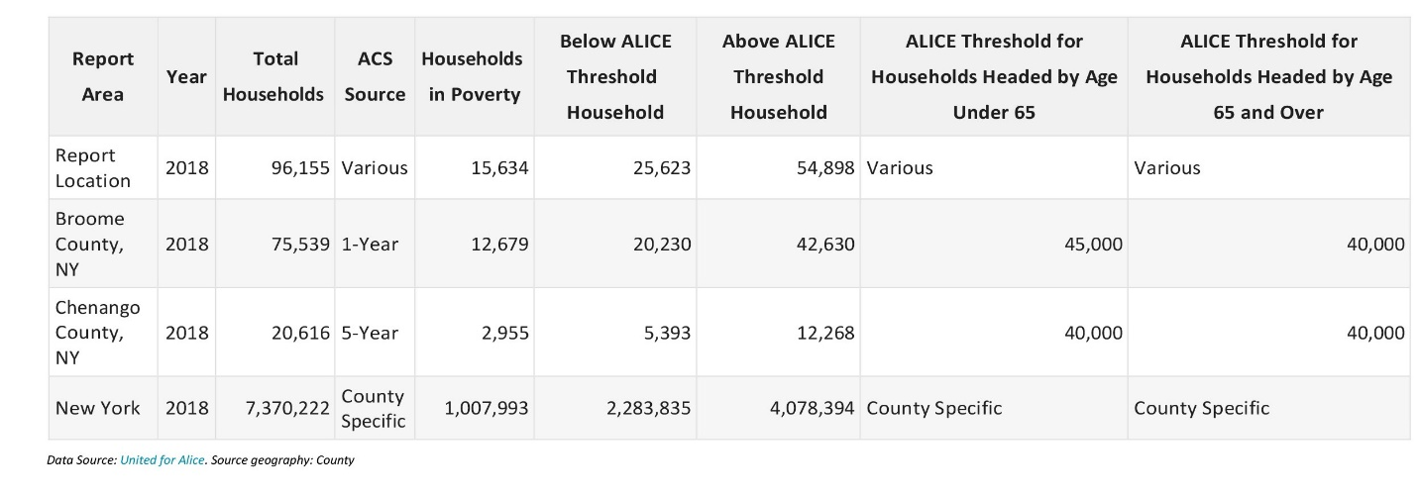
ALICE (Asset Limited, Income Constrained, and Employed) uses American Community Survey (ACS) data, and shows the gap between the Federal Poverty Level (FPL) and the actual amount of money needed to afford a bare‐bones household budget. The combination of households in poverty and ALICE households are deemed to be part of the ALICE Threshold. Depending on the county, ALICE uses 1, 3, or 5-year ACS estimates. For the most recent ALICE Report, data shows that of the 96,155 total households in the selected area, there are 15,634 households at the FPL, and 25,623 households that are above the FPL but still struggle to meet a minimum household budget.

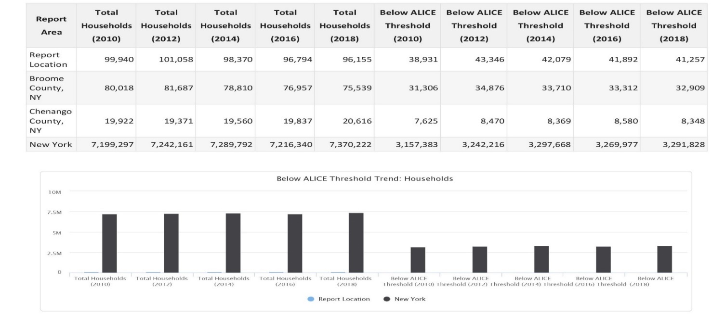
Below ALICE Threshold Trend: Households
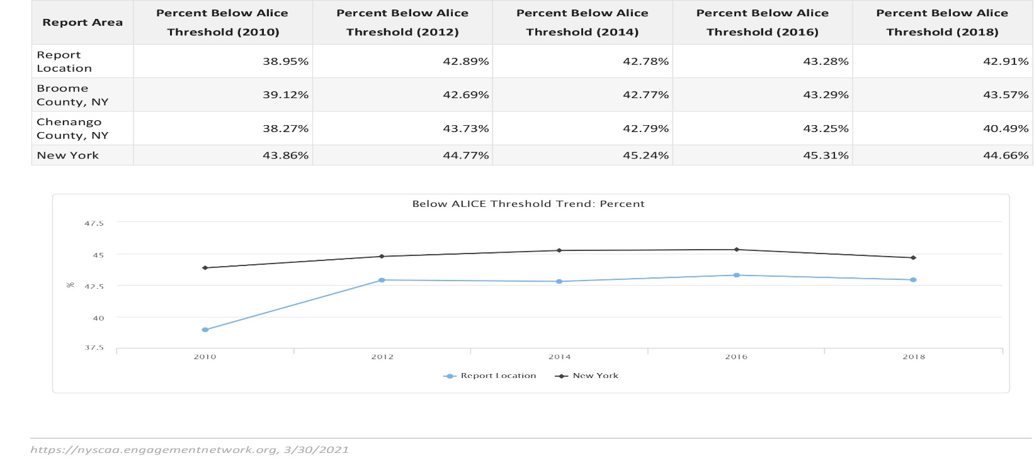
The combination of households under the Federal Poverty Limit (FPL) and ALICE households are deemed to be part of the ALICE Threshold. This indicator shows the number of ALICE Threshold households for the last five reported years.

Key Findings-Update 2023
Of those individuals working and living in New York State, 31% of the population is considered to be living at the ALICE threshold, which means that they earned gross income above the Federal Poverty Level, but less than the cost of living in their county. In Broome County, 25.8% of the population live below the ALICE threshold, with 27.0% of the population in Chenango County living below the ALICE threshold. Although both counties have a lower ALICE average than that of the state, the ALICE population is significantly higher than those living below the poverty level in both counties. Due to the fact that most of those living at the ALICE threshold have income above the Federal Poverty Level, they are most often disqualified from the social programs that could alleviate some of their financial stressors, such as rent assistance or SNAP benefits. Community action agencies, such as Greater Opportunities, provide many programs where the income qualification is at or below 100% of the Federal Poverty Level, which many of those living at the ALICE threshold would income qualify for. In addition, the programs are designed to assist individuals and families, whether it be financially, with counseling, or through a specific service, to become self-reliant and effective members of their communities.

Client Focus Groups-Update 2023

Greater Opportunities invited clientele from all program areas to participate in focus groups to gain qualitative information on their perception on the causes and conditions of poverty within their communities. Twenty clientele participated in the four focus group sessions offered and participants were from both Broome and Chenango Counties. Participants were from the following programs: Head Start, Early Head Start, Supportive Housing Programs, Housing Rehabilitation, and WIC. Focus groups participants were also asked to provide perspective on community conditions, including strengths and areas for improvement. Focus group participants were presented with the following questions and prompts for discussion:
Q1a: What are some things about our community that make it a great place to live?
Q2a: What have you noticed within our community that could use some improvement?
Q3a: With the things that we would like to see improved (as mentioned earlier) do you know people that are affected by these things/needs?
Q3b: How can families that have been affected by these things be supported?
Q4: Have you experienced any challenges in accessing any services in our community? (i.e. health care, addiction treatment)
Q5: How do you feel about the availability of safe and affordable housing, either to own or rent, in our community?
Q6: Is there anything you can think of that Greater Opportunities could do differently to serve you better in terms of creating the life you want for yourself?
Q7: What are the sources of strength that you draw on if challenges arise?

Summary of Themes:
- The community has assets that promote quality of life.

When asked about things that make our community “a great place to live,” participants mentioned access to resources to meet their needs, including churches, shopping, famer’s markets, fairs, local events, and a supportive community. The “rich history”, the “small town feeling” and the “walkability of the area” were all things identified as assets, saying that, “There are a lot of parks in our community and free events that are available and it is a good place to bring my children that does not cost anything..” Other things mentioned were schools and the variety of education options that are available, local law/fire departments, and resources for food and housing costs, especially with the current high cost of living following the pandemic. One participant stated, “I utilize the food pantries and local clothing banks to help reduce living costs for my family. For example, at the clothing bank I can fill a bag for $2.00 and they have clothing, books, and toys for adults and children. .” In addition, participants named farmers markets and local rivers as sources for recreation as assets in both counties.
- The community has areas that could use some improvement.
When asked about areas that needed to improve in the community the participants cited lack of access to services (i.e. medical, mental health/addiction services, etc.), homeless outreach services, lack of transportation, and response time of law enforcement as their top areas of concern. In regards to access resources, many participants noted concern over the lack of dental and vision care for Medicaid recipients Participants stated that they need to either travel outside of county to get services, which can be costly, or wait for several months on a waiting list in order to get services for their children and family members. Largely discussed by group participants was their concern over transportation resources in both Broome and Chenango. The biggest concerns being that transportation is limited, expensive and inconvenient. As stated by one participant, “Public transportation does not go to outlying areas. Many of the routes were condensed during the COVID-19 pandemic and were never reinstated. This creates a barrier to helping people access the resources they need and to get to a job on time.” Participants stated there are no options for those who live in the more rural areas which significantly limits access to a lot of services for them. It should be noted that transportation came up as an area of concern in several different conversations. For example, when talking about access to services, transportation was listed as a significant barrier in accessing services as the majority of providers are located in the cities, and not in the rural areas of the counties . Transportation also was an area of concern in regards to education and accessing Head Start services. One parent expressed concern about accessing local daycare for children not eligible for Head Start/ Early Head Start, especially with the high price of gas and on-going vehicle issues.
Several participants expressed concerns over the lack of behavioral health services in both counties, especially in the areas of mental health and addiction services. Participants noted that the pandemic only intensified the need for these services in both counties, as many of their loved ones were only able to attend services remotely, or not at all, which only. Participants also expressed concerns that because the number of clients seeking assistance far outweighs the number of providers available, individuals can wait months between their appointments with no support available to assist while they wait for the next appointment. Suggestions included more therapists to provide 1 to1 counseling, as well as decrease wait time for those seeking services, and an increase in the length of stay for those individuals requiring inpatient stays for substance abuse and mental health disorders. In reference to the housing programs, participants stated the need for more safe and affordable housing, transitional housing, supportive housing, and the need for better homeless services. Many participants noted that more homeless outreach was needed in both counties. Participants suggested that outreach workers need to go to the areas where those experiencing homelessness are, instead of having to go to service providers in order to access homeless services. Participants voiced the need for the development of more affordable housing with supportive services, specifically aimed at those individuals and families experiencing homelessness.
- When it comes to specialist medical providers, such as substance abuse treatment, community systems are inadequate.
Many of the focus group members discussed the extreme difficulty in accessing medical specialists, such as oncologists, gastroenterologists, and dentists. Focus group members from both counties expressed the difficulty in finding a dentist that accepts Medicaid and that often, they are forced to drive a minimum of an hour in order to get dental services. In addition, they spoke about having limited medical specialists, especially in Chenango County, and having to go to another county in order to receive medical care for a specific condition. Many discussed the extra expense this causes, especially when on a limited income. Participants were vocal in describing the difficulties experienced when trying to in access substance abuse treatment services. One participant stated, “There’s not a lot of local programs in our area.” One participant suggested having a centralized access point for medical and mental health services, where an individual can receive real time information that is specific to a person’s situation. One participant stated, “Wait times to seek mental health support are exorbitant and each time you see somebody different. There is no continuity of care.” Other participants discussed how insurance can serve as a barrier to accessing services. For example, One participant stated, “Insurance only covers certain psychiatrists and it is hard to get to them . You don’t get to pick who you want and who you feel comfortable with. For example, one participant said, “People reach out for treatment and cannot find any, who are they supposed to call?” Participants discussed their own experiences, as well as family members, with the challenges they faced in accessing needed services. Many participants expressed the need of more information disseminated in the counties about available resources and how to access them.
- Mental health services in our community are lacking overall, specifically for adolescents.
A major theme that was present in all focus groups was the lack of mental services available in Broome and Chenango Counties. Participants felt that there are a lack of male professionals in the mental health field, which can make it difficult for males to find an appropriate therapist if they are not comfortable with a female therapist. Focus group participants also discussed their struggles with obtaining an appointment at the mental health organizations that are currently available in each county, with many stated that they had to wait months before getting an initial appointment. This problem was only further exacerbated by the COVID-19 pandemic as appointments were being conducted virtually, which made it very difficult for those in rural areas that have limited internet access. Participants expressed that a better system needs to be developed to support children’s social-emotional development and behavioral health. Many expressed concerns that there were not enough mental health services for children in the area, saying variations on the statement, “There’s definitely not enough; there is a wait list for any kind of service.”

- Lack of safe and affordable housing in our community.
With regard to thoughts on safe and affordable housing, the focus groups felt that although there are few options available in the area overall, as there is not enough affordable housing to choose from and very often the ones that are affordable, have a very long waiting list. Participants also noted the specific need for affordable rental units for larger families. Throughout this discussion, many participants expressed the need for resources in regards to housing, such as landlord lists, HUD approved units available in the area, tenant rights, and eviction laws. For example, one participant stated, “ People are not aware of what apartments are HUD approved. A lot of places do not accept HUD because the landlord does not want to deal with the required inspections. Although you can find apartments through the Pennysaver, and online services, things fall apartment once the landlord is contacted and knows you have Section 8. There is a lot of time spent with no results.” Some participants suggested that the counties should offer incentive programs for landlords that are “good landlords,” and maintaining their units.
Participants noted that following the pandemic and the eviction moratorium put into place in New York State, landlords are very reluctant to rent to individuals and families that have Section 8 or DSS vouchers. Others expressed concern over the fact that rent has become so high, that individuals and families are spending all of their income on rent and cannot afford anything else. In addition, some participants expressed that individuals are settling for units they can afford, even if that unit is in disrepair or overcrowded. Focus group participants that currently reside in our supportive housing programs stated that they would like to have more activities in regards to budgeting and financial literacy. One participant stated, ”Saving money can be a struggle when you have little leftover to save. I need to learn how to budget so that I can stop living pay check to paycheck, and possibly buy my own home.”
- Sources of strength focus group participants draw on in the face of challenges.
The group had a clear understanding of the definition of personal resilience in response to this question. Participants described strength in their support systems, including prayer, social connections such as neighbors, church, community programs, family and other social supports. For example, one participant offered, “I would be homeless without Greater Opportunities. You saved me. I felt completely supported throughout the processes.” Talking further about these topics another participant added, “I have to change my thought process at times. I’ve found that sometimes, you need to realize that things could be “worse,” and be okay with the way things are.” Throughout the course of the discussion, participants expressed gratitude for Greater Opportunities and the services/role they played in changing their lives for the better. About Housing Programs in particular, participants described the support they receive that goes beyond the housing they receive. Representative comments include, “Even through your workers are busy, they always help us.,” We would not survive on our income without Greater Opportunities. Other housing options are not affordable or you have to deal with slumlords,” and “Greater Opportunities gave me a place to call home.” More than one participant shared the suggestion that they would like to have more programming options from Greater Opportunities to provide classes and training on how to obtain gainful employment in the community, budgeting, and informational pamphlets about other available resources within the community.

Needs of Low-Income Individuals, Children and Families: Client Surveys-Updated 2023

This section of the report summarizes the quantitative and qualitative data collected through surveys from program participants involved with Greater Opportunities programs. In addition, it presents qualitative data collected from other Greater Opportunities stakeholders (that do not participate in programs) who responded to surveys. There were a total of 202 clientele that participated in the survey.
Question 1: Community Ratings
Respondents rated the community on aspects of quality of life as “Succeeding (A)”; “Doing OK (B-C), or “Failing (D-F)”. The chart below shows the distribution of “grades” given. Pluralities, (in most cases, majorities) of respondents rated the community as “Doing OK” on most aspects of quality of life.

Question 2: Which conditions are impacting individuals and families the most?

The survey asked respondents to select from a list of conditions they think affect individuals and families the most. The following chart shows the most frequently selected choices.

Question 3: What programs could Greater Opportunities offer that would help improve the community?

An open-ended question asked respondents to describe the programs that they would want to see offered by Greater Opportunities in order to improve the community. Of those surveyed, many answered that would like to see Greater Opportunities continue to offer safe and affordable housing, especially for low-income seniors and those experiencing homelessness. Several respondents indicated that other housing in the area is “unaffordable,” “unsafe,” or “blighted.” One respondent stated that “Greater Opportunities builds good housing and we need more of that in the area.” Respondents also indicated a need for the agency to do more networking and collaborations with other social service agencies in order to provide more comprehensive services. Respondents also identified a need for more housing rehabilitation and first-time homebuyer grants in both Broome and Chenango County.
Respondents identified challenges primarily in the area of money, or jobs, offering comments such as, “Cost of Living;” “Financial Stability,” “Day to day and monthly costs of living,” “Budgeting,” and “Savings.” Related challenges reported included transportation and child care, expressed in comments such as, “Offer care for younger children, infants and toddlers, such as Early Head start;” “Afterschool care for children that are school-aged.,” “Transportation,” and, “Child care that is affordable.”
Respondents from Head Start and Early Head Start programs stated that they would like to see more center-based programs along with more home visitors. Other respondents asked for extended hours for non-traditional workers and for the school year to extend into the summer months. Some participants also asked for Early Head Start programming in Broome County. In addition, those respondents that were parents to Head Start or Early Head Start would like to see a return of parents being allowed back in the classrooms.

Needs of Low-Income Individuals, Children and Families: Stakeholder Survey

Forty-Seven (47) of Greater Opportunities stakeholders who are not Greater Opportunities program participants responded to a survey to rate aspects of community life, rank conditions facing individuals, and describe their challenges and the strengths they draw on to address them. The sector the respondents represent are as follows: Community Partners, Community-Based Organizations, Faith-Based Organization, Educational Institutions, Public Sector, and other community members.

Question 2: Which conditions are impacting individuals and families the most?
The survey asked stakeholders to select from a list of conditions they think affect individuals and families the most. The following chart shows the most frequently selected choices.

Client Satisfaction Surveys

There were 240 Greater Opportunities customers who completed the client satisfaction surveys. Data from these surveys is summarized below.
Question 1: What need brought you to Greater Opportunities?

Question 2: For each program used at Greater Opportunities, how did the program meet your needs?

Question 3: For the program you used, did the program meet your immediate need, prevent future problems, or help with your/your family’s well-being and success?

Question 4: How satisfied were you with the quality of the service you received?

Question 5: How satisfied were you with the way you were treated by Greater Opportunities personnel?

Question 6: How satisfied were you with the ease of working with Greater Opportunities programs?

Question 7: How can Greater Opportunities improve its services?
Open-ended responses included:
- “in my opinion, you all go above and beyond for people so I believe you are doing everything just right.”
- “better/more options to help homeless”
- “more advertising and information on services that are offered.”
- “raise salaries”
- “nothing - their amazing”
- “care for younger children”
- “Helped so much with my family when it was needed the most”
- “more people working there to help”
- “Nothing - you already go above and beyond.”
- “I never had any issues”
- “My youngest babies have nowhere to go”
- “no waiting lists”
- “have a playground”
- “I loved my experience. The teachers and family advocate are very nice and helped with any obstacles they can. They provide a lot of support.”
- “get busing”
- “increase income levels”
- “Thank you for help. I really need help with feeding my kids. Staff at WIC are very nice.”
- “offer job training”
- “There is so much paperwork required.”
- “Be able to accept more kids into the school, instead of being on a waiting list. Also having a school bus to pick kids up because of parents or grandparents working.”
- “Bring back transportation for those who struggle to get their child to school based Headstart everyday.”
- “Pay the teachers and other workers fairly. Make the pay the same across the board for each position no matter what center they are working at”
- “affordable housing in neighboring areas to Binghamton”
- “Get more affordable housing and create affordable day care.”
- “longer days for children”
- “have the same teacher everyday in the class”
- “Updating painting and appliances for long term tenants. I have lived in my apartment for 15 years. It has the same appliances, carpeting, and has never been repainted.”
- “2 year old classroom”
- “smaller classes”
- “More answers and assistance through home visits”
- “More staff to help the kids. My child always comes home happy.”
- “More public awareness of available programs. Classes for younger children.”
- “classes for kids under 3”
- “Get more secure staff. Sadly, they're left short staffed more often than they should be.”
- “Bigger classrooms so more kids can enjoy it”
- “More housing for seniors.”
- “More staff to have more appointments available”

Social Security Administration 2021 https://www.ssa.gov/policy/docs/statcomps/ssi_sc/2019/ny.pdf
U.S Census Bureau (online) 2019 www. census.gov
Center for Community Futures,” Analyzing the Causes and Conditions of Poverty,” Masters and Stansbury, 2017.
www.nlihc.org (online) 2019
Center for Community Futures,” Analyzing the Causes and Conditions of Poverty,” Masters and Stansbury, 2017.
Center on Budget and policy Procedures (online) 2021 www.cbpp.org/research/poverty-and-inequality/tracking-the-covid-19-recessions-effects-on-food-housing-and resources
Scharte, M. & Bolte, G.” Increased health risks of children with single mother: Impact of socio-economic and environmental factors” European Journal of Public Health 2012
https://reliefweb.int: Elderly people are among the most physically and financially vulnerable to COVID-19, but their needs are too often ignored. 2020 9 https://www.osc.state.ny.us/reports/new-yorkers-need-look-poverty-trends-new-york-state-last-decade: New Yorkers in Need: A Look at Poverty Trends in New York State for the Last Decade December 2022
https://crsreports.congress.gov Unemployment Rates During the COVID-19 Pandemic. 2021
http://www.centernyc.org ¹¹ https://www.osc.state.ny.us/reports/new-yorks-labor-force-assessing-10-year-trends-and-pandemic-setbacks
13 https://www.nytimes.com A Simple Equation: More Education = More Income 2021
13 12 Office for Civil Rights Education in a Pandemic: The Disparate Impacts of COVID-19 on America’s Students 2021
(Consumer Financial Protection Bureau, 2021)
https://www.thrivent.com/insights/budgeting-saving/3-ways-the-pandemic-is-changing-homebuying
http://www.centernyc.org
https//: www.health.ny.gov 2021
Broome County Department of Health Community Wide Health Assessment 2019-2024
https://stateofchildhoodobesity.org/stories/how-wic-has-changed-during-the-covid-19-pandemic/
https://www.cbpp.org; wic-works-addressing-the-nutrition-and-health-needs-of-low-income-families 2021

