
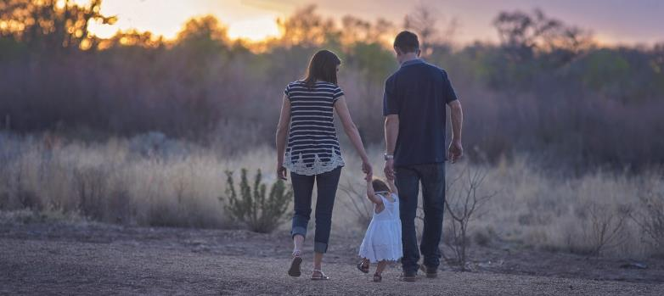
2019 Update to the 2018 Community Needs Assessment
June 30, 2019

TABLE OF CONTENTS
Executive Summary 1
State of the Grantee 3
Methodology 4
Service Area Profile 4
Report Area 4
Population 5
Education 9
Employment, Income and Poverty 11
Health, Disability and Nutrition 15
Social Services 25
Early Education Need and Capacity 28
Child Care Need Among Head Start Families 28
Other Child Care Programs Serving Young Children 29
Needs of Low-income Individuals, Children and Families: Perceived 32
Head Start Parent Survey Data 32
Head Start Parent Focus Group Summary 40
OFB Community Stakeholder Survey 43
Opportunities for Broome CSBG Customer Survey 46
CSBG Customer Focus Group Summary 50
Needs of Low-income Individuals, Children and Families: Observed in Program Data 54
Population Demographics 54
Education 54
Employment, Income, Poverty 54
Health, Disability and Nutrition 55
Social Services 56
Findings On the Causes & Conditions of Poverty, and Recommendations 58
Resources in the Community to Address Identified Needs 61
Appendices 67
Appendix I: Matrix of Perceived and Observed Conditions 67

Executive Summary
This report summarizes a quantitative and qualitative exploration of the causes and conditions of poverty in Broome County, New York. The research reveals the complexity of how community health, safety and economic opportunity interconnect with the ability of low-income people to achieve stability and economic security. It substantiates the interdependence of these two national Community Action goals. The report also contains important insight about the community assets valued by stakeholders, and customer sources of personal strength and resilience. A careful review and interpretation of the data collected for the report produced the following findings and recommendations.
Finding 1: In affected communities, the sale and abuse of illegal drugs has created unsafe and unsupportive environments that constrain the efforts of low income people to achieve stability and economic security.
Recommendations for Finding 1:
- Prioritize safe (low crime, low drug-trade) neighborhoods for any expansion of affordable housing options; consider suburban or rural towns.
- Create and sustain an unrestricted fund to assist individuals and families with the cost of large trash disposal, moving, and purchasing new furniture.
- Program leaders should fully engage in community-wide substance abuse prevention initiatives and efforts.
Finding 2: Mental and behavioral health conditions affect OFB customers and the general population at comparatively unfavorable rates and are identified as a concern by stakeholders, while access to formal mental health services in the county is limited. When individuals face challenges or don’t feel valued, they access personal resilience and trusted support for their emotional well-being.
Recommendations for Finding 2:
- Continue efforts to teach and develop social-emotional competencies in young children and their caregivers using Pyramid Model techniques.
- Work with community partners to improve access to mental health treatment using peer advocates, paraprofessionals and other innovative means to support emotional well-being and treatment compliance.
- Explore models for transforming OFB programs into trauma-informed services.
- Raise community and customer awareness about the effects of trauma through ACEs trainings and movie screenings of Resilience: The Biology of Stress and the Science of Hope
- Formalize emotional supports for OFB customers by installing a trauma-focused caseworker, organizing customer support groups, and offering customer self-care learning opportunities
- With customer co-leadership, create opportunities for OFB customers to demonstrate their value within the community, such as through volunteerism

Finding 3: The cost and limited availability of high quality child care prohibits parents from working, which in turn limits economic opportunity and family income.
Recommendations for Finding 3:
- Expand to a Birth-to-Five Head Start model by securing funding to serve children under age three in center-based programs. In addition to the early childhood development benefits to children, this will have the effect of alleviating part of the cost of child care for parents and freeing up hours when they can work.
- Explore adding a summer program option to relieve the child care cost burden for participating families.
- Explore using child care subsidy dollars to support wrap-around care at Head Start to relieve child care cost burdens for participating families.
- Connect employed parents in the program with Workforce Development programs that build skills for higher paying jobs

State of the Grantee
OFB Head Start began in 1981 as one of a number of anti-poverty programs under the CAP of Opportunities for Broome, Inc. (OFB). At that time, OFB Head Start operated two classrooms in the basement of an Endicott church. Today OFB Head Start operates 12 classes in six Head Start centers located in Chenango Valley, Harpursville, Endicott, Whitney Point and Windsor. The service area includes the school districts of Chenango Forks, Chenango Valley, Deposit, Harpursville, Maine-Endwell, Union-Endicott, Vestal, Whitney Point, and Windsor in Broome County, New York. OFB Head Start currently works in partnership with Union-Endicott and Whitney Point school districts to provide UPK services to 89 children. Currently, the program is funded to serve 178 children while an estimated 952 children aged three and four in the service area are eligible for Head Start. OFB is not funded to offer Early Head Start at this time, while an estimated 1,394 children under age three in the service area would be eligible for the program.
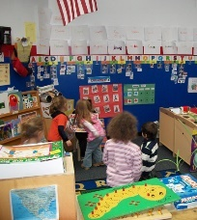
Opportunities for Broome, Inc. (OFB) was incorporated in 1967 and was designated as Broome County’s official Community Action Agency. OFB receives seed-funding from the federal Community Services Block Grant (CSBG). The New York State Department of State is the officially designated state agency responsible for the implementation of the Community Services Block Grant (CSBG) programs. Opportunities for Broome, Inc., through the Department of State, receives a Federal allocation and uses these funds to carry out its mission consistent with the following national goals:
- Goal 1: Individuals and Families with low incomes are stable and achieve economic security
- Goal 2: Communities where people with low incomes live are healthy and offer economic opportunity
- Goal 3: People with low incomes are engaged and active in building opportunities in communities.
Opportunities for Broome, Inc. currently serves all of Broome County and provides numerous services to the community through the following departments:
- Family Development Programs
- Emergency Assistance
- Housing Services
- Early Childhood Services

Methodology
Opportunities for Broome (OFB) worked with Pro Action of Steuben and Yates, Inc. (Pro Action), a fellow Community Action Agency, to conduct a full Community Assessment in 2018, encompassing the overall agency community assessment and the Head Start grantee community assessment. This updated report was developed in 2019.
For the updated report, the primary data gathering phase included surveys distributed to clients of both the Head Start program and OFB’s housing and emergency services program, as well as community stakeholders representing community-based, faith based, private sector, public sector and educational organizations. In addition, focus groups were held with OFB clients and OFB Head Start parents. Through these methods, the study explored stakeholder perceptions about the health of the community, the performance of its institutions, and the conditions most affecting its residents of all ages. In addition, the study probed both through surveys and focus groups to produce insight about community assets and protective factors that can be brought to bear on community challenges. The insight from these surveys and focus groups is presented in this report’s section entitled Needs of Low-income Individuals, Children and Families: Perceived.
The secondary data gathering phase included updating “observed” data from sources such as the U.S. Census Bureau, Bureau of Labor Statistics, New York State Department of Health, New York State Department of Temporary and Disability Assistance and others. Most of this type of secondary data is presented in the Service Area Data section of this assessment. In addition, data from OFB Head Start’s PIR Summary Reports from 2017-2018, 2016-2017 and 2014-2015 is compiled within the report as observed data in the sections entitled Early Education Need and Capacity and Needs of Head Start Eligible Children and their Families: Observed in Program Data.
From this primary and secondary data, Pro Action developed a matrix of perceived and observed conditions (Appendix I). Those issues emerging as both a perceived need among community and customer stakeholders, and an observed need in the general and Head Start populations warranted findings. The report presents findings and recommendations in the section of the assessment entitled Findings on the Causes & Conditions of Poverty, and Recommendations.

Service Area Profile

Report Area
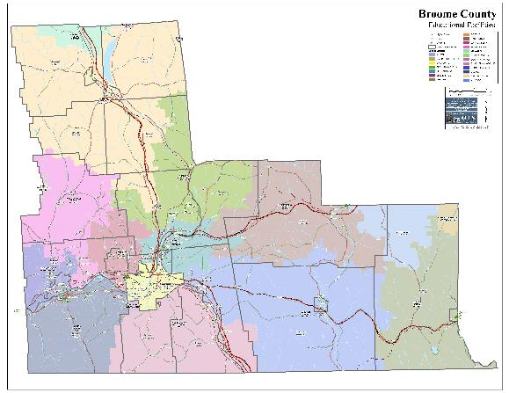
The report area is Broome County. Opportunities for Broome (OFB) serves the entire county, encompassing 716 square miles of land area. OFB Head Start serves the school districts of Chenango Forks, Chenango Valley, Deposit, Harpursville, Maine-Endwell, Union-Endicott, Vestal, Whitney Point, and Windsor. Data is presented either by county or by school district throughout the report, depending on the purpose of including the specific data point, and the availability of the data by school district.

Within the service area, population centers can be found in Binghamton, Endicott, Endwell and Johnson City. The remainder of the county is rural with population densities of less than 1,000 persons per square mile or less.

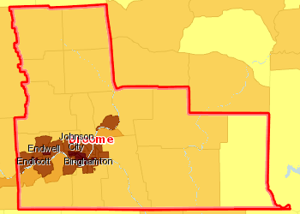 | Population, Density (Persons per Sq Mile) by Tract, ACS 2012-16  Over 5,000  1,001 - 5,000  501 - 1,000  51 - 500  Under 51  No Data or Data Suppressed  Report Area

Population
Following is a chart showing population and population change in the service area. Not updated for 2019.
Data Source: US Census Bureau, American Community Survey. US Census Bureau, Decennial Census. Source geography: County | Percent Change in Population  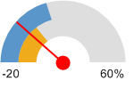  Broome County, NY (-1.57%)  New York (3.8%)  United States (13.2%)
  Report Area | Total Population,  2016 ACS | Total Population,  2000 Census | Population Change from 2000-2016 Census/ACS | Percent Change from 2000-2016 Census/ACS
  Broome County, NY | 197,381 | 200,536 | -3,155 | -1.57%
  New York | 19,697,457 | 18,976,457 | 721,000 | 3.8%
  United States | 318,558,162 | 281,421,906 | 37,136,256 | 13.2%

Age & Gender Demographics
Population by gender within the report area is shown below. According to ACS 2012-2016 5 year population estimates for the report area, the female population comprised 51.27% of the report area, while the male population represented 48.73%. Not updated in 2019.
Report Area | 0 to 4  Male | 0 to 4  Female | 5 to 17  Male | 5 to 17  Female | 18 to 64  Male | 18 to 64  Female | Over 64  Male | Over 64  Female
Broome County, NY | 5,264 | 4,965 | 14,787 | 13,829 | 62,125 | 61,699 | 13,222 | 19,897
New York | 598,437 | 572,286 | 1,562,158 | 1,493,528 | 6,168,618 | 6,408,629 | 1,088,140 | 1,667,884
United States | 10,154,024 | 9,712,936 | 27,455,869 | 26,289,609 | 98,851,301 | 99,913,791 | 18,244,716 | 25,876,504
Data Source: US Census Bureau, American Community Survey. 2012-2016. Source geography: County
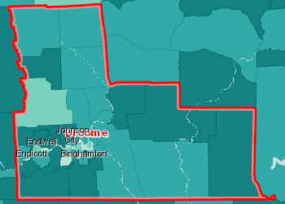 | Median Age by Tract, ACS 2012-16  Over 45.0  40.1 - 45.0  35.1 - 40.0  Under 35.1  No Data or Data Suppressed  Report Area

Veterans, Age and Gender Demographics show the number of veterans living in the report area. According to the American Community Survey (ACS), 8% of the adult population in the report area are veterans, which is less than the national average of 8.01%. Not updated in 2019.
Report Area | Veterans  Total | Veterans  Male | Veterans  Female | % Pop over 18  Total | % Pop over 18  Males | % Pop over 18  Females
Broome County, NY | 12,670 | 11,957 | 713 | 8% | 15.55% | 0.87%
New York | 789,553 | 739,116 | 50,437 | 5.11% | 10.02% | 0.62%
United States | 19,535,341 | 17,948,822 | 1,586,519 | 8.01% | 15.17% | 1.26%
Data Source: US Census Bureau, American Community Survey. 2012-2016. Source geography: County

Families
Households by Composition and Relationship to Householder
Report Area | Total Households | Married Family Households | Single Male Family Households | Single Female Family Households | Non-Family Households
Broome County, NY | 78,821 | 33,760 | 3,902 | 9,075 | 32,084
New York | 7,302,710 | 3,223,907 | 363,352 | 1,045,771 | 2,669,680
United States | 118,825,921 | 57,459,352 | 5,747,150 | 15,092,201 | 40,527,218
Data Source: US Census Bureau, American Community Survey. 2013-2017. Source geography: County
Households with Children by Composition and Relationship to Householder, Percentage of Total Households
Report Area | All Household Types | Married Family Households | Single-Male Family Households | Single-Female Family Households | Non-Family Households
Broome County, NY | 25.8% | 15.12% | 2.96% | 7.18% | 0.54%
New York | 30.06% | 19.01% | 2.43% | 8.37% | 0.25%
United States | 31.71% | 20.59% | 2.7% | 8.12% | 0.29%

Race and Ethnicity
Hispanic population figures by age appear below.
Report Area | 0 to 4 | 5 to 17 | 18 to 24 | 25 to 34 | 35 to 44 | 45 to 54 | 55 to 64 | Over 65
Broome County, NY | 799 | 1,805 | 1,789 | 960 | 878 | 603 | 408 | 372
New York | 306,260 | 705,247 | 430,178 | 610,514 | 528,542 | 458,394 | 319,938 | 302,856
United States | 5,130,570 | 12,816,191 | 6,585,748 | 8,818,195 | 7,972,885 | 6,284,817 | 4,052,919 | 3,537,782

According to ACS 2012-2016 5 year population estimates, the white population comprised 86.1% of the report area, black population represented 5.8%, and other races combined were 7.7%. Persons identifying themselves as multiple races made up 2.8% of the population.
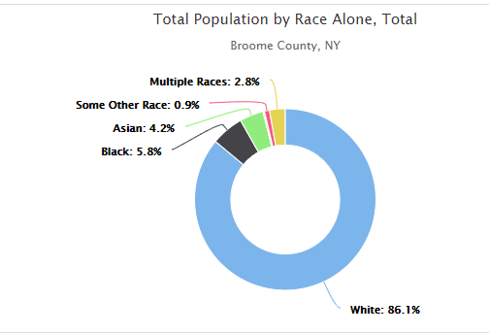

Languages
Population in Limited English Households
This indicator reports the percentage of the population aged 5 and older living in Limited English speaking households. A “Limited English speaking household” is one in which no member 14 years old and over (1) speaks only English at home or (2) speaks a language other than English at home and speaks English “Very well.” This indicator is significant as it identifies households and populations that may need English-language assistance.
Report Area | Total Population Age 5+ | Linguistically Isolated Population | Percent Linguistically Isolated Population
Broome County, NY | 185,876 | 2,385 | 1.28%
New York | 18,621,351 | 1,412,740 | 7.59%
United States | 301,150,892 | 13,323,495 | 4.42%
Note: This indicator is compared to the state average. Data Source: US Census Bureau, American Community Survey. 2013-17. Source geography: Tract
In the school districts served by OFB Head Start, there are a total of 172 students classified as English Language Learners. This represents 1.0 % of the student body in grades PreK through 12 in those school districts, up from 0.8% in the prior school year.
Data Source: NYSED School Report Cards

Citizenship Status
According to American Community Survey (ACS) the report area has a total of 5,943 non-Citizens, or 3% of the total population of 196,124 persons, in contrast to the New York average of 10.1% of the population and the national average of 7% non-Citizens living in the United States.
Data Source: US Census Bureau, American Community Survey. 2013-2017. Source geography: county

Education

Educational Attainment
28.05% of the population aged 25 and older, or 36,408 have obtained an Bachelor's level degree or higher. This indicator is relevant because educational attainment has been linked to positive health outcomes.
Report Area | Total Population Age 25+ | Population Age 25+ with Bachelor's Degree or Higher | Percent Population Age 25+ with Bachelor's Degree or Higher
Broome County, NY | 129,802 | 36,408 | 28.05%
New York | 13,660,809 | 4,820,813 | 35.29%
United States | 216,271,644 | 66,887,603 | 30.93%
Note: This indicator is compared to the state average. Data Source: US Census Bureau, American Community Survey. 2013-17. Source geography: Tract
Within the report area there are 12,429 persons aged 25 and older without a high school diploma (or equivalency) or higher. This represents 9.58% of the total population aged 25 and older. This indicator is relevant because educational attainment is linked to positive health outcomes (Freudenberg & Ruglis, 2007).
Report Area | Total Population Age 25+ | Population Age 25+ with No High School Diploma | Percent Population Age 25+ with No High School Diploma
Broome County, NY | 129,802 | 12,429 | 9.58%
New York | 13,660,809 | 1,895,439 | 13.88%
United States | 216,271,644 | 27,437,114 | 12.69%

In addition, 31.4% of Broome residents over age 25 have a high school diploma or equivalent as the highest level of education attained, compared with 26.3% state rate, according to the American Community Survey.

School Enrollment
The following table shows school enrollment in the Broome Head Start service area for the 2016-2017 and the 2017-2018 school years compared with enrollment for the 2013-2014 school year. Enrollment throughout the service area is down an average of 1.83% between 2013-14 and 2017-18. Harpursville in particular has lost enrollment in recent years.
Data Source: New York State Education Department Data Site, retrieved from data.nysed.gov

Proficiency and Graduation
The New York State Education Department has changed the way that it reports school performance data. In the most recently released reports, schools are rated on a 4-point scale with 1 being the lowest score and 4 being the highest score. The following table provides district rankings for the 2017-2018 school year on key performance indicators.
Data Source: New York State Education Department Data Site, retrieved from data.nysed.gov

Colleges, Universities and Trade Schools
Broome County is home to Binghamton University (SUNY Binghamton), Broome Community College, and Davis College. It is also served by Broome, Delaware, Tioga BOCES, which provides, among other services, career and technical training. Binghamton City School district provides an adult education program for High School Equivalency and English As A Second Language. SAGE Truck Driving School has a location in Endicott. Not updated in 2019.

Employment, Income and Poverty

Employment: Current Unemployment Rates
Total unemployment in the report area for the current month was 3,485, or 4.1%% of the civilian non-institutionalized population age 16 and older (non-seasonally adjusted). This indicator is relevant because unemployment creates financial instability and barriers to access including insurance coverage, health services, healthy food, and other necessities that contribute to poor health status.
Report Area | Labor Force | Number Employed | Number Unemployed | Unemployment Rate
Broome County, NY | 84,117 | 80,632 | 3,485 | 4.1%
New York | 9,543,460 | 9,203,179 | 340,281 | 3.6%
United States | 163,172,637 | 157,701,914 | 5,470,723 | 3.4%
Note: This indicator is compared to the state average.
Data Source: US Department of Labor, Bureau of Labor Statistics. 2019 - April. Source geography: County

Employment: Average Annual Unemployment Rate 2007-2018
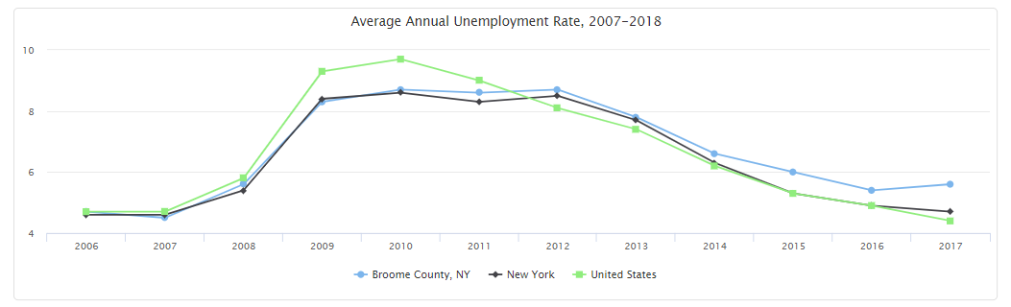

Employment: Commutation Patterns
The mean travel time to work is 19.7 minutes. The U.S. Census Bureau provides the following table and maps on commutation patterns in Broome County. The plurality of Broome residents (58.7%) travel less than 10 miles for work. Note: Source data for charts below was unchanged in 2019.
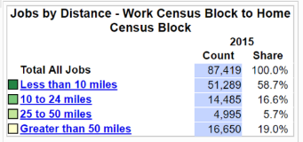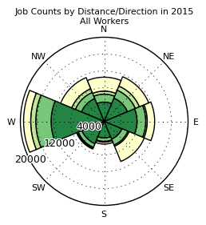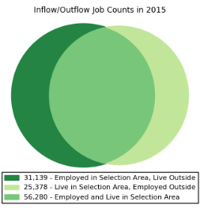

Income: Wages & Other Income
Median earnings for all workers (full-time and part-time) in the county amount to $27,112 per year. A male working full-time earns an average of $46,521 per year while a female working full-time earns an average of $38,218 per year. According to the Bureau of Labor Statistics, the average weekly wage in Broome County in the second quarter of 2018 was $866. The following chart compares average weekly wages across the state.
Income sources for residents of Broome County include: earnings (70.6%); Social Security (36.4%); retirement income (25.9%); Supplemental Social Security (7.3%); cash public assistance (5.3%).*

Income: Household Income and Living Wage
The median household income in Broome County is $49,064. Median family income is $65,022. Per Capita income is $26,790. According to the MIT Living Wage Calculator, a living wage for one adult with two children in the county is $34.92 per hour, or $72,634 per year.

Poverty: Rates of Poverty
According to the U.S. Census Bureau American Community Survey, the poverty rate in Broome County is 17.1%, well above the state rate of 15.1%. Among children age 5-17, the poverty rate is 21.9%, compared with a statewide rate of 20.3%. More than 1 in 4 of children under age 5 live in poverty. Among female-headed families with children under age five, the poverty rate is a staggering 37.7 %. The table below shows the number of families living below 130% of the Federal Poverty Level (FPL) by family type and presence of children

Poverty disproportionately affects certain social groups, including the Hispanic / Latino ethnic group, all non-white race groups, and the female-headed family-type group, as the following charts illustrate. Note: The charts below were not updated in 2019.
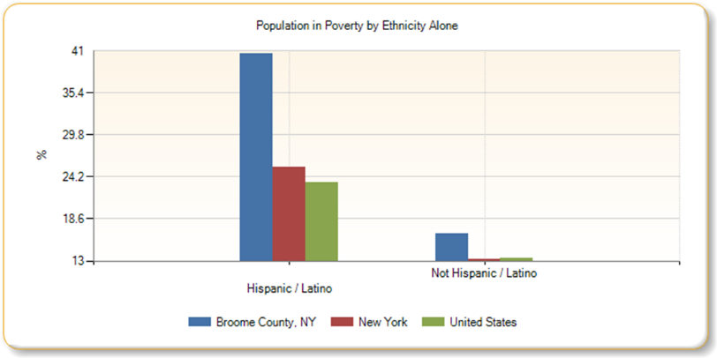
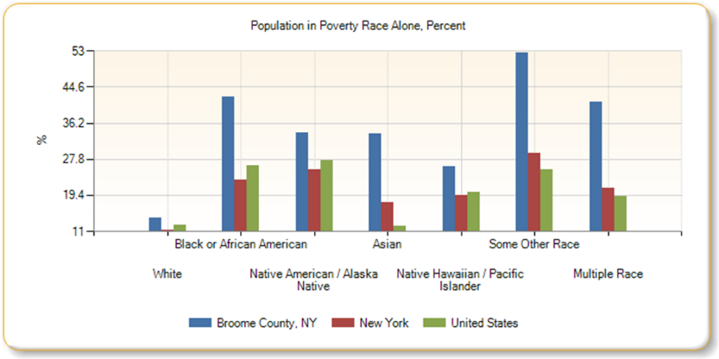
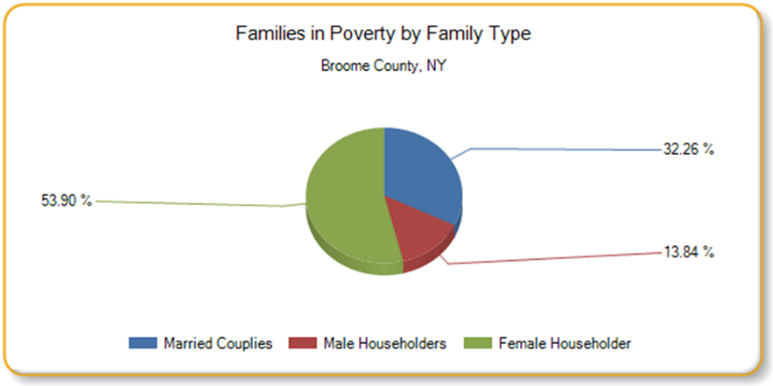

Poverty: Public Assistance
The following table depicts the public assistance caseload in Broome County for February of 2015, February of 2018, and February 2019:
Assistance Type | Number of Cases  February 2015 | Number of Cases  February 2018 | Number of Cases  February 2019
Temporary Assistance | 3,692 | 3,495 | 3,230
Family Assistance | 1,536 | 1,447 | 1,305
Safety Net Assistance | 2,156 | 2,048 | 1,925
Supplemental Security Income | 7,409 | 7,515 | 7,573

Health, Disability and Nutrition

Health Access: Insurance and Capacity
According to the American Community Survey, 5.8% of Broome County residents (11,230 people) have no health insurance coverage. Among employed adults, 7.2% lack health insurance, while 21.3 % of unemployed adults have no health insurance coverage. Among children under age 18, 3.1% have no health insurance coverage. These rates are on par or somewhat better than state rates. Rates of uninsured overall and for employed adults are lower in Broome than across the state. Note: Not updated in 2019
The following chart shows areas of the county where public, means-tested health insurance is more concentrated. Note: Not updated in 2019
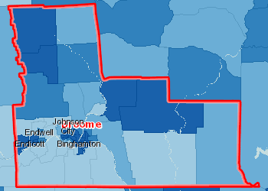 | Insured, Medicaid / Means-Tested Coverage, Percent by Tract, ACS 2010-14  Over 25,0%  20.1 - 25.0%  15.1 - 20.0%  Under 15.1%  No Data or Data Suppressed  Report Area

The following chart shows areas of the county where health insurance from Medicare is more concentrated. Among those using Medicare for health insurance, 18.4% are disabled persons while 81.6% are persons over the age of 65. Note: Not updated in 2019
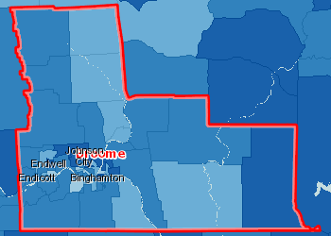 | Insured, Medicare, Percent by Tract, ACS 2012-16  Over 25.0%  20.1 - 25.0%  15.1 - 20.0%  Under 15.1%  No Data or Data Suppressed  Report Area

The following tables compare availability of certain type of care providers in Broome to availability of these providers statewide. The tables show that Broome’s access to dental and mental health professionals in the county compares unfavorably to statewide rates. Access to primary care is on par with statewide rates.

Access to Dentists
This indicator reports the number of dentists per 100,000 population. This indicator includes all dentists - qualified as having a doctorate in dental surgery (D.D.S.) or dental medicine (D.M.D.), who are licensed by the state to practice dentistry and who are practicing within the scope of that license.
Report Area | Total Population, 2015 | Dentists, 2015 | Dentists, Rate per 100,000 Pop.
Broome County, NY | 196,567 | 132 | 67.15
New York | 19,795,791 | 15,530 | 78.5
United States | 321,418,820 | 210,832 | 65.6
Note: This indicator is compared to the state average.
Data Source: US Department of Health & Human Services, Health Resources and Services Administration, Area Health Resource File. 2015. Source geography: County

Access to Mental Health Providers
This indicator reports the rate of the county population to the number of mental health providers including psychiatrists, psychologists, clinical social workers, and counsellors that specialize in mental health care.
Report Area | Estimated Population | Number of Mental Health Providers | Ratio of Mental Health Providers to Population  (1 Provider per x Persons) | Mental Health Care Provider Rate (Per 100,000 Population)
Broome County, NY | 193,639 | 373 | 519.1 | 192.6
New York | 19,849,399 | 52,899 | 375.2 | 266.5
United States | 317,105,555 | 643,219 | 493 | 202.8
Note: This indicator is compared to the state average.
Data Source: University of Wisconsin Population Health Institute, County Health Rankings. 2017. Source geography: County

Access to Primary Care
This indicator reports the number of primary care physicians per 100,000 population. Doctors classified as "primary care physicians" by the AMA include: General Family Medicine MDs and DOs, General Practice MDs and DOs, General Internal Medicine MDs and General Pediatrics MDs. Physicians age 75 and over and physicians practicing sub-specialties within the listed specialties are excluded. This indicator is relevant because a shortage of health professionals contributes to access and health status issues.
Report Area | Total Population, 2014 | Primary Care Physicians, 2014 | Primary Care Physicians, Rate per 100,000 Pop.
Broome County, NY | 197,349 | 223 | 113
New York | 19,746,227 | 22,113 | 112
United States | 318,857,056 | 279,871 | 87.8
Note: This indicator is compared to the state average.
Data Source: US Department of Health & Human Services, Health Resources and Services Administration, Area Health Resource File. 2014. Source geography: County

Although 83.4% adults in Broome County are reported to have a regular health provider, the county ranks in the 3rd (with 4th being the worst performing) ranking group for rate of visits to the emergency department. Note: Not updated in 2019

Health: New York State Department of Health no longer provides the rankings and instead provides dials which suggest higher or lower risk for poor health outcomes. For most indicators, data could not simply be updated for this report. Where important to the report’s overall findings, indicators have been updated using the new risk assessment system.

Health: Preventive Health Care (Note: Not updated in 2019)
When it comes to preventive care, less than 56% of Broome County children in government sponsored health insurance programs have the recommended number of well child visits, compared with a 72% statewide rate. Broken out by age groups reported, 78.7% of Broome children under 15 months, 70.6% between 3 and 6 years, and 45.1% age 12-21 received the recommended number of well visits. All of these figures are lower than statewide rates for the specified age groups, with the gap increasing for older children.
Broome County children receive lead screenings at lower rates than peers throughout the state as well. Among children born in 2012, 38% of Broome children had at least two lead screenings by age 36 months, compared with a 58% statewide rate, placing the county in the 3rd (2nd worst) ranking group on this indicator.
Across all age groups, the county places in the 4th ranking group on the following preventive health measures:
- Percent of children born in 2012 with a lead screening - aged 18-35 months (2012-2015)
- Percent of children with recommended number of well child visits in government sponsored insurance programs (2015) (Overall and for children 0-15 months, children 3-6 years, and children 12-21 years.)
- Percent of women, aged 50-74 years, who had a mammogram between October 1, 2013 and December 31, 2015 (2015)
- Percent of adults aged 65 years and older with flu shot in last year (2013-2014)

Health: Conditions (Note: Not updated in 2019)
Broome County ranks in the 4th (worst performing) ranking group on the following indicators of child and adolescent health conditions. In addition, the county placed in the 3rd ranking group on the incidence of high blood lead levels, asthma hospitalization for children 5-17 years of age, gastroenteritis and otitis media hospitalization rates among children 0-4, and childhood mortality age 1-4.
- Asthma hospitalization rate per 10,000, Aged 0-4 years (2012-2014)
- Pneumonia hospitalization rate per 10,000, Aged 0-4 years (2012-2014)
Broome County ranks in the 4th (worst performing) ranking group on the following indicators of population morbidity and mortality.
Indicators of Morbidity
- Female breast cancer, incidence and late-stage incidence
- Heart attack (Acute Myocardial Infarction) hospitalization rate per 10,000 (Crude)
- Cerebrovascular disease (stroke) hospitalization rate per 10,000 (Crude and Age-adjusted)
- Hypertension hospitalization rate per 10,000 (aged 18 years and older) (2012-2014)
- Homicide mortality rate per 100,000 (Age-adjusted)
- Unintentional injury hospitalization rate per 10,000 (Crude and Age-adjusted; Aged 25-64; Aged 65 and older)
- Falls hospitalization rate per 10,000 (Crude and Age-adjusted; Aged 25-64; Aged 65-74; Aged 85 years and older)
- Traumatic brain injury hospitalization rate per 10,000 (Crude and Age-adjusted)
- Hypertension emergency department visit rate per 10,000 (aged 18 years and older) (2012-2014)
- Hypertension emergency department visit rate per 10,000 (any diagnosis) (aged 18 years and older) (2012-2014)
- Chronic kidney disease emergency department visit rate per 10,000 (any diagnosis) (Crude and Age-adjusted)
- Meningococcal incidence rate per 100,000
- E. coli Shiga Toxin incidence per 100,000
Indicators of Mortality
- Heart attack (Acute Myocardial Infarction) mortality rate per 100,000 (Crude and Age-adjusted)
- Cardiovascular disease mortality rate per 100,000 (Premature Death and Pretransport Mortality)
- Disease of the heart mortality rate per 100,000 (Premature Death and Pretransport Mortality)
- Coronary heart disease mortality rate per 100,000 (Premature Death)
- Non-motor vehicle (accident/injury) mortality rate per 100,000 (Crude and Age-adjusted)

Health: Leading Causes of Premature Death (Note: Data not updated at the source in 2019 but the below was corrected from the original report which reversed the rank order.)
The leading causes of premature death in Broome County in the most recent year reported (2015): (#1) Cancer; (#2) Heart Disease; (#3) Unintentional Injuries; (#4) Chronic Lower Respiratory Disease; (#5) Liver Disease.

Health: Family Planning, Natality and Maternal and Infant Health (Note: Note updated in 2019)
According to the NYS Department of Health’s County Health Assessment Indicators, Broome County has a three-year average pregnancy rate of 76.9 pregnancies per 1,000 females aged 15-44. This rate is higher than a regional rate of 65.9/1,000 and lower than the State rate of 86.5/1,000. In 2014 (the most recently reported year), 2,971 women in Broome County had a pregnancy.
Broome County placed in the 4th (worst performing) ranking group on the following family planning and natality indicators:
- % of births within 24 months of previous pregnancy
- Fertility rate Aged 15-17 years (births to mothers aged 15-17 years/females aged 15-17 years)
- Teen pregnancy rate per 1,000 # (aged 10-14 and 15-17)
- Abortion ratio (induced abortions per 1,000 live births) # (All ages)
Broome County placed in the 4th (worst performing) ranking group on the following maternal and infant health indicators. In addition, the county placed in the 3rd ranking group on several (14) measures of maternal infant health.
- Percent of births with late (3rd trimester) or no prenatal care
- Percent of pregnant women in WIC with early (1st trimester) prenatal care (2009-2011)
- Percent of pregnant women in WIC who were pre-pregnancy obese (BMI 30 or higher) (2010-2012)
- Percent of pregnant women in WIC with gestational diabetes (2009-2011)
- Percent of births delivered by cesarean section
- Newborn drug-related diagnosis rate per 10,000 newborn discharges (2012-2014)

Health: Oral Health
According to the NYS Department of Health’s County Health Assessment Indicators, Broome County placed in the 4th ranking group on the following oral health indicators:
- Dental caries outpatient visit rate per 10,000 (aged 3-5 years) (2012-2014)
- Percent of 3rd grade children with untreated caries # (2009-2011)

Health: Mental Health
According to the NYS Department of Health’s County Health Assessment Indicators, Broome County placed in the 4th ranking group on the following indicator:
- Self-inflicted injury hospitalization rate per 10,000 (Crude and Age-adjusted)

According to the NYS Office of Mental Health, Broome County had the following average daily census rates of mental health inpatient use compared with New York State rates. (Note: This chart has been updated in 2019 due to relevance to findings.)
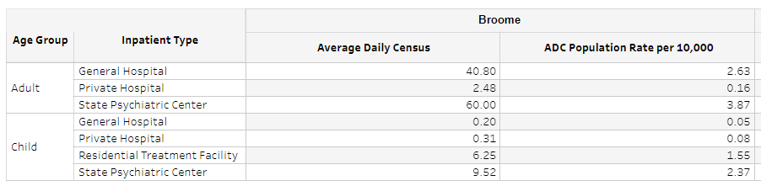
The suicide rate for Broome County is 11.9 per 100,000 people, compared with 11.7/100,000 in the region and 8.4/100,000 across the state.
According to the NYS Kids’ Well-being Indicators Report, in the 2016-2017 School Year, 6.8% of Broome County students in grades 1 through 6 had a Special Education MEB (Mental Emotional Behavioral) code, up from 5.9% in the prior report. This is lower than the state rate of 8.4%. In Broome, however, suspension/expulsion/removal events occurred at much higher rates among students with an MEB designation (1002.8/1,000) compared with statewide rates (307/1,000). (Note: This paragraph reflects updated figures in 2019.)
The New York State Department of Mental Health published its 2016-2020 Statewide Comprehensive Plan. It contains regional needs assessment data showing that the majority of respondents (more than 50%) considered prevention, crisis and treatment services for children and youth as a low need in the Southern Tier region. The only category rated as a high need by the plurality or majority of respondents was transportation, for both children/youth and adults.

Health: Substance Abuse
In Broome County, 79.3% of adults live in homes where smoking is prohibited, compared with an 80.9% statewide rate. Nearly 27% of Broome adults smoke cigarettes, compared with 14.5% of adults across the state. The county’s alcohol-related motor vehicle injuries and deaths per 100,000 rate (37.2) is higher than the state rate of 29.9 per 100,000. The rate of adult binge-drinking (20.1%) is higher in Broome than the state rate of 18.3%).
The New York State Department of Health provides a data dashboard key indicators related to opioids and other substances. The chart below shows that Broome has higher rates than the region and state on all indicators.
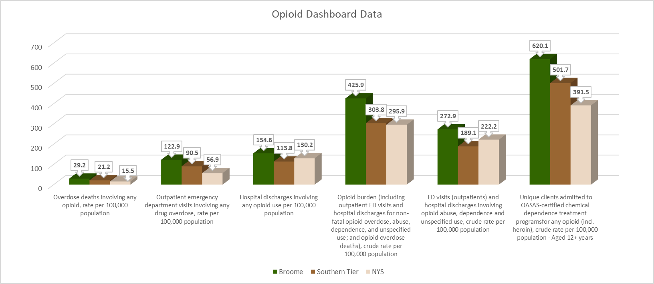

Data from the NYS Division of Criminal Justice Services shows a growing trend in drug arrests and a declining trend in alcohol related arrests over the past three years, as depicted in the graphs below.

Disability: Adults with Disabilities
According to the American Community Survey, 29,392, or 15.1% of, residents of Broome County in the civilian noninstitutionalized population have a disability. Of these, 90.2% are adults. Among adults with a disability, 27.5% are age 75 and over. The following chart depicts the distribution of the types of difficulties experienced by Broome County residents with disabilities Note: This data has not been updated in 2019.
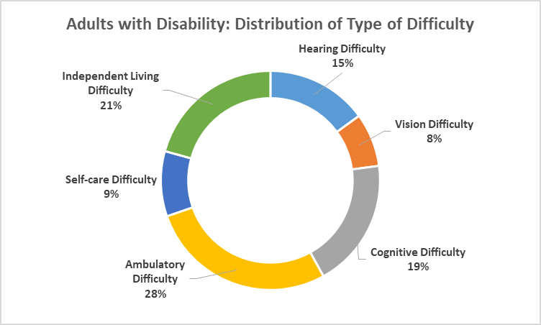

Disability: Children with Disabilities (Note: Updated in 2019)
According to the American Community Survey, there are 2,679 children under age 18 with a disability residing in Broome County, representing 7% of the county’s population in this age group.
According to data published by the NYS Department of Health, the county’s Early Intervention Program served 4.5% (approximately 259 children) of the county’s children under age 3 in 2017, up from 3.9% in 2015.
In the 2017-2018 school year, the school districts in the Opportunities for Broome Head Start service area served 2,276 students with disabilities out of a total student body of 17,403 for a rate of 13.1% students with disabilities in the districts served. The highest rate of students with disabilities (16.1%) occurs in Harpursville Central School District and the lowest rate (10.2%) occurs in Chenango Forks Central School District.

Nutrition: Food Security
The following table depicts rates and trends in rates of students participating in the free and reduced lunch programs in Broome County school districts served by OFB Head Start. Rates of eligibility have risen over the three-year report period in all but Deposit Central School District. Rates are higher than the state in Deposit, Harpursville and Whitney Point. Note: NYSED no longer reports rates of free and reduced lunch. Instead, they report rates of students with economic disadvantage, which factors in more than just qualifying for free or reduced lunch. Therefore, the below table has not been updated in 2019.
In 2017, 27.7% of Broome County children under age 18 received Supplemental Nutrition Assistance Program (SNAP) benefits, compared with 24.5% of children statewide.
Feeding America provides county-level data on food insecurity via its Map the Meal Gap online tool. The USDA Economic Research Service defines food insecurity as follows: “Food Insecurity - the condition assessed in the food security survey and represented in USDA food security reports—is a household-level economic and social condition of limited or uncertain access to adequate food.” The following images depict some facts about overall and child food insecurity in Broome County, updated in 2019 with 2017 data.

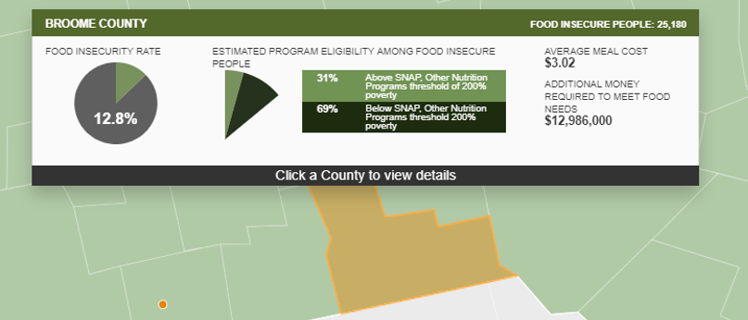

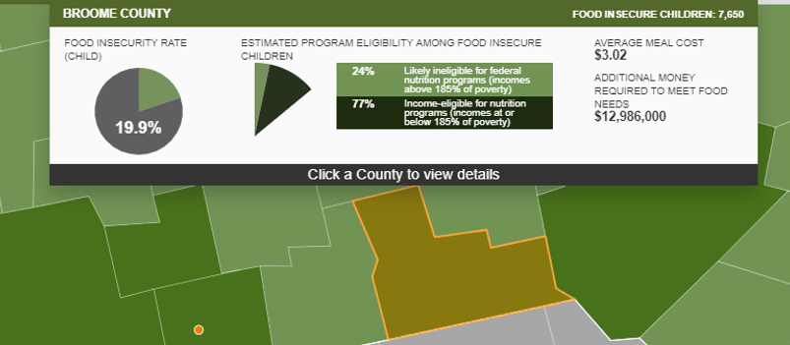

Nutrition: Overweight and Obesity (Note: This data has not been updated in 2019)
Among a sample of Elementary School students in Broome County, 31.3% are overweight or obese. This rate is slightly lower than the region (31.9%). The county is placed in the low risk category on this indictor. (Note: Updated in 2019.)
Figures from the WIC (Women, Infants, Children) program show that 33.5% of women in the program were pre-pregnancy obese, placing the county in the high risk category on this indictor. The rate of children age 2-4 in the WIC program who are obese is in Broome (13.9%) which is equal to the state rate and Broome County places in low risk category on this indicator.
A reported 54.5% of Broome County adults are overweight or obese, a rate much lower than the 64% reported in the original Community Assessment and lower than the 60.5% of adults in New York State who are overweight or obese. The county is placed in the low-risk category on this indicator. The county compares places in the “middle risk” category on most other obesity-related indicators. It places in the high-risk category on the following obesity-related indicators: Age-adjusted percentage of adults with cardiovascular disease (heart attack, coronary heart disease, or stroke) and Age-adjusted diabetes hospitalization rate per 10,000 (primary diagnosis).

Social Services

Social Services: Family Well-being (Note: This data has not been updated in 2019)
In 2017, 45.2 per 1,000 children under age 18 in Broome County were in indicated reports of child abuse /maltreatment, compared with a statewide rate of 17.1 per 1,000. In addition, Broome County reports a higher rate than the state of admissions to foster care (2.4/1,000 vs. 1.7/1,000) and a higher rate of children in foster care (4.7/1,000 vs. 3.0/1,000). While 32.7% of Broome children in foster care were discharged in 2017, 36.4% of children in foster care across the state were discharged.
A total of 923 victims of domestic violence were reported in 2017 in Broome County, suggesting that 2.0% of families in the county are affected by violence and that 2.5 people per day experienced family violence in Broome County during 2017. Of these reported victims, 560 were a female in an intimate partner incident, 98 were a male in an intimate partner incident, and 265 were family victims not part of an intimate partner relationship. The highest number of victims (324) was reported by the Binghamton City Police Department. (Note: No new data was available at the source for the domestic violence indicators.)
In Broome County, there are 2,672 grandparents living with their own grandchildren. Of these, 37.1% are responsible for the grandchildren. Among grandparents living with and responsible for their grandchildren, 66.7% are female and 54.5% are married.

Social Services: Housing and Homelessness
According to the American Community Survey, the plurality (30.2%) of homes in Broome County were built in 1939 or earlier. This is better than the state rate of 32.3% built in 1939 or earlier. Nearly 66% of housing units are owner-occupied while 34.3% are renter-occupied. The plurality of householders (27.1%) moved into the unit between 2010 and 2014. The large majority of housing units are occupied by less than or equal to one occupant per room, suggesting that over-crowding is not widespread.
When it comes to affordability, nearly 26% of Broome home owners pay more than 30% of their income on housing, compared with a state rate of 35.6%. Exactly 54.1% of renters in Broome County pay more than 30% of their income for housing costs, compared with a state rate of 53.5%. Among renters statewide and in Broome County, the plurality (44.3% and 46.3% respectively) are actually paying more than 35% of income on housing, well beyond the affordability threshold of 30%.
During the 2017-2018 School Year, there were 291 students in the school districts served by OFB Head Start who experienced homelessness, representing 1.7% of the student body in those districts, down from 2.1% in the prior school year. During the 2013-2014 school year, there were 306 students reported as having experienced homelessness, representing a 19.9% increase in student homelessness over the three-year reporting period.

Public Safety and Crime (Note: This data has not been updated in 2019)
Property crime has generally decreased in Broome since 2013. Violent crime appears to have increased but the NYS Division of Criminal Justice Service began using the FBI’s expanded definition of rape in 2015, accounting for some of the increase documented in the chart below. Since 2015, incidence of rape has not changed much. Aggravated assault cases have generally risen while other violent crimes have declined or remained fairly steady.

Transportation (Note: This data has not been updated in 2019)
Broome County is served by a public transportation system called BC Transit which operates four services: BC Transit Fixed Route, BC Country, BC Lift, and OFA Mini-bus. In addition Coach USA provides bus service to Deposit and Whitney Point and Greyhound service takes passengers to cities throughout the U.S. The Greater Binghamton Airport provides daily commercial flights on Delta Airlines to many destinations via Delta’s Detroit hub.
The County’s Highway Division reports the following, “The Highway Division is responsible for: The maintenance and upkeep of 343.24 centerline miles of roads and is responsible for maintaining 105 bridges with spans of 20 feet or more, 150 culverts with diameters ranging from five (5) to twenty (20) feet and 3,500 culverts with diameters of five (5) feet or less. This involves the inspection and evaluation of county roads and bridges, and planning, reconstruction, repair and maintenance projects.”

Early Education Need and Capacity

Child Care Need Among Head Start Families

Head Start Parent Employment and Work Schedules
According 2017-2018 PIR Data 42.1% of Head Start families have both or the only parent working, compared with 36.5% in 2016-2017. Therefore, in 2017-2018 about 90 of the 214 families enrolled in the program relied on it (at least in part) for child care purposes. By contrast, figures from the U.S. Census Bureau’s American Community Survey show that, of the general population with children under the age of six in Broome County, 64.5% have all parents working. Head Start children from families with a stay-at-home parent, of course, experience the substantive benefits of participating in the program regardless of the family’s ability to take advantage of its role as child care to facilitate workforce participation. The following table shows the family employment based on program and family composition:

Employed Head Start parents responding to a survey report working, on average, 35.4 hours per week, which is up from 32.9 hours reported in the 2018 community assessment. The following chart displays the typical shifts reported by Head Start parents.

Other Child Care Programs Serving Young Children

Head Start Eligible Children Aged Three and Four
In the OFB Head Start service area, an estimated 962 three- and four-year-olds are eligible for Head Start based on 2017-2018 enrollment figures from the school districts served by the program. The program in 2017-18 was funded to serve 178 children. There are approximately 784 eligible children who cannot be served by the program. Put another way, the program is funded to serve just 18.5 percent of the children eligible for it. The following table shows the eligibility estimates.

Head Start Eligible Children Under Age Three
In the OFB Head Start service area, an estimated 1,197 children under age three would be eligible for Early Head Start based on birth records and rates of poverty among children under age five in the county. The program is not currently funded to serve any children in this age group. The following table shows the eligibility estimates.

Public Pre-kindergarten
A total of 746 children (of all incomes) attended public PreK in the service area during the 2017 – 2018 school year. Nine school districts in the service area provide 10 Pre-K programs. Of these, six are half-day programs. Some children (89) attending public PreK also are served by Head Start because the two programs combine to serve children. Therefore, these children are counted in both Pre-K and Head Start totals served.

Non-eligible Children
According to the calculations presented in Tables 4 & 5 above, there are an estimated 6,005 children under the age of five in the OFB Head Start service area. Subtracting from this total the number of children served by OFB Head Start (178) and public Prekindergarten in the service area (746 less 89 counted in Head Start total) results in a difference of 5,170, or, the estimated number children in this age group who are not served by public programs. While all 5,170 of these children would benefit from early childhood education programming, about 3,335 children in this age group have all parents in the labor force (based on 64.5% county-wide rate) and therefore potentially “need” child care. According to a recent community assessment report published by the Family Enrichment Network (FEN), there are child care providers serving children in this age group in the OFB Head Start Service Area as follows:
 | Child Care Centers | Family Child Care | Group Family Child Care
Endicott / Endwell | 5 | 9 | 2
Vestal | 3 | 1 | 2
Surrounding Areas | 2 | 8 | 3

The same FEN report estimates unmet child care need. Based on data on all families in Broome County (that is, the OFB Head Start service area PLUS Binghamton, Johnson City and Susquehanna Valley school districts), the report estimates that an additional 1,464 slots are needed to meet the demand for child care for children under age five. This figure takes into account the fact that an estimated 2,580 children in the county are cared for by friends, family or neighbors in the unregulated market for child care. The report also notes that 48 percent of care needed in Broome County was for children under age three. In addition, it notes that the areas where demand is greater than supply are for the following types of care: infant/toddler, child care deserts, children with challenging behaviors or special needs, school age child care.
According to its 2017 Annual Report, the Broome County Department of Social Services provided child care fee assistance to 1,409 children from 777 families on average each month in 2017. Based on U.S. Census Bureau estimates from the American Community Survey, there are 5,944 children under age 6 living in households with incomes below 200% of the Federal Poverty Level, which is the eligibility threshold for child care fee assistance. If five-sixths of these children are under age five, then there are 4,951 children under age five eligible for fee assistance if their parents work, have TANF or are involved in other programs. If 64.5* percent of these children meet at least one of these conditions, then approximately 3,194 children need child care and are eligible for fee assistance. By these estimates, the child care subsidy program is serving, on average, 44.1 percent of those who need and are eligible for it.
This report documents that the average weekly wage in Broome County is $866. The average market rate for child care for children under age five (calculated as the average of the low of $150 per week for a preschooler in subsidized family child care and a high of $200 per week for an infant in private-pay center care) is $175 per week. Therefore, a family earning the average weekly wage would have to pay 20.2 percent of its income to pay for child care for one child, while an acceptable level of affordability for child care is ten percent of family income.

Needs of Low-income Individuals, Children and Families: Perceived

This section of the report summarizes the quantitative and qualitative data collected through surveys and focus groups from program participants involved with Opportunities for Broome (OFB) Head Start and other programs. In addition, it presents qualitative data collected from other OFB stakeholders (that do not participate in programs) who responded to surveys.

Head Start Parent Survey Data
There were 81 Head Start parents who completed surveys. Data from these surveys is summarized below.

Question 1: Community Ratings
Respondents rated the community on aspects of quality of life as “Succeeding (A)”; “Doing OK (B-C), or “Failing (D-F)”. The chart below shows the distribution of “grades” given. Pluralities, (in most cases, majorities) of respondents rated the community as “Doing OK” on most aspects of quality of life. The one case where a plurality of respondents rated the community as “Succeeding” was in the area of “Primary / General Healthcare Options”, with 48% of respondents rating it with an “A” grade. Family well-being, child well-being, school systems and dental health service options also garnered a high share of “A” grades, with each earning “A’s” from more than 40% of respondents. The county rated lowest on “Substance Abuse Prevention,” with 27% of respondents giving it a “Failing” rating. “Housing options,” and “Cost of living,” received a failing grade from 21% and 20% of respondents, respectively.

Question 2: Childhood Conditions Affecting Families
The survey asked respondents to select from a list of three childhood conditions they think affect families the most. The following chart shows the most frequently selected choices. These are the same top three as in the 2018 original report.

Question 3: Parental Challenges and Strengths
An open ended question asked respondents to describe the biggest challenge they had faced in the past year, and the strength that they drew on to overcome it. Challenges and strengths were coded to reveal themes, with strengths relating to the Center for Social Policy’s Strengthening Families: A Protective Factors Framework. These protective factors include: knowledge of parenting and child development, concrete support in times of need, social & emotional competence of children/parents; parental resilience, and social connections.
Respondents identified challenges primarily in the area of money, or jobs, offering comments such as, “Cost of Living;” “Financial Stability,” “Day to day and monthly costs of living,” “Getting fired from one job,” and “Not having a job.” Related challenges reported included housing, transportation and child care, expressed in comments such as, “Finding housing;” “Getting into our own home,” “House fire,” “Transportation,” “Keeping our vehicle up and running,” “Finding childcare for certain work shifts,” and, “Child care that is affordable.” (Note: Housing, Transportation and Child Care are more prominently reported as challenges this year while Transition and Instability, which factored prominently as challenges in last year’s report, were barely mentioned as challenges this year.)
Other challenges reported included loss, day-to-day coping and mental health issues. Some representative comments include: “Losing my dad;” “Lots of death in our family,” “Everything,” “Depression,” “Anxiety and Depression,” “Being a full time single mom. “and “Suicidal statements and feelings with my child.”
Finally, parents reported challenges with health and disabilities, describing these in terms such as, “Severe Allergies & Illness with my children;” “I have had major surgery and complications I am dealing with.;” “Taking care of my father with diabetes;” “Being a disabled grandmother,” “My son's loss of hearing.,” and “Not enough special education (OT- SEIT).” (Note: Health and Disabilities were mentioned as challenges very frequently this year. Challenges with Parenting and Family Functioning, which factored prominently last year, were reported at lower levels this year.)
Parents primarily report drawing on their own resilience to overcome challenges. Parental resilience includes concepts such as calling forth inner strength, solving general life problems, having faith or feeling hopeful, and believing one can make and achieve goals. Parent comments demonstrating use of resilience to address challenges included, “Will power and opportunity;” “Keep working, stay focus;” “God and faith;” “Be proactive, Don't be depressed,” and, “Personal strength ability to overcome loss.”
A second strength that parents frequently report drawing on to meet challenge is social connections. Social connections includes concepts such as trusting relationships, feeling respected, and having friends or family members who provide a variety of concrete and emotional support that buffers parent stress. Parent comments reflecting their use of social connections to overcome challenges include, “Support from friends and family;” “Lots of family time, building each other up;” “Became closer to my family because they are they ones who helped me,” and, “Support from friends and family.”
Also mentioned often as a strength to overcome challenges is concrete supports in times of need. This factor includes the concepts of being resourceful, being able to access basic necessities and aspects of accessing services and navigating systems. Representative comments included, “Utilizing services for help;” “Saving enough money for security;” “Acquired two jobs,” and “Budgeting.”

Question 4: School Districts Represented
The following chart shows the distribution of school districts where responding families reside:

Question 5: Program Outcomes
Respondents answered, “yes” or “no” to provide their perception of whether certain outcomes were met as a result of their participation. The following chart depicts the response:

Question 6: Service Satisfaction
Participants responded about their level of satisfaction with certain aspects of their Head Start participation. The following chart displays the frequency of responses.

Question 7: Program Recommendation
The overwhelming majority of respondents agreed they would recommend OFB Head Start to others.
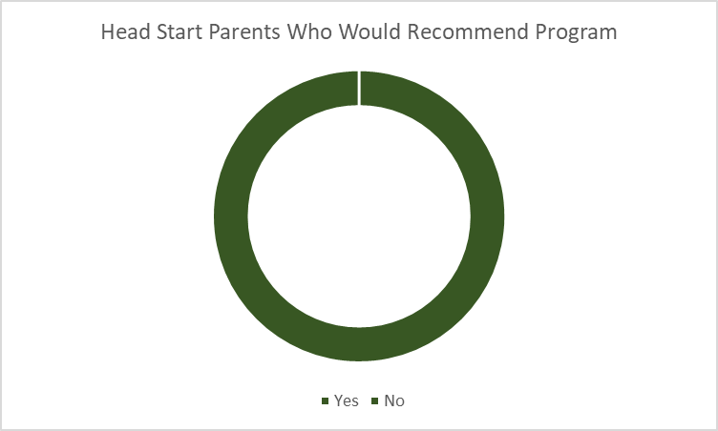
YES
100%

Question 8: Program Options
Respondents provided open-ended responses about how the program could serve them better, and were offered examples of program options, including “year-round or summer options,” and “Early Head Start for children under age 3.” In their open-ended free text responses, parents frequently cited summer options (16 mentions, plus 3 “full-year” mentions); Early Head Start (9 mentions); More classrooms, more teachers, longer day (7 mentions), and transportation (6 mentions).
In addition, parents were specifically asked their opinion about whether parents would use center-based Early Head Start if it were offered. The following chart displays the distribution of responses.

Comments suggest that parents would use center-based Early Head Start if they work, need child care, or feel their child is ready to be in that type of learning environment.

Question 9: Parent Leadership
The survey asked parents to say if they would participate in parent leadership opportunities at Head Start. The following chart displays the distribution of responses.

Most people who said, “no” or “it depends,” suggested that time and availability would be the factors limiting their participation.

Question 10: Methods of Communication
Parents selected from fixed choice responses to indicate their preferred way to receive information from the program. See the chart below for the distribution of responses.

Question 11: Parenting and Child Development Learning
Parents selected from fixed choices to express a preference for how to receive parenting education. The chart below displays the distribution of responses.

An open-ended question solicited ideas for useful topics for parenting classes or tip sheets. The most frequently mentioned topics were related to parenting and child discipline (mentioned 25 times) and child development (mentioned 14 times). Time management and organization were mentioned 5 times and nutrition was mentioned 3 times.

Question 12: Child Care
Parents described their child care arrangements in an open-ended question. They report primarily using informal care from family or friends (25 mentions), self-arranged care, in which parents alternate schedules to allow one to be home when the other isn’t (13 mentions), School, pre-school or Head Start alone or as part of the mix with these other child care methods (19 mentions), and daycare or sitter (8 mentions).. Twelve parents reported not needing child care.

Question 13: Services Used
The following chart shows that a number of local services are not widely used, even though parents know about them.

Question 14: Health and Nutrition
The following chart depicts responses to questions about nutrition and health.

Head Start Parent Focus Group Summary
Ten parents involved in the Opportunities for Broome Head Start Program attended a focus group to provide deeper perspective on community conditions and themes emerging from early results of the yearly parent survey. Accordingly, focus group participants were presented the following questions and prompts for discussion:
Q1: Name some things that make our community a great place to live.
Q2: The parent survey asked respondents to give the community a grade of A, B-C, or D-F on various aspects of living here. More than 1 in 4 of early survey takers gave the community failing grades in the area substance abuse prevention. We’d like to explore these issues with you a little further. Do you know people who are affected by a substance abuse crisis? Can you speak to what they are going through or what would help?
Q3: When it comes to childhood conditions impacting families the most, “Social-emotional skills / self-regulation” was the most frequently selected by survey takers, followed by depression, and then anxiety disorders. Have you noticed issues with children’s behavioral health in our community? Do you think there is enough access to mental health services for young children in our area?
Q4: Many survey takers said that Early Head Start and summer program options would better serve families. When asked if families with children under age 3 would use Early Head Start if it were offered, many respondents said it would depend on the family circumstances and the child’s readiness. Under what conditions do you think parents of children under age 3 would use center-based Early Head Start? What about home-based Early Head Start?
[Q4a: ]How much do you think that families rely on Head Start to fill in gaps for child care needs?

Q4: What is the number one thing that Head Start could do to serve you better in terms of programming, for example offering Early Head Start, more classrooms, or a summer option? Why?
Q5: The program is also wondering how it can engage more parents as leaders who participate in parent-driven program activities. What ideas do you have for inspiring parents to get involved or making it easier to participate on committees and attend events?
Q6 [if time]: What are some things that you and other parents you know are really great at? Also, what are the sources of strength that you call up if challenges arise?
In the course of the ninety-minute discussion, the following themes emerged.

Summary Of Themes: Head Start Parent Focus Group
The people, community life, and support services are advantages to living in this community. Asked what makes this community a great place to live, participants cited, “The people,” “Sense of community,” and “Lots of activities for kids and things to do during summer, local churches, parks and things.” They also described positive differences living here compared with a bigger city.
When it comes to substance abuse, community systems for prevention and treatment are inadequate. Participants describe their knowledge about difficulty that affected populations have in accessing treatment services, saying that, “There’s not a lot of local programs from what I hear. They have to go out of the area for treatment, or they’re waiting for treatment, waiting for spots to open up. There’s not enough treatment here,” and, “We have the CPAP facility but they just check you in for the night and release you the next day and say get to a psychologist the next day. And then it’s another 2 weeks.” They also commented on systems’ doing things that aren’t helpful, such as using substances to try to address a substance problem, or approaching this health problem as a crime. For example, one participant said, “Realize they need help and treatment and not just being thrown in jail.” Participants expressed a belief that prevention is what is really needed, and it was suggested that mental health issues can be the cause. According to one participant, “I think it would be best if we could figure out why people turn to substances. They might see it or someone they love doing it, and they feel they have to. But I know a family friend who has a lot of anxiety so she turned to it to help it. We need to find the underlying cause as to why people are turning to that instead of other options.” Finally, the group agreed that demand drives the drug trade locally. Asked if sellers prey on vulnerable people, participants echoed one another in the claims that, “They’re not out there promoting it; people are looking for it,” and, “If you’re on drugs, you’re gonna find it.” One person described an instance when she was prescribed percoset, and said people tried to buy it from her.
Mental health services for children are insufficient to meet the need. In addition, parents and schools need mutually agreeable routines for communicating and working together to support children’s social-emotional development and behavioral health. Participants were asked if they have noticed issues with children’s behavioral health and whether there is enough access to mental health services for young children. Participants agreed that there are not enough mental health services for children in the area, saying variations on the statement, “There’s definitely not enough; there is a wait list for any kind of service.” In one personal example, a participant explained, “I was referred to Syracuse and my middle child was put in inpatient in Sayre. Even if they were admitted to a general hospital, they sent us to pediatric at Syracuse and Packer, there’s juvenile there. Literally there is nothing here.”
The participants then focused on causes and expressed concern about what children are exposed to when they go to school, whether it be bullying or media content inappropriate for their age. The conversation turned to discipline in school. Parents express frustration about what they perceive as a lack of communication from teachers and schools. Some participants with teachers in their family offered a different point-of-view, saying that teachers often give up on working with parents who they perceive as being unresponsive. For example, one participant said “Teachers are not involving the families. My kid was getting in trouble in school and I didn’t even know. I was even talking to the school psychologist and I wasn’t even asked.” On the other hand, another participant added, “Just to play devil’s advocate on side of teachers, a lot of them know that they probably have tried to contact the parents at home and then nothing has happened and nothing is changing. So they think, ‘what can I do in school?’ My sister knows … she calls home and nothing changes.”
Beyond the issue of school-family communication, participants were asked if they thought it would help to have mental health services in schools. Opinions were mixed but, for the most part, participants seemed to agree that mental health services in schools would improve access to care/treatment, and the stakes are high because, as one participant put it, “There are six year-olds committing suicide. So, I think it should be at elementary level.” But participants agreed that it would need to be done correctly to protect student privacy. For example, one participant said, “If it’s offered, make it discreet so they don’t get bullied for going,” and another added, “I would be worried about the privacy of her information. Kids talk, teachers talk, parents talk.” They also suggested that the systems for identifying children needing services and connecting children with services could use some improvement.
Center-based Early Head Start would benefit children and families if it could be configured to meet the needs of a variety of families, including the need for child care coverage during work hours.
Participants expressed positive sentiments across the board about the idea of providing Head Start education to children under age 3. The devil appears to be in the details, though, as some participants believed younger children could not withstand a full day in a center, while other participants wondered if a shorter day would allow a parent enough time to work or accomplish anything. Representative comments include, “Timing: my daughter is in half-day PreK. She gets on bus at 8 and off the bus at 11. So it’s like, can I do a job? Either I don’t have a job or I find a babysitter,” and, “There needs to be some kind of change. People are trying to better themselves. Even if it was a half-day, you would need daycare, and daycare is half your paycheck. And if you make an extra dollar, you can’t get help.” Transportation was another logistical concern expressed by participants. Someone suggested that the program might be helpful for people who have cars, and then people started wondering about how small children would even be bussed given the need for safety seats and adult care provision during the bus ride. Asked if home-based Early Head Start would be helpful, participants with experience in home visiting programs attested to the benefits in terms of child development and parent education, and people agreed this would be a good option for people without transportation. At the same time, they emphasized children’s socialization as a key need, while time with other children figures less prominently in the home-based program.
Focus group participants recommend three strategies to facilitate parent engagement in Head Start parent-directed opportunities as well as parent connection to one another: (1) time activities to fit easily into parent schedules, (2) provide online options and (3) promote the importance of engagement. When participants were asked their ideas for inspiring parent involvement or making it easier for them to participate, several immediate responses emphasized online options. For example, one person suggested the program use online forms, and another suggested online meetings or forums. This theme had also surfaced when talking about children’s need for socialization, as parents describe needing social connection, too. Participants in the group seemed enthusiastic about the idea of starting a local Head Start parent group on a social media platform. By using this format, they feel that parents will become more engaged with one another. One participant testified, “Our school has PTA meetings and I haven’t been to one. We do get notices days in advance so you can schedule in advance, but I haven’t been and I don’t think I will, I’m not gonna lie. But a Facebook page I can do at 3:00 a.m.”
Participants expressed a healthy interest in working to engage fathers. A dad in the group commented, “Sometimes as a Dad, as a guy, it’s hard to talk to the other parents. I drop off the kids and I play with the kids, and some parents look at that kinda weird; I would too. But you don’t see that a lot.”
For in-person meetings, convenience is of prime importance for parent participation. A focus group participant described a transformation at her center when the meeting was changed from 30 minutes after drop-off to 6:00 in the evening with dinner and child care. She explained, “Our parent meetings were supposed to be 9 a.m. the first Tuesday of month. The first two years, we had no involvement. Finally this year when … our advocate said, ‘Hey if we did it at 6 p.m. with dinner and child care, would you guys come?’ She sent out a survey, so that’s what we’ve been doing since November and we’ve had a lot more involvement because it’s much more accessible.”
Parent participants rely on help and support from family and friends, or their own personal resilience, in the face of challenges. Asked what they and their peers are “great at,” or what strengths they call up when challenges arise. In response, participants in the group mentioned participants mentioned family, friends, and self-care. For example, one participant said, “You have to have strong connections with other people. It builds you up so you feel confident. Even if you do something wrong, they don’t beat you up they help you.” But another person responded, saying, “Why do you need someone else to lift you up, can’t you do that on your own?” More than talking about larger challenges, participants again returned to the need for social connection as they described general stressors in daily life and parenting, and the need to, “Have someone there if you do need someone to talk to.”

OFB Community Stakeholder Survey
Fifty-four OFB stakeholders who are not OFB program participants responded to a survey to rate aspects of community life, rank conditions facing individuals, and describe their challenges and the strengths they draw on to address them. Note: In 2018, there were separate community stakeholder surveys for OFB Head Start and OFB as a whole. In 2019, a single community stakeholder survey was distributed. The type of respondents and the sector they represent are depicted in the following charts.

Question 1: Community Ratings
Respondents rated the community on aspects of quality of life as “Succeeding (A)”; “Doing OK (B-C), or “Failing (D-F)”. The chart below shows the distribution of “grades” given. Majorities of respondents rated the community as “Doing OK” on many aspects of quality of life. There were no aspects of community life that received a majority of “Succeeding” grades. The aspects of community life receiving a majority or plurality of “Failing” grades included, “Housing Options,” “Mental Health/Emotional Well-being,” “Mental Health Service Options,” and “Transportation Systems,” and “Treatment options for children with special needs.” The following chart displays the distribution of responses.

Question 2: Childhood Conditions Affecting Families
The survey asked respondents to select from a list of three childhood conditions they think affect families the most. The following chart shows the most frequently selected choices.

Question 3: Personal Challenges and Strengths
An open ended question asked respondents to describe the biggest challenge they had faced in the past year, and the strength that they drew on to overcome it. Challenges and strengths were coded to reveal themes, with strengths relating to the Center for Social Policy’s Strengthening Families: A Protective Factors Framework. These protective factors include: knowledge of parenting and child development, concrete support in times of need, social & emotional competence of children/parents; parental resilience, and social connections. Even though a number of non-parent stakeholders answered from a professional perspective, the protective factors codes still were relevant and appropriate.
Respondents reported challenges in helping customers access needed services due to a lack of local services to address customers’ needs for mental health services, child disability services, and housing. Representative comments include: “Working with families with MH concerns and addiction issues;” “Finding services for pre school children with disabilities,” and “Being able to keep the families in the affordable housing.” A few respondents answered from their personal perspectives and mentioned challenges with housing, such as, “Finding a place to live with trustworthy roommates and a responsible landlord,” and challenges with health or mental health, in terms such as, “Recovering from health issues;” and “Mental health issues.” A few respondents cited job stressors as challenges, such as “Merging with Chenango;” and, “Hiring adequate staff.”
The strengths that non-parent stakeholders call on to address these challenges include primarily concrete supports to identify solutions to challenges and find services. Representative comments include, “Knowledge of resources;” “Local support systems. There needs to be more support at the county level for this population,” and “Asking many organizations.” Even though it wasn’t being cited specifically in a parenting context, respondents identified aspects of resilience in their comments about strengths used to address challenges, expressed in comments such as, “Keeping an open mind and understanding all aspects;” “Grit and determination,” and “My independence and strong willed personality.” Speaking about accessing funding to sustain programs, one person commented, “We do the best we can with the funds we have, overworked and understaffed.”

Opportunities for Broome CSBG Customer Survey
There were 42 OFB customers who completed surveys. Data from these surveys is summarized below.

Question 1: Community Ratings
Respondents rated the community on aspects of quality of life as “Succeeding (A)”; “Doing OK (B-C), or “Failing (D-F)”. The chart below shows the distribution of “grades” given. Pluralities, if not majorities, of respondents rated the community as “Doing OK” on most aspects of quality of life. No aspects of community life received a plurality or a majority of “Succeeding” grades. A few aspects of community life received a noteworthy share of “Failing” grades. These included, “Cost of living,” (39%); “Wages,” (35.9%; “Specialist health service options,” (35.1%) and “Job Opportunities,” (34.1%%) The following chart displays the distribution of responses.

Question 2: Conditions Affecting People
The survey asked respondents to select from a list of three conditions they think affect individuals and families the most. The following chart shows the most frequently selected choices.

Question 3: Personal Challenges and Strengths
An open ended question asked respondents to describe the biggest challenge they had faced in the past year, and the strength that they drew on to overcome it. Challenges and strengths were coded to reveal themes, with strengths relating to the Center for Social Policy’s Strengthening Families: A Protective Factors Framework. These protective factors include: knowledge of parenting and child development, concrete support in times of need, social & emotional competence of children/parents; parental resilience, and social connections. Even though a number some respondents might not be parents, the protective factors codes still are relevant and appropriate, as the components of resilience apply to everyone.
Respondents reported challenges involving personal well-being in terms such as, “Addiction,” “I would hope that I could keep in mind the meaning of "onward/hope/vision,” and “Finding ways to remain sober. To lead a productive life.” A number of respondents specifically mentioned health as a challenge they had experienced in the past year. Representative comments include: “Had a massive heart attack in 09/2018,” “Foot Surgery, one of many in the past few months,” “Carrying my son and giving birth,” and “Maintaining myself. Dealing with health issues, and moving forward.” Finally, a few respondents described challenges related to money or employment, expressed in comments such as, “Income,” “Finding a job,” and “Enough money to pay bills and afford to get my car fixed. Need program to fix car. No way to afford to fix personal car for medical transport and groceries.”
In facing these challenges, respondents describe accessing Concrete Supports, such as “Resources from the community. Such as opportunities for Broom and DSS,” “Regular Dr. Appt.,” and “Therapy.” In addition, respondents rely on their Resilience, expressed in comments such as, “Stopped smoking, now exercising,” “Just believing better days are ahead,” and “Knowing no one is gonna do it for me.”

Note: In 2019, only one customer responded to the survey from the perspective of a recipient of Family Development and Emergency Services. Therefore, only Housing responses are included below.

Question 4:
What need first prompted you to seek help from OFB Housing Services? (n=41) Respondents could select more than one response. The following chart shows the most frequently selected responses. Four respondents selected “other,” and three of these indicated “shelter.”

Question 5:
Indicate the level of help you received.

Question 6:
Has an advocate worked with you on future goals?

Question 7:
Housing Customer Satisfaction and Current Residence. How satisfied were you with …?

Question 8:
Would you recommend the program to others?

Question 10:
How could OFB improve its services? In addition to one comment praising the organization, suggestions for improvement appear below.
- Keeping their word getting dumpster back, and paint for Apt.
- Branch out to other agencies.
- Lower DSS rent. Can't live without money.
- YMCA
- More 3 bedroom apartments for larger families in a safe neighborhood. Plus bigger handicap apartment for bigger families. More family events together as OFB families.
- Routine check ups.

CSBG Customer Focus Group Summary
Fifteen participants in Opportunities for Broome’s Family Development, Emergency Services and Housing programs attended two focus groups to provide perspective on community conditions, including strengths and areas for improvement. Accordingly, focus group participants were presented the following questions and prompts for discussion:
Q1a: What are some things about our community that make it a great place to live?
Q1b: What are some things the community could improve on?
Q2a: In a perfect world, what would you want more of in your life?
Q2b: And in that perfect world, what would you want less of in your life?
Q3: Is there anything you can think of that OFB could do differently to serve you better in terms of creating the life you want for yourself?
Q4: What are some things that you are really great at?
Q5: What are the sources of strength that you draw on if challenges arise?

Summary Of Themes: CSBG Customer Focus Group

The community has assets that promote quality of life. When asked about things that make our community “a great place to live,” participants mention services such as food pantries that help people meet their basic needs, as well as child care, OFB services, transportation and services for survivors of domestic violence. In addition, participants named parks for recreation as assets in the community. Finally, participants described the city’s walkability and convenience of retail stores as assets.
Crime, substance abuse, housing, employment, and inequity are inter-connected problems that, acting together, create complexity that defies traditional service solutions. In the group’s discussion of crime and substance abuse in particular, themes of inequity, employment and housing surfaced and resurfaced. For example, a participant recovering from addiction described how housing stability allowed her to do the work of recovery, saying, “For me, for instance, when I got sober, I couldn’t really work because I needed to focus on me, go to programs, [etc.]. I needed stable housing in order to do that. Medicaid wasn’t going to pay for long-term care but it would pay for the OFB apartment here and that in turn let me go to the groups. All of that in tandem allows me to work on myself, get where I needed to be, where I am now.” Participants also described being placed in housing where cigarette and pot smoking is tolerated, even while these housing services are being offered to people recovering from addictions. Similarly, two participants described inequity in the quality of healthcare services they received due to their disadvantaged station in life. Comments included, “I was tortured and beaten once and I went to the hospital and when they found out I was homeless … they were going to admit me, but they found out I didn’t have insurance and didn’t have a home … .” and, “I don’t know if it’s the same with Medicare, but with Medicaid, you see a doctor, even if you get to a specialist but it’s hard because they look at you a certain way because they know you are lower middle class. They don’t want to put their full opinion into you because you’re not … worthy?” Another person recounted this story, “I had a challenge when I was employed at Doubletreee Hotel. The insurance was so expensive, I couldn’t afford to get my teeth fixed. And as I grew up my teeth became a problem with approaching people for jobs because I felt bad about my teeth. And I got them fixed a few times, but it doesn’t last. I went to DSS and finally got help.”
Regarding employment, participants brought up the problem of getting employment with a criminal record, saying, “I been up here 15 years and I have felonies. To get a job up here in Binghamton is so hard, even with misdemeanors, you can’t get a job up here; it’s crazy. You served your time. You did it and you want to get a job, you have no other thing but to go back to streets and do what you gotta do. I been bonded but to look for a job they go right by me.” Following this, someone offered that this is true regardless of race.
As the above comments illustrate, drugs and crime can lead to poor job prospects, poor housing, and poor healthcare, which in turn puts one in the path of unemployment, drugs and crime, even while they are working to get out of these traps.
Further details emerged in the conversations on these specific topics. Asked about crime in neighborhoods, participants expressed concern about personal safety, security for possessions. In addition, participants agreed that there has been a cultural shift which has diminished accountability among perpetrators. As one participant put it, “It’s blatant. It’s as if it’s a change in attitude. Like even 25/30 years ago, they would at least’ve had sense enough in their own mind to do it a little under cover, but not now.” Similarly, another participant described her reaction to having a package stolen by a neighbor and said, “Maybe I did an injustice by not pursuing justice. Nobody has the right to take anything from us; no one has that right. Sometimes people think they can do these things and you’re not going to say anything. Maybe they would have gotten reprimanded, and wouldn’t do it again.”
Regarding substance abuse, the participants expressed mixed views about the origins of the drug trade in the area, with some believing it came from New York City, another saying it came from wealthy suburban teens, and still others asserting that drugs have always been in the community. Either way, participants seemed to agree, that people with the money to buy drugs in the first place are the ones who brought them. Again, the topic of inequity surfaced when one participant attested, “They found out it was affecting their own children. There is a class system here; why aren’t you taking action when it’s affecting lower middle class, why are you waiting till it affects different people? Participants also expressed mixed views about what causes people to turn to substances. In addition, participants described problems with quality in service systems that create barriers to recovery. For example, participants who had experience with substance abuse treatment discussed being grouped with others at different places on the path to recovery, and even with drug dealers. They described as another problem the fact that counselors use general approaches when some patients have specialized needs. One participant agreed with these concerns, saying, “I’ve been through it myself. If there was a way of going through the process of going to a shelter or group … put them at a certain level so each person is with same quality of person and then to have a certain type of counselor qualified to handle a certain type of person.”
With regard to access to specialty healthcare services, participants cited dental, vision and prescription care as areas where costs and lack of coverage inhibit access.
OFB customers exhibit gratitude, personal resilience and detailed knowledge of support systems, but they can be wary of support systems. Throughout the course of the discussion, participants expressed gratitude for OFB and other services for the role they played in changing their lives for the better. About OFB in particular, participants describe support they receive that goes beyond the housing they receive. Representative comments include, “OFB is a blessing,” “OFB does more for me than [other service provider] ever did and they are more cooperative. They deserve the higher compensation,” and, “If you’re in a secure safe building where you can go to sleep … like here, at OFB, I have a clean, safe apartment, my own safe space.”
Participants were asked specifically to talk about the sources of strength they draw on in the face of challenges. OFB customers in the focus groups describe personal resilience in response to this question. Representative comments include: “Read the Bible a lot,” and “When you’re sick and tired of being sick and tired, you gotta rely on some kinda higher power.” At the same time, the discussion did not linger long on strengths and, instead, returned to problems. At one point, a participant lamented what she perceived as a loss of people’s will to fight for change, saying, “In 1961 my mother fought for housing. One of the first housing they built, they didn’t let Blacks in. One problem is people, don’t fight like they used to, like we’re doing this group ...” Another participant interrupted to say, “Like we can’t go out and do a protest; the police will stop you.”
Participants also describe strength in their support systems, including social connections and community programs / supports. For example, one participant offered, “Talking about networking, it has to be the people who know what you can get. In that same situation, we will tell each other what help you can get.” Again the discussion turned from strengths to challenges fairly quickly as participants told tales of trying to get help and running into barriers, or recounted programs elsewhere that were more effective in helping them than those found locally.

Needs of Low-income Individuals, Children and Families: Observed in Program Data

Population Demographics
The average age of children in the Head Start program has gone up very slightly from 3.53 in 2013-14 to 3.58 in 2016-17. It was back down to 3.54 in 2017-18.
During the same period, the program has seen a rise in racial diversity. In 2013-14, 19.5% of enrollees identified as non-white. In 2016-17, 27.6% of enrollees identified as non-white. In 2017-18, 24.9% of enrollees identified as a race other than white. In the general population, 13.9% of the population identify as a race other than white.
Compared with the general population, higher rates of children in Head Start identify as a race other than white.

Education
For each level of parent educational attainment, rates have changed little since 2014-15 within the Head Start program. 2019 Update: The rate of parents with less than a high school diploma has risen more than two points from 16.4% last year to 18.7% percent in the 2017-18 program year.
The rate of Head Start parents with less than high school as their highest education achieved is higher at 18.7% than the 9.6% rate in the county’s general population of adults older than age 25. At the same time the rate of Head Start parents who have achieved a bachelor’s degree or higher is much lower at 4.7% than the rate of 28% in the general Broome population.
Compared with the general population, Head Start parents have attained lower levels of education.

Employment, Income, Poverty
Parents in the Head Start program experience unemployment at higher rates than their peers in the general population. Among individual parents of Head Start enrollees in 2017-18, the rate of unemployment was 46.3%, compared with an April 2019 county-wide unemployment rate of 4.1%.
At the same time, with more nearly 54% of parents working (an average of 35.4 hours per week among survey respondents), 54.5% of enrollees qualify for the program with incomes below 100% of the Federal Poverty Level. In the general population, the rate of poverty among children under age 5 is 26%. Despite working, parents with children in Head Start live in poverty. Children enrolled in Head Start experience poverty at twice the rate of their peers in the general population. An additional 23.7% of children were eligible for the program based on receipt of TANF, a program for which general eligibility is 185% of the Federal Poverty Level. Therefore, 77.5% of enrollees are living in poverty or on very low incomes, despite having employment.
In 2017-18, 9.3% of families in the Head Start program received Supplemental Security Income (SSI) as a source of income, compared with 14.1% in 2013-14 and 11.1% in 2016-17. In the general population, 7.3% receive SSI.

Health, Disability and Nutrition

Physical Health
By the end of the program year in 2013-14 and in 2016-17, roughly 99% of children in Head Start had health insurance. At the end of the 2013-14 year, 84% had a medical home while this figure was 100% for 2016-17. In 2013-14, 89% were up-to-date on immunizations or met guidelines for exemptions, and 84% were up to date on the schedule of age-appropriate primary and preventive health care. In 2016-17, 100% of children met both of these standards. 2019 Update: While similar percentages of children had insurance and a medical home, and were up-to-date on immunizations, in 2017-18, a much lower percentage of children (71% compared with 100% last year and 84% in the base year) was up-to-date on the schedule of age-appropriate primary and preventive health care.
Access to healthcare services has improved for children enrolled in Head Start over the past few years, but barriers apparently existed for the 2017-18 cohort in accessing primary and preventive health care.
In 2013-14, 10.4% of children in Head Start were diagnosed with a chronic condition needing treatment, compared with 5.5% of children in the program during 2016.17, a roughly 5-point decrease. In 2017-18, this figure rose slightly to 7.1%. In 2013-14, the condition for which the most children (16) needed treatment was asthma. In 2016-17, vision problems was the most common diagnosis (7), followed by hearing difficulties (4). 2019 Update: Asthma was the most common diagnosis (15), followed by anemia (7) and vision problems (7).

Oral Health
Compared with 2013-14, a greater share of enrollees have a dental home (97.2% versus 84.5%) yet only (77.9%) completed a professional dental examination in 2016-17 and 70.6% did so in 2014-15. In 2016-17, 22.1% of enrollees were diagnosed as needing treatment and 56.3% of those got it. By comparison, in 2013-14, 19.1% of enrollees were diagnosed as needing treatment and 57.6% of those got it. While the county as a whole has better access to dental care than statewide averages, it is in the lowest ranking group on several indicators of oral health, including outpatient visit rates for dental caries among children 3-5, and untreated dental caries for children in third grade. 2019 Update: In 2017-18, similar percentages of enrollees had a dental home and completed a professional dental exam. More children were diagnosed as needing treatment (33.9% in 2018-18 compared with 22.1% in 2016-17) and more children received treatment (64.5% in 2017-18 compared with 56.3% in 2017-18.)
Despite access to dental care, children in Broome County’s general population and in OFB Head Start require dental treatment, and not all of them are getting it.

Mental/Behavioral Health
Within Head Start, 2.8% of 2016-17 enrollees were the subject of three or more consultations between parents and the mental health consultant, up from 1.0% of enrollees in 2013-14. The share of enrollees referred outside the program for mental health services was less than one percent in both years. Data on the prevalence of mental health conditions among children in the general population is not widely available. By one measure reported by the NYS Office of Mental Health, Broome County children used inpatient mental health services at higher rates than the state rates. More than 70% of parents involved with Head Start used mental health family services. No parents used substance abuse services. 2019 Update: in 2017-18, the percentage of enrollees who were the subject of three or more mental health consultations declined by one point. However, the number of children referred outside the program for mental health services rose by almost a whole point. In 2017-18, a much smaller percentage of parents used mental health family services (12%, compared with more than 70% reported last year.)

Disability
Compared with school students in the county and across the state, children enrolled in Broome Head Start experience disability at higher rates. And, rates of disability in the Head Start program are on the rise. While 24.6% of Broome Head Start 2017-18 enrollees had an Individualized Education Plan, just 13.1% of students in school districts in the service area were counted as students with disabilities. The statewide public school rate of students with disabilities is 17%. The rates of Head Start enrollees with an IEP compares were 24.9% in 2016-17 and 17.5% in 2013-14.

Nutrition
Compared with a sample of elementary school students in the county, OFB Head Start enrollees experience overweight and obesity at higher rates. In the county, 31.3% of a sample of elementary students were overweight or obese, compared with 43.8% of 2017-18 Head Start enrollees, 37.3% of 2016-17 enrollees and 38.2% of 2013-14 enrollees. Within the program, the rate of overweight and obesity has increased more than 6 points since last year, while the rate of underweight has gone down from a spike of 5.1% in 2016-17 to a more typical 1.8% in 2017-18. Rates of overweight and obesity among OFB Head Start enrollees are higher than rates among peers in elementary schools in the service area.
By all measures, children in the Head Start program experience food insecurity at approaching double the rate of all children in the county. For example, 27.7% of children under age 18 in the county receive SNAP and Feeding America reports a child food insecurity rate of 19.9% for the county. By comparison, 51.9% of families with children in the Head Start program receive SNAP. Of concern is that fewer families accessed WIC and SNAP in 2016-17 than in 2013-14, by 6.8 and 2.9 points, respectively. 2019 Update: Rates of WIC and SNAP usage declined again between 2016-17 and 2017-18, by 2.1 points and 13.7 points, respectively. Despite high rates of food insecurity, children in OFB Head Start are accessing assistance at declining rates.

Social Services

Family well-being
In the general population, 4.7 per 1,000 children were in foster care last year compared with 85 per 1,000 children in OFB Head Start in 217-18. Within Head Start, 56.6% of families are headed by one parent while 43.5% are headed by two parents. In the general population, among households with children under age 18, 62.1% are headed by a married couple, while 37.9% are headed by a single householder with no spouse present. As in the general population, a grandparent represents the parent-figure in some Head Start families (6 in 2017-18.) Just 2% of families used child abuse & neglect family services and the same share used domestic violence family services. About 61% used parenting education.

Housing/Homelessness
Among school children in school districts served by OFB Head Start, 1.7% were identified as homeless during the 2017-18 school year. Less than one percent children in Head Start (2 children) were homeless during the same program year, while five children were homeless during the 2013-14 program year. In 2017-18, one child found housing during the year. In 2013-14, three of the five children found housing. Compared with the 2013-14 program year, children in Head Start last year experience homelessness at lower rates in 2016-17 and 2017-18. And children in Head Start experience homelessness at somewhat lower rates than children in the school districts served by OFB Head Start.

Transportation
The program provided transportation to 77 children during the 2017-18 school year, up from 48 children during the 2016-17 program year.

Crime
No parents used assistance to families of incarcerated individuals during the 2017-18 program year.

Findings On the Causes & Conditions of Poverty, and Recommendations

The Matrix of Perceived and Observed Conditions at Appendix I of this report summarizes the issues emerging as concerning in the OFB service area. Any issue where observed and perceived evidence suggests cause for concern warrants a finding. With that said, the overwhelming evidence linking substance abuse, crime and housing options in the community seems to overshadow, at least for people living in affected neighborhoods, the traditional conditions of poverty such as food insecurity, low educational attainment, and homelessness. The following findings reflect how the substance abuse-crime-housing problem binds and constrains people in their efforts to escape poverty and hardship. They also relate how mental and emotional health conditions are an additional strain on families, and explain the role of child care costs in preventing families from earning higher incomes.
On an editorial note, the questions used in focus groups this year refreshingly prompted participants to discuss their own personal strengths and community assets. This came about in part because of OFB’s commitment to a strengths-based approach with customers, and in part because one participant in the prior year became exasperated that the questions were causing attendees to relive difficult challenges while the group was not designed to offer solutions or hope. The researcher’s observation is that the new format indeed had the opposite effect, and is grateful to the prior year participant for influencing the change.
Finding 1: In affected communities, the sale and abuse of illegal drugs has created unsafe and unsupportive environments that constrain the efforts of low income people to achieve stability and economic security
People, need safe, nurturing environments to promote their development. Lacking a feeling of personal safety and security, people act primarily from the survival area of their brains, where they cannot plan, organize or make informed judgments. People in the OFB service area, particularly in the more urban areas, lack safety and security because of pervasive illegal drug trade and individual substance abuse. While the trade itself leads to crime and community violence, the individual abuse of drugs exposes children to unhealthy lifestyles, leads to family loss and grief, and fosters unhygienic housing conditions. OFB customers trying to improve their lives understand that these conditions could undermine their efforts. This is especially true for those in recovery who have a greater chance for success if distanced from the drug scene. In the ideal scenario, they would move away from this environment, but barriers prevent it. The cost of moving has always been a barrier for low income families primarily driven by first month’s rent and security deposit. Now, customers describe as prohibitive the cost of disposing of their existing home furnishings, linens, etc., and replacing these with brand new furnishings. Wanting to escape a toxic environment but lacking the resources to do it, they face an impossible choice between safety and economic stability.
Recommendations for Finding 1:
- Prioritize safe (low crime, low drug-trade) neighborhoods for any expansion of affordable housing options; consider suburban or rural towns.
- Create and sustain an unrestricted fund to assist individuals and families with the cost of large trash disposal, moving, and purchasing new furniture.
- Program leaders should fully engage in community-wide substance abuse prevention initiatives and efforts.
Finding 2: Mental and behavioral health conditions affect OFB customers and the general population at comparatively unfavorable rates and are identified as a concern by stakeholders, while access to formal mental health services in the county is limited. When individuals face challenges or don’t feel valued, they access personal resilience and trusted support for their emotional well-being.
The county’s low rankings on suicide rate and self-inflicted injury hospitalizations are evidence that mental illness is a concerning community condition. Within Head Start, there is a growing share of children requiring mental health consultations or services, depending on the year. Meanwhile, mental illness, social-emotional competency and self-regulation are perceived across stakeholder groups as conditions affecting families and individuals the most. At the same time, the community’s capacity for mental health treatment is limited, with provider-to-population ratios lower than the state average. Focus group participants and survey respondents did not describe the consequences of these conditions in their own lives, but we know from research that mental illness is strongly correlated with both poverty and with addiction. According to the Substance Abuse & Mental Health Services Administration (SAMHSA), “The relationship between mental illness and poverty is complicated. Poverty may intensify the experience of mental illness. Poverty may also increase the likelihood of the onset of mental illness. At the same time, experiencing mental illness may also increase the chances of living below the poverty line.”
OFB customers don’t typically claim mental illness as a personal challenge when speaking in focus groups, but they call it a concern for “families,” or “individuals,” on surveys. However, when CSBG customers in focus groups talk about themselves as members of a group that government institutions and community leaders don’t care about, they tacitly admit to feeling undervalued by society. While harboring that belief, it has to be difficult to feel hopeful about a future in which one’s contributions are worthy and valued. When they explain what strengths they draw on to “keep going,” they illustrate a strong reliance on themselves, trusted family or friends, and trusted community programs. While they highly value the broad support they receive from OFB, and some credit this support as instrumental in their personal transformations, they do not value the institutions in society that they don’t believe value them.
Recommendations for Finding 2:
- Continue efforts to teach and develop social-emotional competencies in young children and their caregivers using Pyramid Model techniques.
- Work with community partners to improve access to mental health treatment using peer advocates, paraprofessionals and other innovative means to support emotional well-being and treatment compliance.
- Explore models for transforming OFB programs into trauma-informed services.
- Raise community and customer awareness about the effects of trauma through ACEs trainings and movie screenings of Resilience: The Biology of Stress and the Science of Hope
- Formalize emotional supports for OFB customers by installing a trauma-focused caseworker, organizing customer support groups, and offering customer self-care learning opportunities
  - Customers describe difficulty getting enough sleep. This could be an important self-care learning topic.
- With customer co-leadership, create opportunities for OFB customers to demonstrate their value within the community, such as through volunteerism

Finding 3: The cost and limited availability of high quality child care prohibits parents from working, which in turn limits economic opportunity and family income.
Parents of young children participating in OFB Head Start with young children say they opt to keep one parent home raising their young children, and limiting family earning potential, because work income barely covers the cost of child care. Another factor in this equation for parents is the perception that options for high quality child care are very limited. In other words, families calculate that they would not realize the benefit of working when their income after child care expenses is minimal and the quality of that child care is not satisfactory to them. They look at the period when their children are too young for school as a time when it is necessary to make a trade-off between earning a small amount of money and providing the primary caregiving for their own children. Some families have one parent stay home full-time while the other works one or more jobs to maximize family income. In other families, parents arrange their work schedules so that one is home when the other is working, thus bringing in two incomes without the expense of child care. This method erodes the quality time families can spend together building relationships and sharing the work of managing the home and raising the children. Less than half of Broome residents eligible for child care subsidy receive it. Therefore, the assistance available for low-income families to offset the costs of working is not adequate to meet the needs in the County.
Recommendations for Finding 3:
- Expand to a Birth-to-Five Head Start model by securing funding to serve children under age three in center-based programs. In addition to the early childhood development benefits to children, this will have the effect of alleviating part of the cost of child care for parents and freeing up hours when they can work.
- Explore adding a summer program option to relieve the child care cost burden for participating families.
- Explore using child care subsidy dollars to support wrap-around care at Head Start to relieve child care cost burdens for participating families.
- Connect employed parents in the program with Workforce Development programs that build skills for higher paying jobs

Resources in the Community to Address Identified Needs
Customer stakeholders provided input on community assets and personal strengths. The following chart summarizes their input:
COMMUNITY ASSETS, PERSONAL SOURCES OF STRENGTH
 | Perceptions of Head Start Customers | Perceptions of CSBG Customers
Community Assets | - Parks, Festivals | - Parks, Pools, Rivers  - Services: pantries, churches, OFB  - City (Binghamton) cleanliness, walkability and public transit
Sources of Strength | - Social Connections  - Concrete Supports  - Resilience | - Resilience  - Concrete Supports

A 2-1-1 First Call for Help Search produced the following information on programs serving Broome County by category of need:
MENTAL HEALTH
Adolescent Day Treatment Program (ADT) – GBHC / Greater Binghamton Health Center: 425 Robinson St, Binghamton, NY 13904-1735; 607-724-1391; www.omh.ny.gov ; ADT treats and educates youth (13-17 yrs) with severe emotional and/or psychiatric illness. Broome/Tioga BOCES provides the educational component. Program designed to meet the needs of adolescents who have difficulty with expectations of regular school programs due to their psychiatric and/or emotional problems. Treatment includes individual, group, and family therapy, as well as medication prescription and monitoring when needed; social/recreational programming provided as well as teen vocational program and parent support group. ADT is a 12-month therapeutic program.
Counseling Services - Elder Family Counseling and Caregiving Consultation: 355 Riverside Dr, Johnson City, NY 13790-2744; 607-729-6206; www.familycs.org. Private counseling offered to elder individuals and couples experiencing difficulties such as depression, anxiety, or experiencing problems associated with issues of aging; caregiving; and complicated bereavement. Counseling provided in the client's home as in-home service. Fee: Medicare, private insurance.
Family and Children's Society: 257 Main St, Binghamton, NY 13905-2596, 607-729-6206, www.familycs.org.
Counseling Services: Works to help individuals (adults, children (5+ yrs), teens, and elders) and families resolve their problems, overcome trauma, develop positive relationships and enhance self-esteem. Provides therapeutic intervention to help clients find more successful ways of coping. Therapists have considerable experience with anxiety, depression, divorce, family and marital problems, gay and lesbian issues, parenting, troubled relationships, grief, loss, and sexual abuse. Family Support Centers are located in Whitney Point, Maine-Endwell and Union Endicott schools and provide therapeutic intervention and support services in those schools.
Family Mental Health Clinic: Outpatient mental health clinic offers mental health services for adults, teens and children, including: Individual psychotherapy, Family and group therapy, Medication evaluation and management, Psychiatric consultation, Individual, family or group counseling by professional psychotherapists, Assessment and consultation by a licensed psychiatrist and psychiatric nurse practitioner.
Family Support Centers: Offer clinical services: individual, group, and family therapy; support groups; parent education programs; and social skills building groups for students and families of Harpursville, Maine-Endwell, Whitney Point, and Union Endicott Central Schools. Centers work collaboratively with each school district to provide array of resources for parents that are easy to access in the school setting, and result in children coping, feeling better, and being more successful in school. Services available at no cost. School-based services at locations: Union-Endicott School District Office Bldg, 3rd Fl, 1100 E. Main St, Endicott; Maine-Endwell School District; Whitney Point Central School
Family and Individual Counseling - Catholic Charities Broome: 232 Main St, Binghamton, NY 13905-2699; 607-729-9166; www.catholiccharitiesbc.org. Provides psychotherapy to individuals, families, and couples, and counseling for single, expectant parents and their families by professionally-trained staff and NYS licensed clinical social workers. Service areas: personal development; pre-marital evaluations/counseling; marriage/relationship counseling; parent/child relationships; family therapy; separations/divorce adjustment; and school adjustment counseling; individual pre-natal and parenting instruction; counseling/groups for single parents; pro-life options in pregnancy planning; abortion-stress counseling. Offers Early Childhood STEP (birth - 6 yrs) and STEP (Pre-teen 6-12 yrs) Parenting Classes to learn and use new skills to make parenting more effective; and individualized parenting instruction (Baby Steps).
Catholic Charities Broome: 86-88 Walnut St, Binghamton, NY 13905-2928; 607-584-7800 ext 445; www.catholiccharitiesbc.org.
Functional Family Therapy - Provides home-based confidential family therapy services to at-risk youth between 11-17 yrs and their families. FFT is an evidenced based short-term family counseling model. The focus is to maintain youth in their homes preventing youth's out of home placement. Referrals through DSS and SPOA. No fee.
Gateway Center for Youth - Free and confidential counseling for Broome County youth (8-21 yrs). Parental permission not required, but family involvement is encouraged. Provides assessment, short-term counseling, referral, and coordination of services to youth and their families.
Mental Health Consumer Advocacy - Catholic Charities Broome: 277 Front St, Binghamton, NY 13905-2428; 607-729-9166, 607-729-4909; www.catholiccharitiesbc.org. Consumer advocates available to talk with consumers having difficulties with mental health system or needing help connecting to services in community or who just like to talk with someone who may have had similar experiences.
Lourdes Center for Mental Health: 184 Court St, Binghamton, NY 13901-3515; 607-584-4465; www.lourdes.com. New York State Office for Mental Health (OMH) licensed outpatient mental health clinic. Provides Psycho-social and psychiatric assessment and treatment. Individual, family and group psychotherapy around issues such as anger management, drug/alcohol use, weight control, smoking cessation, and others. Psychopharmacological medication management. Staff includes: medical director; family nurse practitioner; certified social workers; psychiatrist; registered nurse; chemical dependency specialist; family support specialist; psychology consultants; and medical secretary. Mental health evaluations and treatment. Individual, family, and group therapy.
Christian Counseling Center - Johnson City: 780 Harry L Dr, Johnson City, NY 13790-1036; 607-422-3020; www.christiancounsel.us/. Provide excellent, professional Biblical counseling services by well-trained counselors in a responsive and affordable manner to address depression, addictions, anxiety, trauma, abuse, and relationship issues from a Christian perspective.
Samaritan Counseling Center Endwell Office: 3001 E Main St, Endwell, NY 13760-5843; 607-754-2660; www.samaritancounseling.org.
Samaritan Counseling Center Windsor Office 103 Main St, Windsor, NY 13865-0467; 607-754-2660; www.samaritancounseling.org
Counseling: Professional counseling for individuals of all ages, couples, and families.
Educational Services: Provides trained experts to lead workshops/seminars in: parent education; stress management; grief/loss; spirituality and prayer; communication; and team building, etc. Training available to organizations, churches, businesses, government agencies, and colleges.
Mental Health Association of the Southern Tier: 47 Broad Ave, Binghamton, NY 13904; 607-771-8888; www.yourmha.com.
Peer Support Warmline: Provides peer support for anyone feeling lonely or stressed and who wants someone to talk to.
Sunrise Wellness Center: A peer-run program that promotes recovery for individuals with mental illness. Services include: peer support, wellness coaching, education, self-care techniques, reading lounge, computer lab, social programming and creative expressions. Call for monthly newsletter and calendar of events.
Beacon Drop In Center – MHAST: 254 Robinson st, Binghamton, NY 13904, 607-771-8888 ext 313; www.yourmha.com. Offers safe supportive environment for those with mental health and addiction concerns. Provides weekend drop-in center offering peer support. Services include: peer counseling, information, referrals, chemical dependency groups, wellness and recovery groups. Dual Recovery Anonymous (DRA) and Alcoholic Anonymous 12-step meetings also available Saturday and Sunday at 2:00 pm.
Healing House Journey, A program of Healing House: Tabernacle United Methodist Church, 83 Main St, Binghamton, NY 13905-2810; 607-725-0440; http://myhealinghouse.org. Facilitates peer-run support groups to encourage growth and healing for adult victims of sexual abuse/sexual crimes. Offers Courage to Heal Group; Fitness and Morning Meditation; Cooking Lifestyle Classes; Self-Esteem & Stress Management Peer-Support Group.
Psychological Clinic – BU: Clearview Hall Rm 88 CV-88, 4400 Vestal Pkwy E, Vestal, NY 13850; 607-777-2103; https://www.binghamton.edu/psychological-clinic/about.html. Provides psychotherapy and counseling services to local community and serves as training facility supporting the Clinical Psychology Doctoral program. Offers mental health counseling services for adults, children, couples, families and groups. Also offers assessment, neuropsychological evaluations and consultation services to individuals, professionals and outside agencies.
Readjustment Counseling Services for Combat Veterans and their Families: 53 Chenango St 1st Fl, Binghamton, NY 13901-2805; 607-722-2393; Offers counseling services for combat zone veterans from every conflict. Offers safe place for combat veterans or those who have suffered military sexual trauma and PTSD. Offers veteran-focused bereavement counseling and military sexual trauma counseling. Individual, group, marital and family counseling. Alcohol/drug assessment and referral. Anger and stress management. Also offers parenting classes, benefits/job counseling, physical therapy, meditation/yoga.
EMPLOYMENT / JOB TRAINING
Broome- Tioga Workforce NY: 171 Front Street, Binghamton, NY 13905; General Inquires: (607) 778-2136; Hours: Monday–Thursday: 8:00AM-4:45PM and Friday: 8:00AM-4:00PM; http://www.broometiogaworks.com/
Career and Technical Training for Adults - BT BOCES; Provides 30+ job training programs for qualified persons 16+ yrs. Call for course list. No high school diploma required. Tuition assistance available to eligible applicants. Programs include: Health Careers; Automotive Technology; Business; Building & Construction Trades; Industrial/Manufacturing; Welding and CNC; BOCES Education Ctr., 435 Glenwood Rd., Binghamton, NY 13905; Telephone: 607-763-3616; Hours: 8am-4pm Mon-Fri
SUNY Broome Community College (SUNY BCC); To provide two-year college accredited learning opportunity and educational support services; PO Box 1017, 907 Upper Front St, Binghamton, NY 13902-1017; Telephone: 607-778-5000; 607-778-5100; Hours: 8am-5pm Mon-Fri
Binghamton University - SUNY (BU); To provide full-service University of State University of New York at Vestal Parkway E, Vestal, NY; PO Box 6000, 4400 Vestal Pkwy E, Vestal, NY; Telephone: 607-777-2000
Empire State College – SUNY; To provide non-traditional individualized higher education opportunities for adult students; 44 Hawley St., State Office Bldg Rm 505, Binghamton, NY 13901-4451; Telephone: 607-721-8651; Hours: 9am-5pm Mon-Fri
CHILD CARE AND EARLY EDUCATION
Child Care Resource & Referral (CCRR) - Broome - (FEN); Provides referral to family day care, group day care, school-age child care programs, and center-based day care. Recruits, trains, and supports family child care providers. Available to all parents, community businesses, and locally-based employees of national corporations that offer enhanced child care services to their employees. Publishes Child Care Directory to assist families when making childcare plans. Available to all parents, community businesses, and locally-based employees of national corporations that offer enhanced child care services to their employees. Publishes Child Care Directory to assist families when making childcare plans; Telephone: 607-723-8313 ext 872; Hours: 8am-5:30pm Mon-Fri
PARENTING AND FAMILY LIFE
CCSI Parenting Support Groups – Broome; Offers support groups: Parents & Grandparents Night Out, Positive Parents Connection, Kinship Coffee Break and Morning Support; Telephone: 607-584-7800 ext 411; Hours: Call for current schedule.
Even Start – Binghamton; Offers family literacy program where adults participate in parenting education classes, adult education classes, child education classes and family enrichment programs. Parents and children learn together. Eligibility: Family with children (birth-5 yrs); live in Binghamton; want to improve reading / writing / problem-solving skills; or need and want GED; and agree to participate in activities; Benjamin Franklin Elementary School, 262 Conklin Ave., Binghamton, NY 13903-2308; Telephone: 607-762-8340
Family/Child Referrals - Broome DSS; Assesses and arranges or provides appropriate preventive services as defined by OCFS to families with issues such as: domestic violence, drugs/alcohol use, inadequate parenting skills, anger management, children with developmental delays and children with severe behavior problems; 36-42 Main St., Binghamton, NY 13905; Telephone: 607-778-2635; Hours: 8:30am-5pm Mon-Fri
PAL (Parents as Leaders) Family Resource Center – Binghamton; Provides "drop-in" play center, place for families to play in different surroundings, meet other families, attend parenting and other educational classes, obtain information from resource library, or have screenings performed by health service professionals from participating agencies. Provides an alternative site for supervised visitations. One-on-one mentoring available. Call Bonnie or Sarolta at 771-6334. Offers Early Childhood S.T.E.P. parenting workshop (Systematic Training for Effective Parenting), call Beth at CSS 231-0726 Thursday night dinners at 5:30PM. Summer feeding site: Noon Mon-Fri.; 457 State St., Binghamton, NY 13901; Telephone: 607-771-6334; Hours: 9am-1pm Mon/Tue/Wed/Fri; 2pm-7pm Thu
Parenting Education & Resources - CCE Broome; Provides informal education and written resources for parents, grandparents, caregivers and professional staff. Topics include: discipline, stress management, child care and child development; Telephone: 607-772-8953 ext 136

SUBSTANCE ABUSE PREVENTION AND TREATMENT
Drugs, A Deadly Game - Baden-Powell: 2150 NYS Rt 12, Binghamton, NY 13901-5422; 607-648-7888; www.bpcouncil.org. Program contains interviews with famous people about just saying No to drugs; consists of youth brochure and teacher/leader guide. Program available to all scout units, community groups and schools. Videotape available upon request.
SMART Moves - Drug Prevention Program - Boys and Girls Club of Binghamton: 90 Clinton St, Binghamton, NY 13905-2322; 607-723-7404; www.bcgbinghamton.org. SMART Moves promotes abstinence from substance abuse and adolescent sexual involvement through discussion, role-play, practicing resilience and refusal skills, developing assertiveness, strengthening decision making skills and analyzing media and peer influence. This program involves Boys & Girls Club staff, peer leaders, parents and community representatives.
BC Promise Zone – BCMHD: 36-42 Main St; Binghamton, NY 13905-3199; 607-778-1146; www.gobroomecounty.com/mh/. Working to achieve New York State's goals of student engagement, academic achievement, dropout prevention, social and emotional competence, establishing positive school culture and school safety. Program is partnership with Binghamton University, BOCES, local school districts and child-serving state and local agencies in Broome County.
Yes! Safe Choices for Kids – Lourdes: 33 Lewis Rd Ste 3, Binghamton, NY 13905-1040; 607-778-6043; www.lourdes.com. Drug/alcohol prevention programs, resources, and education aimed at community action/awareness. Assists schools/community to design and establish specialized prevention programs.
Youth Services - Student Assistance Program - Lourdes: 607-584-3110; School-based program offering counseling and prevention services to students at risk of drug/alcohol use or who have begun experimenting with drug/alcohol use. Program tailored to individual schools and programming may include: crisis, individual, group/family counseling; education and consultation for students, school personnel, parents and community members. Current schools enrolled: Binghamton, Deposit, Johnson City, U-E, Windsor; Seton.
Addictions Center (ACC) – Fairview: 247 Court St, Binghamton, NY 13901-3602; 607-722-4080; 607-723-3321; http://frsinc.co. Provides structured alcohol/substance abuse treatment services for both adult males and females from Broome County and surrounding areas. Program, which is completely voluntary, has 18-bed capacity. Length of stay: 1-14 days. The ACC program will provide a safe environment in which a person may stabilize withdrawal symptoms, severe cravings, psychiatric and medical symptoms before referral or transition to another program or element of structured treatment/recovery. The Stabilization program will be under the supervision of a physician.
Primary Care Unit: Provides services to adult intoxicated persons including: 24-hr medically-monitored detox, medical referrals, counseling referrals, and continuing care referrals.
Chemical Dependency Treatment Services – ACBC: 30 W State St, Binghamton, NY 13901-2357; 607-723-7308; www.addictionctrofbroomecounty.org. Individualized assessment and treatment planning. Intensive rehabilitation and clinic services. Specialized programming for: Criminal Justice System participants, integrated dual disorder treatment, relapse recovery; individuals affected by other peoples' substance use, family and individual treatment.
ECHO Project (Education, Change, Help, Opportunity) – STAP: 277 Main St, Johnson City, NY 13790; 607-237-0497; www.stapinc.org. Provides outreach to active substance users and people who inject drugs. Provides education about substance use treatment options, navigation and accompaniment services to access substance use treatment, and referrals to additional necessary support services. Program staff (Johnson City and Ithaca offices) work actively with the Syringe Exchange Program to engage individuals who are actively injecting drugs or misusing opiates.
UHS New Horizons Alcohol and Chemical Dependency Treatment Center – BGH: 10-42 Mitchell Ave, Binghamton, NY 13903-1617; 607-762-3288, 607-762-3232, 762-2255; www.uhs.net/care-treatment/addiction-chemical-depencency/. Information regarding programs offered through New Horizons.

Appendices

Appendix I: Matrix of Perceived and Observed Conditions

OFB 2019 Community Assessment: Matrix of Observed and Perceived Conditions
EDUCATION
 | Observed as Worse Than State Rate or Growing Problem in General Population | Observed as Worse than General Population or Growing Problem in HS/EHS Population | Perceived as a problem by Program Participant Population | Perceived as a problem by other Program Stakeholders
Attainment | - Higher HS only; lower Bachelor’s | - Higher than GP without HS diploma (15.7% vs. 9.6%)  - Lower Bachelor’s or higher (4.7% vs. 28%)  - 10% of families received GED services
Early Care & Ed | - Shortage of regulated child care for demand  - Subsidy serves less than half of estimated eligible  - Head Start capacity insufficient to serve all eligible  - No Early Head Start | - Very few parents surveyed use child care subsidy, despite knowing about it | - Community given a low grade for child care options  - Parents in focus groups cite child care cost as a reason for not working | - Community given a fairly low grade for child care options

EMPLOYMENT, INCOME & POVERTY
 | Observed as Worse Than State Rate or Growing Problem in General Population | Observed as Worse than General Population or Growing Problem in HS/EHS Population | Perceived as a problem by HS/EHS Parent Population | Perceived as a problem by HS/EHS Community Stakeholders
Employment | - Higher than state and national unemployment | - 42.1% have all parents in workforce, compared with 64.5% in GP  - 46.3% HS parents not employed | - Cost of child care prohibits working  - CSBG customers give low grades to job opportunities  - Customers in focus group discuss criminal record and poor access to dental healthcare as barriers to employment
Income | - 3rd quartile among NYS counties in average weekly wages  - Median income well below living wage | - Children qualify for Head Start despite 67.3% of families having at least one adult working | - HS parents give wages and cost of living a fairly low grade  - CSBG customers give cost of living and wages low grades  - Money often cited as a challenge | - Stakeholders give wages a fairly low grade
Poverty | - Higher than state poverty rate  - Nearly 38% single moms of young children live in poverty | - 78% qualify with HH income below 100% FPL or as TANF recipient

HEALTH, NUTRITION & DISABILITY
 | Observed as Worse Than State Rate or Growing Problem in General Population | Observed as Worse than General Population or Growing Problem in HS/EHS Population | Perceived as a problem by HS/EHS Parent Population | Perceived as a problem by HS/EHS Community Stakeholders
Access & Conditions | - Low rates of well-child visits and lead screenings – child  - Low rates of mammograms and flu shots – adult  - Asthma & Pneumonia hospitalization, child 0-4  - Untreated dental caries, low use of sealants, high outpatient rate for children  - 4th Ranking group multiple adult conditions  - High rates of unintentional injury and falls; unintentional injury a leading cause of death | - Despite most enrollees having a dental home, only 64.5% of those diagnosed as needing treatment received it | - CSBG customers give access to specialist health service options and dental service options low grades on survey  - CSBG focus group participants describe high costs inhibiting access to dental care, vision care and prescriptions  - CSBG customers describe health issues as challenges faced in the past year
Weight | - County placed in high-risk category on the indicator of WIC women pre-pregnancy obese | - Higher rates of obesity and overweight than GP | - Overweight & Obesity 4th most frequently selected condition impacting families by HS parents | - Overweight and Obesity 4th most frequently selected condition impacting families
Food Security | - Higher than state children receiving SNAP  - Higher than state rates of adult & child food insecurity | - Children in Head Start receive SNAP at more than double the rate of children in the general population | - Cost of living given low grades by both groups
Disability |  | - Children in HS experience disability at higher rates than school students in the service area (24.6% HS with IEP vs. 13.1% students with disabilities in districts served | - Frustration among HS parents with inconsistent quality of experience getting services from school district to school district | - Developmental disabilities 4th most frequently selected condition impacting families (tied with overweight/obesity)

MENTAL HEALTH & SUBSTANCE ABUSE
 | Observed as Worse Than State Rate or Growing Problem in General Population | Observed as Worse than General Population or Growing Problem in HS/EHS Population | Perceived as a problem by HS/EHS Parent Population | Perceived as a problem by HS/EHS Community Stakeholders
Mental Health | - Access to MH professionals  - Inpatient use certain populations & facilities  - Suicide rate  - Self-inflicted injury hospitalizations | - Rate of children referred outside the program for mental health services up nearly one full point. | - Parents rank top 3 conditions affecting families most as social-emotional/self-regulation, depression, and anxiety.  - Parents have difficulty working with schools on child behavioral health issues  - Parents attribute substance abuse problems to unaddressed mental health issues  - CSBG customers rank Mental Illness 2nd among conditions affecting families  - Focus group participants describe being on waiting lists or having to go out of town for services | - Stakeholders fail the community on mental health/emotional well-being and mental health service options  - CSBG Stakeholders rank Mental illness 2nd among conditions affecting families
Substance Abuse | - Broome worse than the state on all dashboard indicators | - 44% of parents responding to the survey have a smoker in the household | - Parents give the community low grades on substance abuse prevention  - Parents discuss limited access to substance abuse treatment and inadequate prevention strategies  - CSBG customers give relatively low grades to substance abuse prevention  - CSBG customers rank addiction as the top condition affecting people most  - CSBG focus group participants link drugs to crime and lost opportunity, and describe inadequate, inaccessible and ineffective systems of care. | - Stakeholders give the community low grades on substance abuse prevention  - CSBG Stakeholders rank substance abuse 1st among condition affecting people most

SOCIAL SERVICES
 | Observed as Worse Than State Rate or Growing Problem in General Population | Observed as Worse than General Population or Growing Problem in HS/EHS Population | Perceived as a problem by HS/EHS Parent Population | Perceived as a problem by HS/EHS Community Stakeholders
Family Well-being | - Indicated reports of abuse & neglect  - Foster care admissions, in care, discharges  - 2.5 people per day experience family violence | - Much higher rates of children in foster care  - Higher rates of single parenting  - Families not accessing Healthy Families Home Visiting despite knowing about it | - CSBG customers give the community somewhat low grades on child abuse prevention  - CSBG customers bring up domestic violence when discussing crime in the community | - Stakeholders give the community somewhat low grades on child abuse prevention  - Stakeholders rank family/social problems 3rd condition affecting people most (tied with substance abuse.)
Housing/Homelessness | - Unaffordable rent | - Rise in children experiencing homelessness | - Head Start parents give the community low grades on housing options.  - CSBG focus group participants describe a need for more housing like OFB offers, and lament the growth of higher end housing added to the community for BU students  - CSBG focus group participants describe experiences with homelessness and poor housing conditions before accessing OFB | - Stakeholders fail the community on housing options  - Stakeholders describe as a challenge difficulty accessing quality, affordable housing or helping customers access it
Transportation |  |  | - Transportation is described as a challenge by many people. | - Stakeholders give transportation systems fairly low grades
Crime | - High rates of homicide mortality  - Aggravated assault arrests rising |  | - Parents give the community fairly low grades on the prevention of violent crime  - Perception expressed in HS focus group that there is a prevalence of pedophiles in the community  - Crime cited by CSBG focus group participants as a problem in their neighborhoods, link it to substance abuse

COMMUNITY ASSETS, PERSONAL SOURCES OF STRENGTH
 | Perceptions of Head Start Customers | Perceptions of CSBG Customers
Community Assets | - Parks, Services | - Services: pantries, churches, OFB  - City (Binghamton) walkability and public transit
Sources of Strength | - Social Connections  - Concrete Supports  - Resilience | - Resilience  - Concrete Supports  - Social Connections

U.S. Census Bureau, American Community Survey 2012-2016 5-Year Estimates, retrieved from https://factfinder.census.gov
U.S. Census Bureau, On The Map tool, retrieved from: https://onthemap.ces.census.gov/
U.S. Census Bureau, American Community Survey 2012-2016 5-Year Estimates, retrieved from https://factfinder.census.gov
U.S. Bureau of Labor Statistics, retrieved from https://www.bls.gov/regions/new-york-new-jersey/news-release/pdf/countyemploymentandwages_newyork.pdf
U.S. Census Bureau, American Community Survey 2013-2017 5-Year Estimates, retrieved from https://factfinder.census.gov *Shows the percentage of residents receiving this type of income. Some residents may have multiple sources of income. Therefore these percentages do not add up to 100.
Ibid.
MIT Living Wage Calculator, retrieved from http://livingwage.mit.edu/counties/36097
U.S. Census Bureau, American Community Survey 2012-2016 5-Year Estimates, retrieved from https://factfinder.census.gov
ibid
NYS Office of Temporary and Disability Assistance retrieved from: https://otda.ny.gov/resources/caseload/
NYS Department of Health County Health Assessment Indicators retrieved from https://www.health.ny.gov/statistics/chac/indicators/mih.htm
NYS Department of Health County Health Assessment Indicators retrieved from https://www.health.ny.gov/statistics/chac/indicators/mih.htm
Ibid.
NYS Dept. of Health; Leading Causes of Death, retrieved from https://www.health.ny.gov/statistics/leadingcauses_death/pm_deaths_by_county.htm
NYS Department of Health County Health Assessment Indicators retrieved from https://www.health.ny.gov/statistics/chac/indicators/mih.htm
NYS DOH Suicide Mortality Rates retrieved from https://www.health.ny.gov/statistics/chac/mortality/d24.htm
NYS Kids’ Well-being Indicators Clearinghouse retrieved from http://www.nyskwic.org/get_data/county_report_detail.cfm?countyid=36097&profileType=10&Go.x=17&Go.y=13&Go=Go
NYS Office of Mental Health Statewide Comprehensive Plan, retrieved from https://www.omh.ny.gov/omhweb/planning/docs/507-Plan.pdf
NYS DOH County Health Assessment Indicators retrieved from https://www.health.ny.gov/statistics/chac/chai/docs/sub_44.htm
NYS DOH Opioid Related Data, retrieved from https://www.health.ny.gov/statistics/opioid/#i_two
NYS Division of Criminal Justice Services, retrieved from http://www.criminaljustice.ny.gov/crimnet/ojsa/arrests/index.htm
American Community Survey 5-Year Estimates, retrieved from https://factfinder.census.gov
American Community Survey 5-Year Estimates, retrieved from https://factfinder.census.gov
NYS Education Department School District Report Cards retrieved from https://data.nysed.gov/lists.php?start=87&type=district
NYS Kids Well-being Indicators Clearinghouse, retrieved from http://www.nyskwic.org/get_data/county_report_detail.cfm?countyid=36097&Go.x=19&Go.y=20&Go=Go
Feeding America, Map the Meal Gap online tool retrieved from http://map.feedingamerica.org/county/2015/overall/new-york
NYS DOH County Health Assessment Indicators retrieved from https://www.health.ny.gov/statistics/chac/chai/docs/sub_44.htm
NYS Kids Well-being Indicators Clearinghouse, retrieved from http://www.nyskwic.org/get_data/county_report_detail.cfm?countyid=36097&Go.x=19&Go.y=20&Go=Go
NYS Division of Criminal Justice Services retrieved from http://www.criminaljustice.ny.gov/crimnet/ojsa/domesticviolence/index.htm
American Community Survey 5-Year Estimates, retrieved from https://factfinder.census.gov
Ibid.
NYS TEACHS SIRS Data on Student Homelessness retrieved from http://www.nysteachs.org/info-topic/statistics.html
NYS Division of Criminal Justice Services retrieved from http://www.criminaljustice.ny.gov/crimnet/ojsa/indexcrimes/county_totals.htm
64.5% is the rate of children under age 6 with all parents in the workforce. This report estimates that 64.5% of children under age 6 in households with incomes below 200% FPL have all parents in the workforce, OR meet the other eligibility requirements for subsidy fee assistance.

